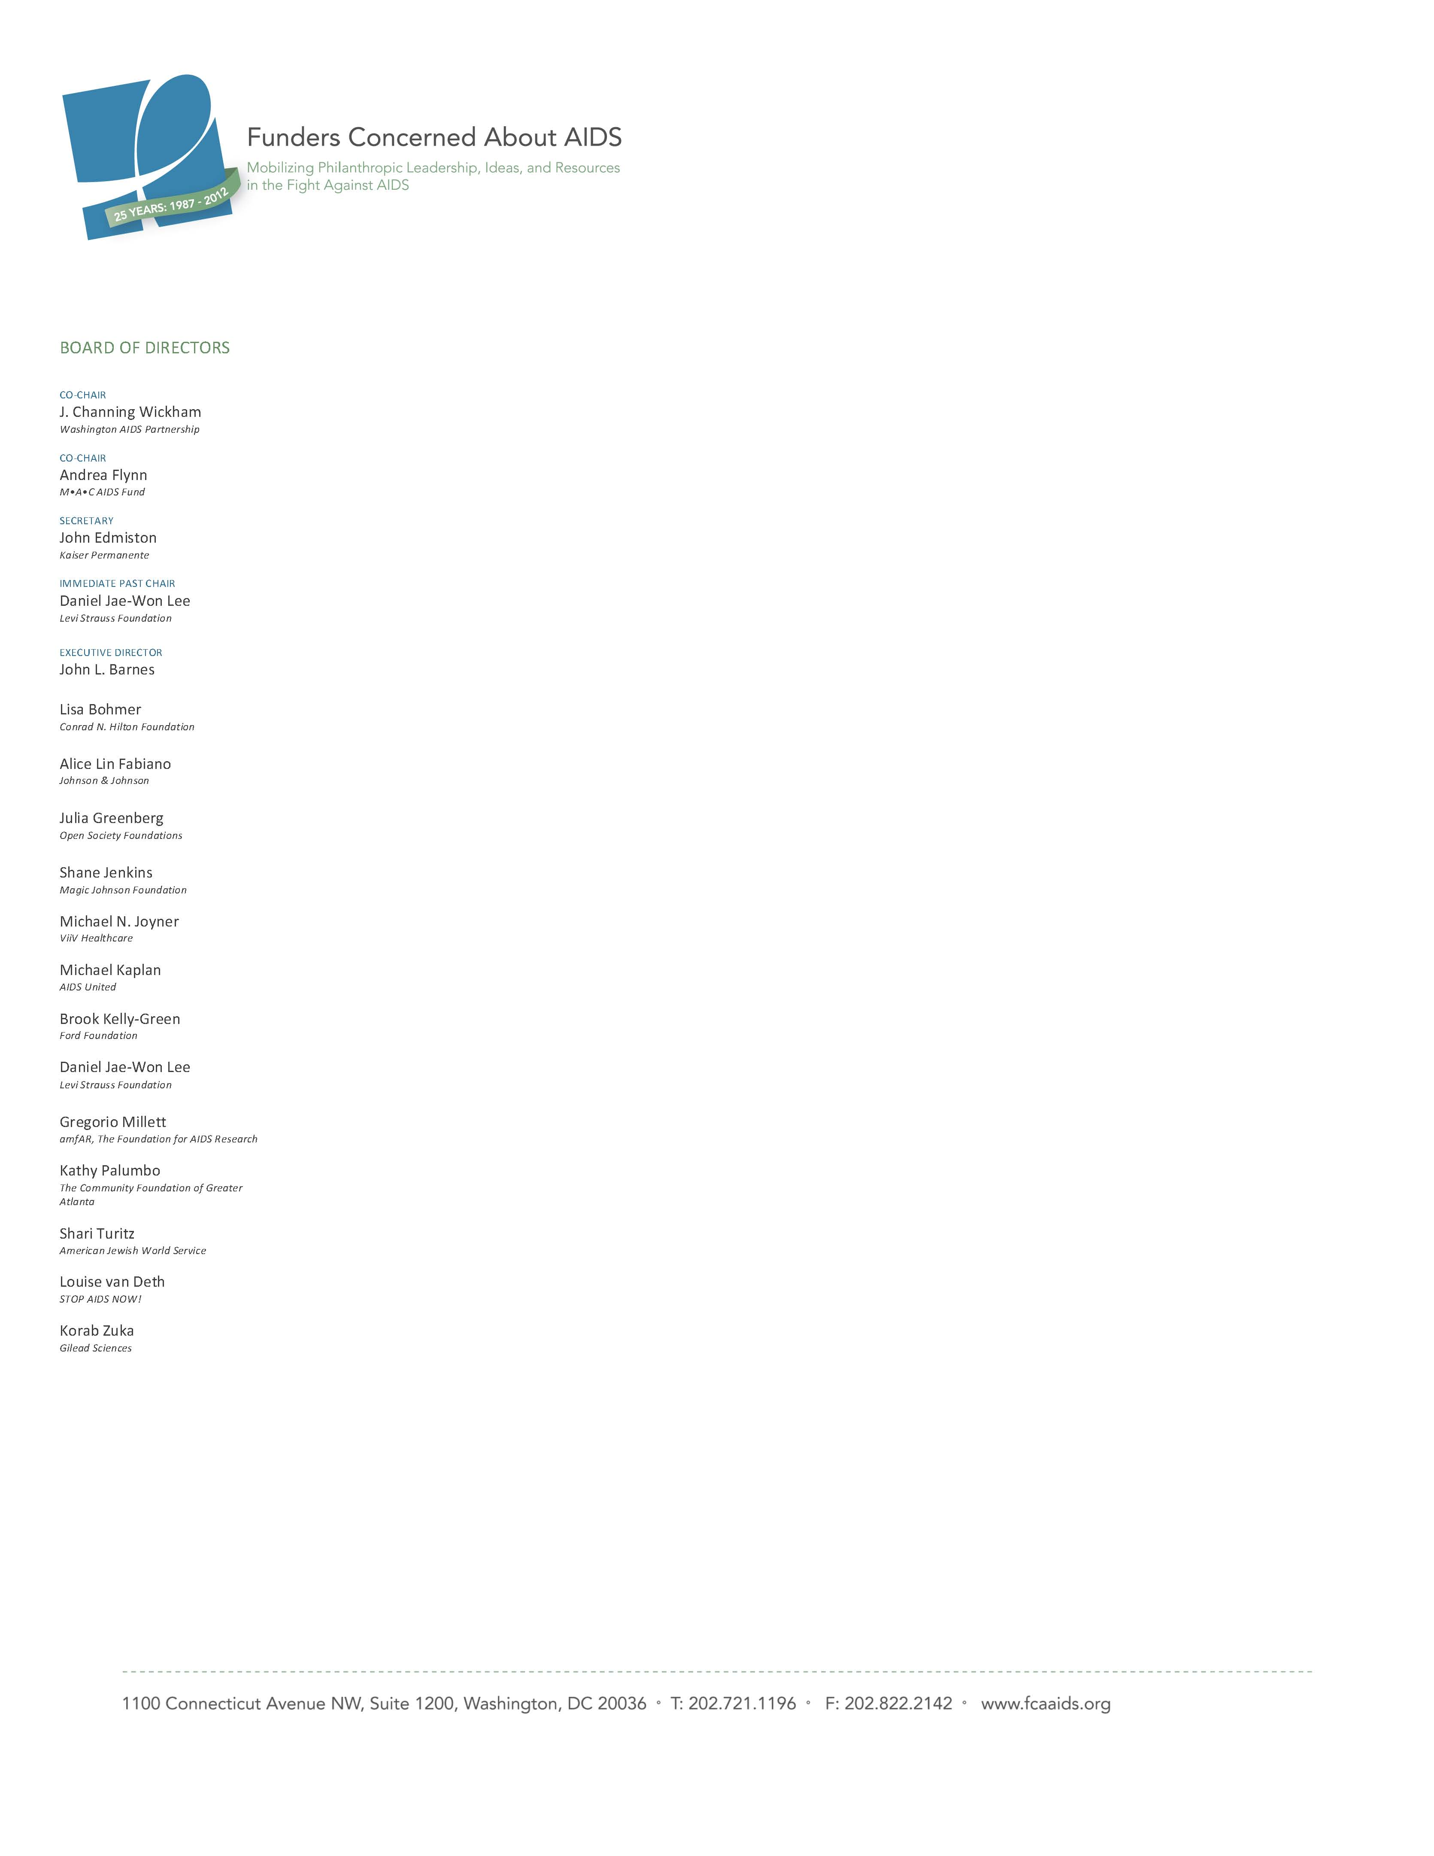

Funders Concerned About AIDS
Data Privacy Policy
UPDATED: March 2016

WINGS Data Charter Principle 4, Accountability: Data providers, collectors, and users should be responsible stewards of data, placing concerns for human dignity and confidentiality first, but striving for maximum transparency, truthfulness and objectivity, and for the productive and constructive use of data.

Background:
Funders Concerned About AIDS (FCAA) has tracked the field of AIDS-related private philanthropy for more than a decade. Each year FCAA relies on surveys completed by funders, with supplemental review of data from grant databases and funders’ grant lists. The data from this effort is published in an annual resource tracking report: Philanthropic Support to Address HIV/AIDS. In preparation for its upcoming 13th edition of resource tracking, FCAA launched a new strategy in April 2015 to encourage funders to submit grant lists in lieu of completing the previous survey template. This new strategy will help to increase the depth of FCAA’s analysis and reporting, as well as decrease the burden on the participating organizations. FCAA’s vision is that with increased access to data, the organization will be able to improve reporting on the true nature of AIDS-related philanthropy, as well as provide better technical assistance and support to the field. Currently resource tracking data is currently only available via the printed report that is also available in PDF and interactive reader online at www.fcaaids.org/resourcetracking. FCAA is beginning to expand its analysis into additional FCAA blogs and online tools.

To implement these changes, FCAA also realized a need to develop a transparent data privacy policy to help funders understand how their data will be used and protected within this new resource tracking policy.
Data Policy:
The FCAA resource tracking project consists of three main tools:
- The annual report: Philanthropic Support to Address HIV/AIDS
- The online funding map – aidsfundingmap.org – that currently provides total funding and engaged philanthropic organizations per region, country, and U.S. state.
- Subsequent analyses – in the form of blogs, infographics, presentations, and articles – that provide a deep dive on funding for a specific issue, population or geography. A recent example can be found at: bit.ly/1M7Clnd.

Submitted data will be used to inform the tools listed above.

Additional details:
- Individual organization grant lists will never be shared outside of FCAA
- Grantee-level information and locations will not be shared in the report or subsequent analyses. Funders may also note a grantee as anonymous within grant lists if there are concerns about protecting their identity or location, and/or the funder’s activity within a particular geography.
- If funders do NOT want their data included in the full set of resource tracking tools (see above), they must express their desire to opt-out when they submit their data. As an alternative, they can also anonymize any data they do not wish to be shared publically.

FCAA’s work, including this signature resource tracking project, is overseen and guided by a 18-member Board of Directors. The organization will commit to ensuring that data privacy is an ongoing subject for discussion, and to review this policy on an annual or as-needed basis.

Your feedback:
This policy represents a start to our commitment and conversation on data privacy. We encourage funders to share their feedback, concerns, or questions on this process so we can continue to update this policy to meet the needs of the AIDS philanthropic sector. If your organization as additional concerns with data sharing that are not adequately addressed by this policy, FCAA would be happy to develop an organization-specific policy that would continue to enable your full participation in resource tracking. FCAA encourages you to share your feedback on this process and policy with Sarah Hamilton at sarah@fcaaids.org or 509-747-0535.

