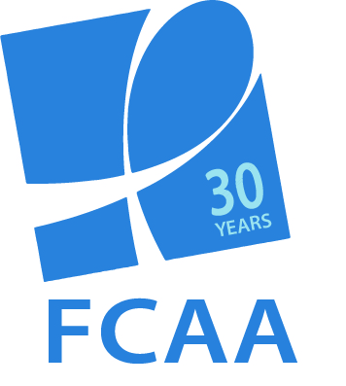

PHILANTHROPIC SUPPORT TO ADDRESS HIV/AIDS
SOCIAL MEDIA TOOLKIT

For the past 15 years, Funders Concerned About AIDS’ signature report, Philanthropic Support to Address HIV/AIDS, has helped to identify gaps, trends, and opportunities in HIV-related philanthropy. This report, the most comprehensive of its kind, captures data on more than 7,000 grants, awarded by 392 funders in 15 countries.

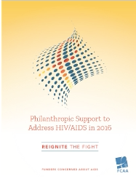

As we prepare to launch this year’s report on December 7, we would welcome your assistance in helping to build awareness of the data. To that end, we have created template content to share through your respective social media platforms. Please note: This content is embargoed until December 7.

We ask for your help by encouraging you to:
- Begin posting this content on December 7
- Continue to use this content, as appropriate, in the days and weeks following the launch
- Use the hashtag #FundAIDSFight and/or #ReigniteTheFight in your posts
- When possible, tag @FCAA in your posts
- Download helpful photos to accompany your posts at: http://bit.ly/2k0ePCV

We hope you find this material useful. As always, please let us know if you have any questions or would like further information.

FACEBOOK

@FCAAIDS’ Philanthropic Support to Address HIV/AIDS captures data on more than 7,000 grants, awarded by 392 foundations in 15 countries. It can be used to identify gaps, trends, and opportunities in HIV-related philanthropy. Learn more about the most recent data, just released today http://bit.ly/2g6AXKR #FundAIDSFight

In the 15th edition of its Philanthropic Support to Address HIV/AIDS report, @FCAAIDS sounds the alarm bell on lagging political will and decreasing resources to fight the epidemic. In this challenging environment, we must #ReigniteTheFight. Read more here http://bit.ly/2g6AXKR #FundAIDSFight

Don’t have time right this minute to dive deep into @FCAAIDS new resource tracking report? No worries! Check out this short video that covers the high points of philanthropic funding to fight #HIV #AIDS. #FundAIDSFight LINK TO VIDEO

TWITTER

Launched today: 15th edition of @FCAA’s resource tracking report shows 3rd straight year of growth in philanthropic resources to fight #HIV #AIDS. But organization warns that findings must be viewed in larger context. http://bit.ly/2g6AXKR #FundAIDSFight

New @FCAA report warns we can’t allow flagging resources and ill-informed policy to roll back progress in fight against #HIV #AIDS. Now more than ever the philanthropic sector must increase support to #FundAIDSFight http://bit.ly/2g6AXKR #ReigniteTheFight

Philanthropic funding to low- and middle-income countries increased by 11% from 2015 to 2016 according to @FCAA’s latest resource tracking report. http://bit.ly/2g6AXKR #FundAIDSFight

The top regional recipients for philanthropic #HIV #AIDS funding in 2016 were North America and East & Southern Africa http://bit.ly/2g6AXKR #FundAIDSFight

Where do philanthropic funders allocate #HIV #AIDS resources? According to @FCAA’s new report, research and prevention topped the list for intended use of funds. http://bit.ly/2g6AXKR

Commitments to advocacy and human rights increased by 1%, bringing the total level of resources allocated to this critical issue to a new high of $125 million. http://bit.ly/2g6AXKR

New @FCAA report highlights good news/bad news scenario. The GOOD: philanthropic funders increased funding (by 1%) for #advocacy & #humanrights in 2016. But now the BAD: funding for all key populations decreased in the last 12 months. http://bit.ly/2g6AXKR #FundAIDSFight

.@FCAA’s new report tracks philanthropic sector's strategic investments in key area including PrEP, advocacy & human rights, key pops, capacity building & leadership development. Learn more http://bit.ly/2g6AXKR #FundAIDSFight

.@Gatesfoundation .@gileadsciences .@viivhc .@macaidsfund .@wellcometrust .@ejaforg & .@ejaf .@CIFFChild .@Aidsfonds .@jnjnews & .@hiltonfound named as top 10 private HIV funders in 2016 http://bit.ly/2g6AXKR #FundAIDSFight

Here’s a quick overview of @FCAA’s new #HIV #AIDS philanthropic resource tracking report in video format. It includes the key takeaways that anyone working to #FundAIDSFight should know. http://bit.ly/2zVCDhM

