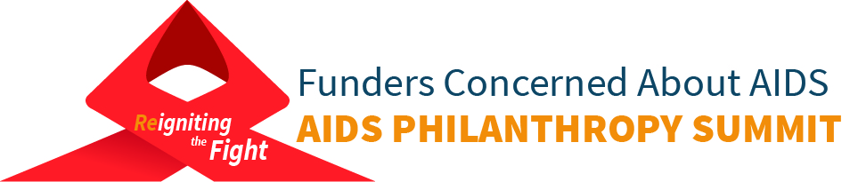
2017 AIDS Philanthropy Summit Social Media Toolkit

The social media content below is intended to aid in promoting registration and interest in the 2017 AIDS Philanthropy Summit. Download correlating images/logos below: https://www.dropbox.com/sh/retfzcolwv18squ/AAClDuuVhSlRgM3FsGflyzuUa?dl=0

Twitter Content

Join us to celebrate 30 years of bringing philanthropic attention to the #AIDS crisis. http://ow.ly/jF8h30cteRt #FCAASummit #FundAIDSFight (Attach summit logo with date and location)

Join us Sept18-19 to reignite commitment to future of fight against #HIV & #AIDS http://ow.ly/jF8h30cteRt #FCAASummit #FundAIDSFight

Now more than ever we need to #FundAIDSFight. Bring your spark Sept18-19 & reignite the fight http://ow.ly/jF8h30cteRt #FCAASummit #AIDS (Attach summit logo with date and location)

Uncertain public funding for #HIV & #AIDS =greater need 4 increased amt & impact of philanthropy http://ow.ly/jF8h30cteRt #FCAASummit

Learn abt impact of #HIV philanthropy, successes & where more resources are needed http://ow.ly/jF8h30cteRt #FCAASummit #FundAIDSFight

Celebrate 30yrs of leadership tht built infrastructure to support those affected by #HIV http://ow.ly/jF8h30cteRt #FCAASummit #FundAIDSFight

Philanthropic funding to fight epidemic rose 10% from 2014-15=$663m but more needed to #FundAIDSFight http://ow.ly/jF8h30cteRt #FCAASummit

Facebook Content

FB#1
The President’s FY2018 Budget plan proposes dramatic cuts to funding for both global and U.S. domestic health and development programs, which could critically set back progress made in ending the HIV and AIDS epidemic. With this uncertainty, it is increasingly important to come together as a community and reignite our commitment to the future of the fight against HIV and AIDS. Join us September 18-19 for the 9th annual AIDS Philanthropy Summit where we will celebrate 30 years of bringing philanthropic attention to the AIDS crisis and together, recommit to building the advocacy and infrastructure needed to support those affected by HIV. #FundAIDSFight http://ow.ly/jF8h30cteRt #FCAASummit

FB#2
2017 marks 30 years since @FCAA was founded by a group of grant makers dedicated to bringing philanthropic attention to the AIDS crisis. Once again, as we face a changing and uncertain political and financial landscape, we remind ourselves that we are not starting from the beginning. We will meet this challenge with the strength and wisdom of more than three decades of a powerful movement that created the advocacy and infrastructure to support those affected by HIV. Join us in this fight at the 9th annual AIDS Philanthropy Summit this September, where we will celebrate 30 years of philanthropic leadership and together, reignite our commitment to the future of the fight against HIV and AIDS. #FundAIDSFight http://ow.ly/jF8h30cteRt #FCAASummit

