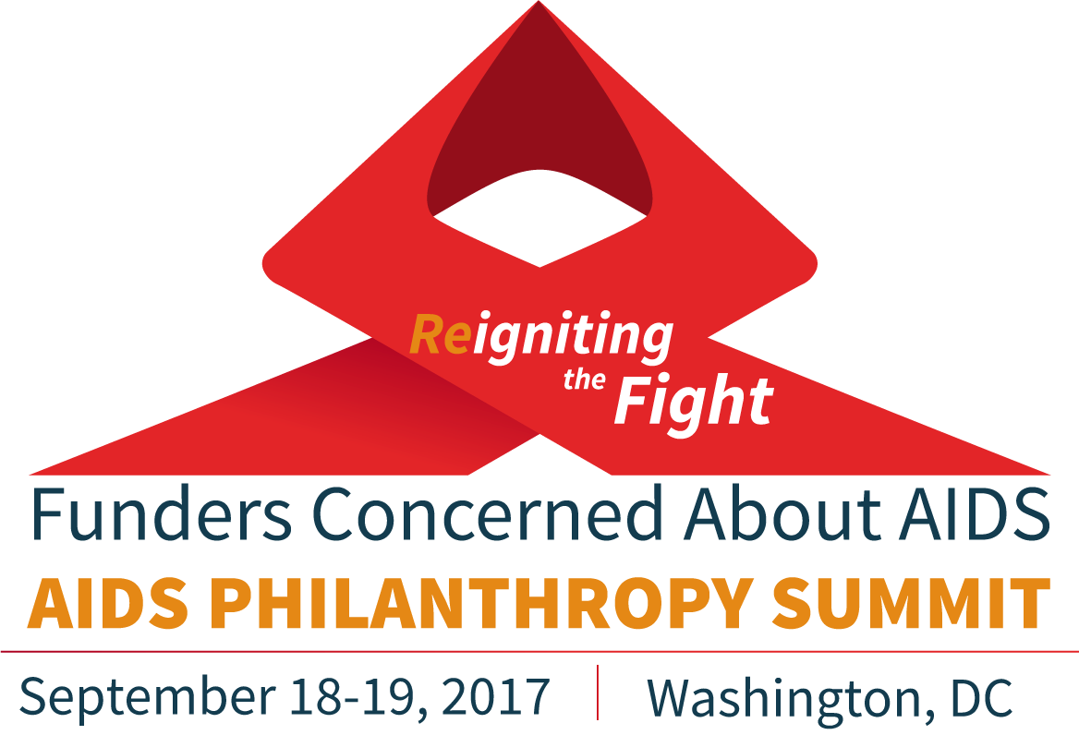

SUMMIT RESOURCES
A selection of resources and reading from Summit session organizers. This list will be updated as necessary following the Summit. Have a resource to suggest? Send to sarah@fcaaids.org.

DAY 1 SESSIONS

Be Bold! Engaging in and Supporting Advocacy as an Act of Resistance

- Bolder Advocacy. Philanthropy Advocacy Playbook. https://www.bolderadvocacy.org/focus-on-foundations/philanthropy-advocacy-playbook

PLHIV Networks: A Good Idea in the 80s, An Even Better Idea Today

- People Living with HIV Network Empowerment Project. SERO NEP 2017. http://www.seroproject.com/network-empowerment-project/
- People Living with HIV Networks Listing. SERO NEP 2017. http://www.seroproject.com/state-networks/
- Meaningful Involvement of People with HIV/AIDS (MIPA) AIDS United 2017. http://www.seroproject.com/wp-content/uploads/2017/05/Meaningful_Involvement_of_People_with_HIV_AIDS_MIPA.pdf
- The Denver Principles 1983. http://www.seroproject.com/wp-content/uploads/2016/11/denver_principles-FINAL.pdf
- ’The Denver Principles’ Changed Healthcare Forever. Mark S. King 2013. https://www.poz.com/blog/how-the-denver-princ
- Greater Involvement of People with HIV/AIDS (GIPA) UNAIDS 2007. http://data.unaids.org/pub/briefingnote/2007/jc1299_policy_brief_gipa.pdf
- A History Of The PWA Self-Empowerment Movement. M. Callahan and Dan Turner 1988. https://web.archive.org/web/19990503115605/http://members.aol.com/sigothinc/pwahist1.htm
- A Grassroots History of the HIV/AIDS Epidemic in North America. James Gillett 2010. https://www.amazon.com/Grassroots-History-Epidemic-North-America/dp/0982659776

Advocacy Works!

- Forbes. Millions Could Die If Foreign Aid Is Cut, Gates Foundation Warns. September 2017. https://www.forbes.com/sites/matthewherper/2017/09/13/millions-could-die-if-foreign-aid-is-cut-gates-foundation-warns/#48c2459d1c70
  - Gates Study link: http://www.globalgoals.org/goalkeepers/datareport/case-studies/hiv
- Friends of the Global Fight. ‘Dear America’: A Campaign for U.S. Support of the Global Fund. http://www.theglobalfight.org/dearamerica/
- Friends of the Global Fight. Brief: The Case for U.S. Investment in the Global Fund and Global Health. January 2017. http://www.theglobalfight.org/case-us-investment-gf-global-health/
- KFF and UNAIDS. Financing the Response to AIDS in Low- and Middle-Income Countries: International Assistance from Donor Governments in 2016. July 2017
- http://www.kff.org/global-health-policy/report/donor-government-funding-for-hiv-in-low-and-middle-income-countries-in-2016/
- Stop AIDS. A Stocktake Review of DFID’s Work on HIV and AIDS – Executive Summary
  - Accompanying infographic
- Treatment Action Group. Community Mobilization: An Assessment of Mechanisms and Barriers at Community-Based and AIDS Service Organizations in Nine U.S. Metropolitan Areas. January 2017.
http://www.treatmentactiongroup.org/sites/default/files/comm%20mobiliaztion%20web_0.pdf

Civil Society-driven Actions on Sustainability and Domestic Resource Mobilization for HIV and AIDS

- Abuja Declaration
http://arasa.info/files/7915/0235/4592/abuja_declaration.pdf
- Press statement: 2016 Malawi budget analysis
http://arasa.info/files/7115/0235/4592/PRESS_STATEMENT_BUDGET_ANALYSIS-1.pdf
- BONELA responds to the 2017 Botswana national budget speech
http://arasa.info/files/1615/0235/4597/RESPONSE_TO_THE_2017_BUDGET_SPEECH_-_Final.pdf
- Media articles on Malawi civil society domestic financing advocacy http://arasa.info/files/8815/0235/4505/Malawi_dossier_-_BMET.pdf
- Brief: Tanzania 2016/2017 health budgets
http://arasa.info/files/4315/0235/4614/Tanzania_health_budget_brief.pdf
- Policy briefs on 2015 domestic health budgets and financing for key population interventions in Botswana, Malawi and Tanzania
http://arasa.info/index.php/download_file/view/1740/761/
http://arasa.info/index.php/download_file/view/1741/761/
http://arasa.info/index.php/download_file/view/1744/761/

HIV Health Care Access: The Impact of ACA Repeal Efforts and Budget Cuts

- AIDS Foundation of Chicago. Protect Our Care Illinois. http://protectourcareil.org/index.php/resources/

Funding Community Resilience – If Not Now, Then When?

- Open Democracy: Closing Space for Civil Society
https://www.opendemocracy.net/openglobalrights/closing-space-for-civil-society
- Red Umbrella Fund. China: A Case Study of Sex Worker Organising
http://www.redumbrellafund.org/china-case-study-sex-worker-organising/
- Red Umbrella Fund. APROSMIG: A Case Study
http://www.redumbrellafund.org/aprosmig-case-study/
- Red Umbrella Fund. Sisonke: A Case Study
http://www.redumbrellafund.org/sisonke-case-study/
- Meet the Changemakers: Funding Resilience, Building Leadership Capacity
http://lnp.foundationcenter.org/training/calendar/washington-dc/funding-resilience-building-leadership-capacity-2016-09-08
- Resourcing for resilience: lessons from funding women’s rights movements
http://civicus.org/images/SOCS2015_ESSAY20_ResourcingForWomensRights.pdf
- Capacity Building and Resilience: What Participants Learned through ArtsLab
http://www.giarts.org/article/capacity-building-and-resilience
- Integrated Security: The Manual
http://www.integratedsecuritymanual.org/sites/default/files/integratedsecurity_themanual.pdf
- Our Right To Safety: Women Human Rights Defenders’ Holistic Approach to Protection
https://www.awid.org/sites/default/files/atoms/files/Our%20Right%20To%20Safety_FINAL.pdf
- Wellness, Self-Care and Security – Why this is Important to Feminism
https://www.awid.org/news-and-analysis/wellness-self-care-and-security-why-important-feminism

SUMMIT RESOURCES: DAY 2 SESSIONS

Girls and Young Women at the Center of the HIV Response

- AIDSpan. Global Fund Steps Up Investments on Women and Girls. January 2017.
http://webcache.googleusercontent.com/search?q=cache:WZ9DG8eD9LkJ:www.aidspan.org/gfo_article/global-fund-steps-investments-women-and-girls+&cd=1&hl=fr&ct=clnk&gl=cm
- DEVEX. The big picture: Empowering, not just reaching, all women and girls. May 2016.
https://www.devex.com/news/the-big-picture-empowering-not-just-reaching-all-women-and-girls-88033
- Janet Fleischman, Center for Strategic & International Studies. The Next Frontier: Stop New HIV Infections in Adolescent Girls and Young Women. July 2017.
https://www.csis.org/analysis/next-frontier
- The Global Fund to Fight AIDS, Tuberculosis and Malaria. Technical Brief: Adolescent Girls and Young Women in High-HIV Burden Settings. January 2017.
https://www.theglobalfund.org/media/4576/core_adolescentgirlsandyoungwomen_technicalbrief_en.pdf
- UNAIDS. Guidance Document: HIV Prevention Among Adolescent Girls and Young Women. July 2016.
http://www.unaids.org/en/resources/documents/2016/20160715_Prevention_girls
- Women 4 Global Fund (W4GF) website
http://women4gf.org/

Growing the Global Movement to End HIV Criminalization: Challenges and Opportunities

- GNP+ and HIV Justice Network. Advancing HIV Justice 2: Building momentum in global advocacy against HIV criminalisation. April 2016 http://www.hivjustice.net/advancing2
- HIV Justice Network. Beyond Blame: Challenging HIV Criminalisation @ AIDS 2016 (Video and written reports): http://www.hivjustice.net/aids2016
- HIV Justice Worldwide. A global campaign to abolish criminal and similar laws, policies and practices that regulate, control and punish people living with HIV based on their HIV-positive status. http://www.hivjusticeworldwide.org/
- AIDS and Rights Alliance for Southern Africa. HIV, TB and Human Rights in East and Southern Report, 2016 http://www.arasa.info/files/3314/8119/1044/ARASA_2016_Human_Rights_report.pdf
- 2nd Africa Regional Dialogue on HIV, TB and the Law Issue brief: Criminalisation of HIV, TB and key and vulnerable populations, August 2017 http://africadialogue.net/wp-content/uploads/2017/08/ISSUE-BRIEF-05_Criminalisation-of-HIVTB-and-Key-and-Vulnerable-Populations.pdf
- 2nd Africa Regional Dialogue on HIV, TB and the Law Issue brief: Women, HIV, TB and the law, August 2017 http://africadialogue.net/wp-content/uploads/2017/08/ISSUE-BRIEF-04-Women-TB-HIV-and-the-Law.pdf
- OHCHR and UNAIDS. Expert meeting report: Understanding and building synergies for addressing the misuse of the criminal law and its impact on women, sex workers, people who use drugs, people living with HIV and LGBT persons. May 2017 https://tinyurl.com/criminallawsynergies
- UNAIDS. Ending overly-broad criminalisation of HIV non-disclosure, exposure and transmission: Critical scientific, medical and legal considerations, May 2013 http://www.hivjustice.net/news/unaids-publishes-updated-detailed-guidance-on-hiv-criminalisation/

Aging with HIV: Challenges and Opportunities
- acria. roah Study https://www.acria.org/roah/
- FCAA. HIV Philanthropy for Older Adults. September 2017. http://www.fcaaids.org/wp-content/uploads/2017/09/agingInforgraphic2017-FINAL.pdf
- Older Women Embracing Life (OWEL) http://www.owelinc.org/
- Age Is Not A Condom http://ageisnotacondom.org/en/home/

What the Transgender Community Needs Grantmakers to Know

- AIDS United. Meaningful Involvement of People with HIV/AIDS (MIPA). 2017
https://www.aidsunited.org/resources/meaningful-involvement-of-people-with-hivaids-mipa
- AIDS United. Stepping Up: A Consensus Statement by Trans Leaders. 2017
https://www.aidsunited.org/resources/stepping-up-a-consensus-statement-by-trans-leaders
- Centers for Disease Control and Prevention. HIV Among Transgender People. 2016
http://www.cdc.gov/hiv/group/gender/transgender/
- Funders Concerned About AIDS. HIV Philanthropy for Transgender Communities. 2014
http://www.fcaaids.org/wp-content/uploads/2016/11/Infographic-HIV-Philanthropy-for-Transgender-Communities-in-2014.pdf
- Funders Concerned About AIDS. Putting the “T” in LGBT HIV Funding: Matching Funder Response to Community Needs. 2016.
http://www.fcaaids.org/what-we-do/convenings/funder-briefing-programs/putting-the-t-in-lgbt-hiv-funding-matching-funder-response-to-community-needs/
- Transgender Law Center. Positively Trans: Initial Report of a National Needs Assessment of Transgender and Gender Non-Conforming People Living with HIV. 2016.
http://transgenderlawcenter.org/wp-content/uploads/2016/02/PositivelyTrans-spreads-3.24.16.pdf
- TransLatin@ Coalition. The State of Trans Health: Trans Latin@s and Their Healthcare Needs. 2016.
https://www.translatinacoalition.org/blog/2016/11/29/the-state-of-trans-health

HIV in the U.S. South

- New York Times Magazine. America’s Hidden HIV Epidemic. June 2017. https://www.nytimes.com/2017/06/06/magazine/americas-hidden-hiv-epidemic.html
- Atlanta Journal Constitution. 5-part series - The Silent Epidemic: Black Gay Men and HIV http://specials.myajc.com/black-men-HIV/
- Southern HIV/AIDS Strategy Initiative. HIV Stigma Study in the Deep South: Descriptive Findings. September 2017. https://southernaids.files.wordpress.com/2017/08/revised-stigma-report-formatted-in-pdf.pdf
- Southern HIV Impact Fund – Request for Proposals https://www.aidsunited.org/Funding-Opportunities/Southern-HIV-Impact-Fund-RFP.aspx

