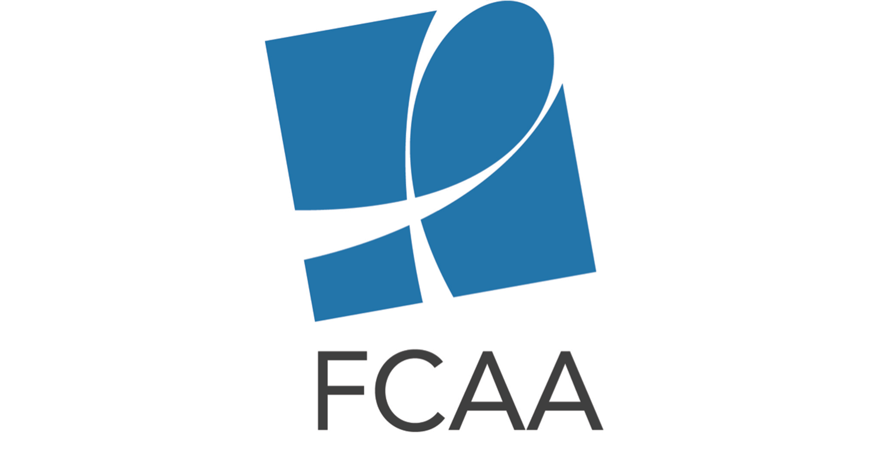
HIV Philanthropy for Advocacy & Human Rights Social Media Toolkit

The social media content below is intended to aid in the rollout of the HIV Philanthropy for Advocacy Human Rights infographic.
Shareable infographic link: http://bit.ly/2qvZ8bQ
Download shareable images at: https://www.dropbox.com/sh/7zmp60f4h8150m2/AACpBy-jBDjjag-40xCfRgqaa?dl=0

Twitter Content

General:

New infographic details #HIV philanthropy for #advocacy & #humanrights bit.ly/2qvZ8bQ #AIDSFunding

W/ public funding for the epidemic under attack, WE NEED TO INCREASE #HIV PHILANTHROPY FOR #ADVOCACY & #HUMANRIGHTS bit.ly/2qvZ8bQ #FundAIDSFight

Breakdown of Infographic Content:

In 2015 $123.5M in #HIV-related philanthropy went to #advocacy & #humanrights, a 35% from 2014 bit.ly/2qvZ8bQ

Check out analysis of the who, what, where & why of #HIV-related philanthropy for #advocacy #humanrights bit.ly/2qvZ8bQ #FundAIDSFight

In 2015, 18% of private #HIV philanthropy addressed #advocacy #humanrights bit.ly/2qvZ8bQ

Funding for orgs doing #advocacy & #humanrights work ensures adequate public resources & sound policy bit.ly/2qvZ8bQ #HIV #FundAIDSFight

Many communities heavily impacted by #HIV epidemic are underfunded. Must increase philanthropy bit.ly/2qvZ8bQ #FundAIDSFight

E.Europe & C.Asia =19% of new #HIV infections but only got 5% of HIV-related philanthropy for #advocacy & #humanrights bit.ly/2qvZ8bQ

Communities disproportionately affected by #HIV in US only got 2-3% of HIV-related philanthropy for #advocacy & #humanrights bit.ly/2qvZ8bQ

Find out the #Advocacy & #humanrights-related strategies supported by #HIV philanthropy bit.ly/2qvZ8bQ #FundAIDSFight

In 2015, 32% #HIV philanthropy for #advocacy & #humanrights went to low & #MICs. Find out where else it went: bit.ly/2qvZ8bQ

(1/3) In 2015 Top10 #HIV philanthropic funders for #advocacy & #humanrights include: @GileadSciences @MACAIDSFund @FordFoundation bit.ly/2qvZ8bQ

(2/3) In 2015 Top10 #HIV philanthropic funders for #advocacy & #humanrights include: @gatesfoundation @OpenSociety @ejaforg @ViiVhc bit.ly/2qvZ8bQ

(3/3) In 2015 Top10 #HIV philanthropic funders for #advocacy & #humanrights include: @AIDS_United @LeviStraussCo @TidesCommunity bit.ly/2qvZ8bQ

Facebook Content

Post #1: Over the course of the HIV epidemic, advocacy and rights-based programming has driven scientific and therapeutic advancements, changed policies and public opinion, and raised the voices and protections of those most vulnerable. Unfortunately, this crucial work is often undertaken with inadequate support and faces with political opposition. Learn more about funding for these critical efforts through this new infographic on HIV philanthropy for advocacy and human rights: bit.ly/2qvZ8bQ #FundAIDSFight

Post #2: Many communities continue to be heavily impacted by the HIV epidemic but insubstantially funded. Funding for organizations doing advocacy and rights-based work is our strongest tool to ensure adequate public resources and sound policy reach these populations. With public funding for the epidemic under attack, it is critical to increase HIV philanthropy for advocacy & human rights. Learn more about the state of HIV philanthropy for advocacy and human rights in FCAA’s new infographic. bit.ly/2qvZ8bQ #FundAIDSFight

