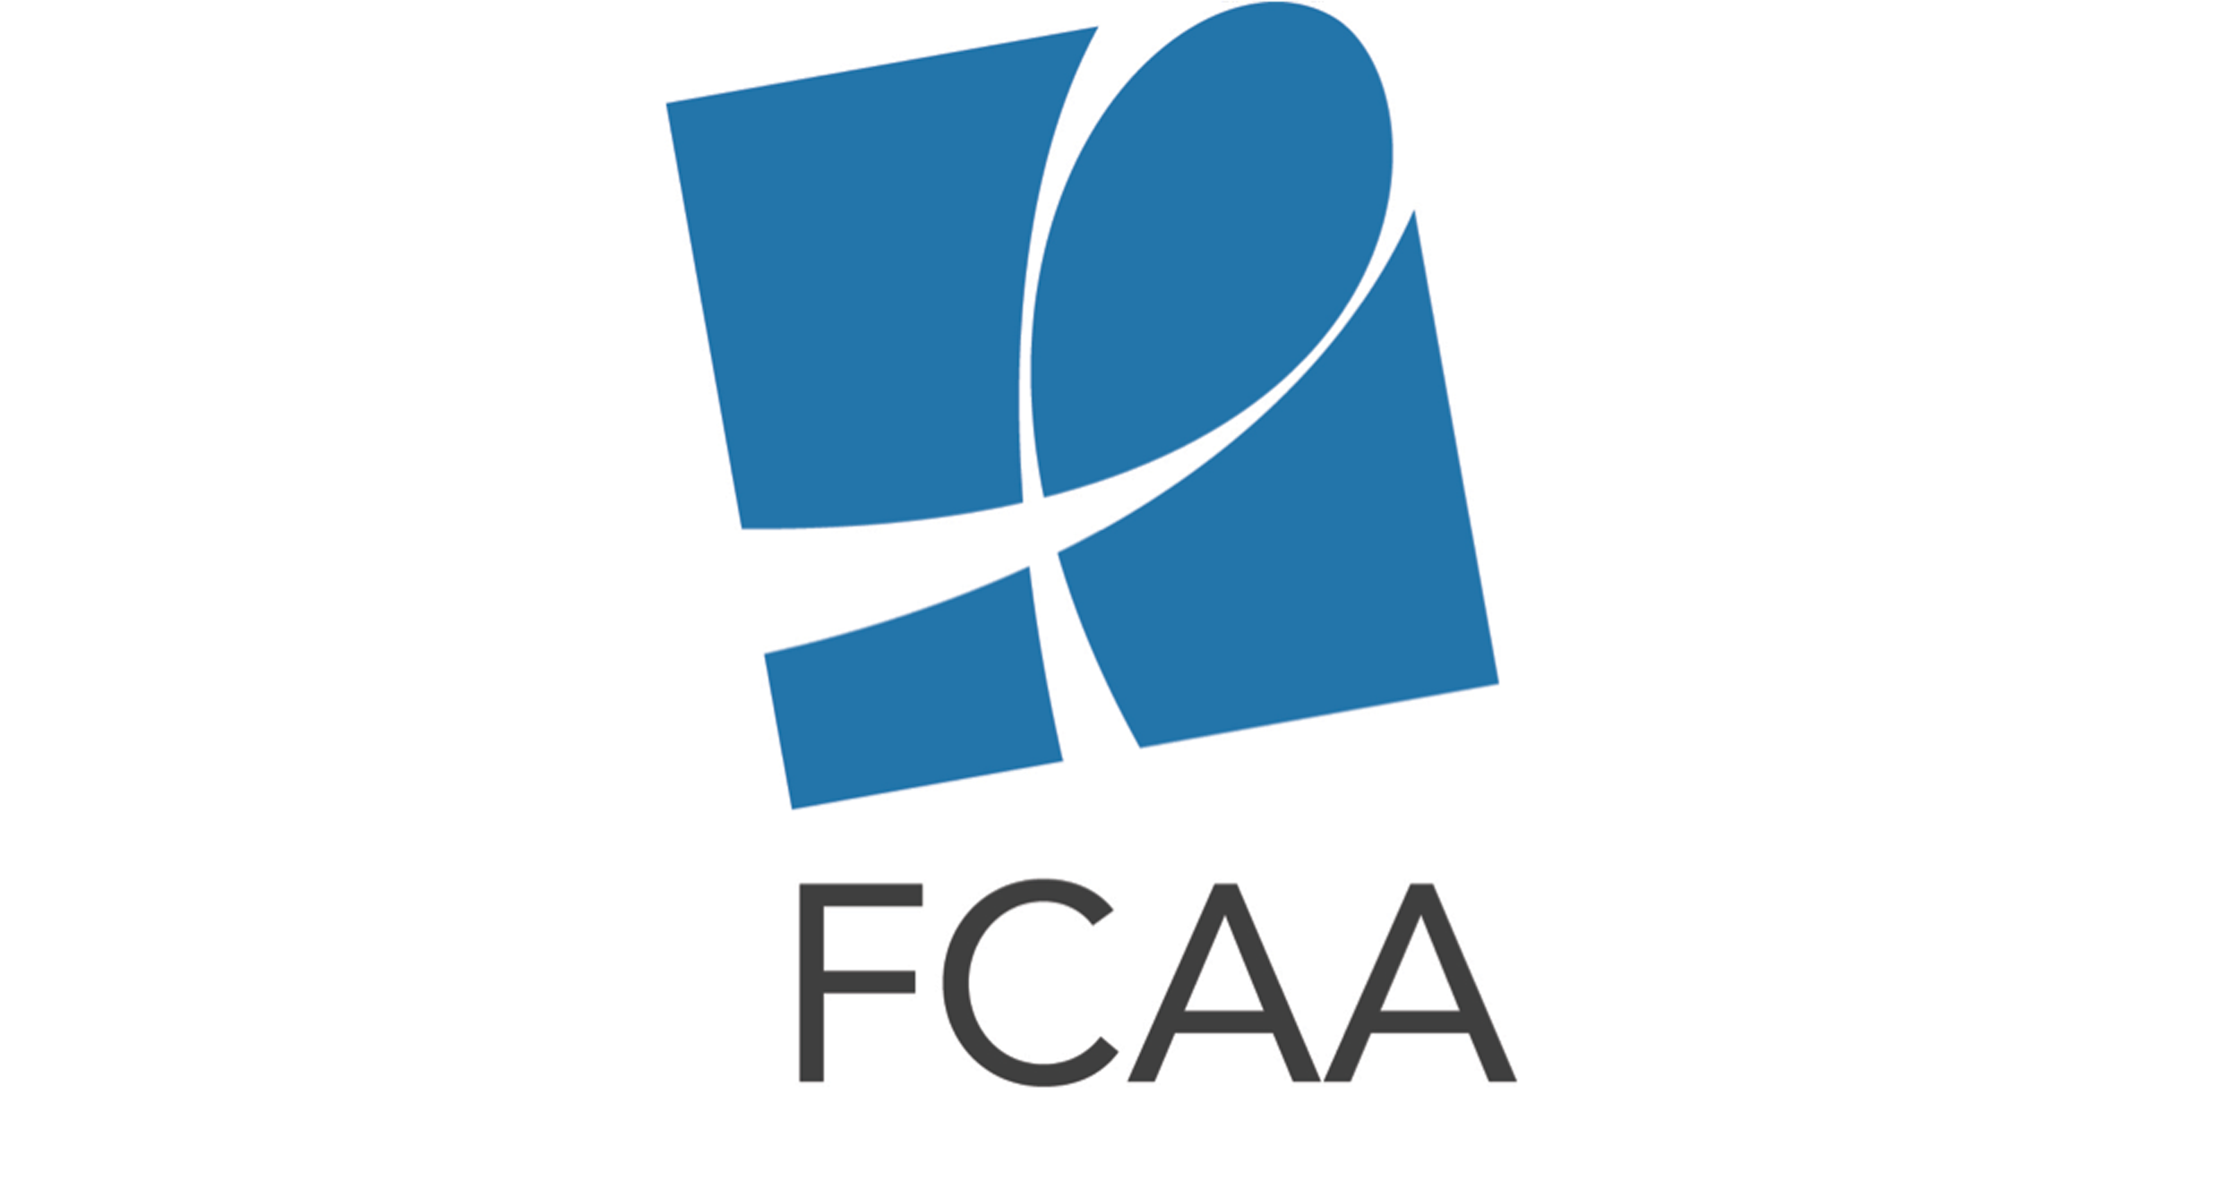
2017 AIDS Philanthropy Summit Social Media Toolkit

The social media content below is intended to aid in promoting registration and interest in the 2017 AIDS Philanthropy Summit. Always use the main conference hashtag, #FCAASummit, when tweeting. When possible, also include #ReigniteTheFight.

Download shareable images at: https://www.dropbox.com/sh/retfzcolwv18squ/AAClDuuVhSlRgM3FsGflyzuUa?dl=0

Twitter Content

General:

Join us to celebrate 30 years of bringing philanthropic attention to the #AIDS crisis. http://ow.ly/jF8h30cteRt #FCAASummit #ReigniteTheFight (Attach summit logo with date and location)

Join us Sept18-19 to reignite commitment to future of fight against #HIV & #AIDS http://ow.ly/jF8h30cteRt #FCAASummit #ReigniteTheFight

Now more than ever we need to #FundAIDSFight. Bring your spark Sept18-19 & reignite the fight http://ow.ly/jF8h30cteRt #FCAASummit #AIDS (Attach summit logo with date and location)

Uncertain public funding for #HIV & #AIDS =greater need 4 increased amt & impact of philanthropy http://ow.ly/jF8h30cteRt #FCAASummit

Learn abt impact of #HIV philanthropy, successes & where more resources are needed http://ow.ly/jF8h30cteRt #FCAASummit #FundAIDSFight

Celebrate 30yrs of leadership tht built infrastructure to support those affected by #HIV http://ow.ly/jF8h30cteRt #FCAASummit #ReigniteTheFight

Sneak peak of the #FCAASummit incredible sessions & plenaries now up on our site http://ow.ly/jF8h30cteRt #ReigniteTheFight

Plenary Sessions:

Explore America’s Hidden #HIV Epidemic with @lindavillarosa #FCAASummit US South Plenary http://ow.ly/jF8h30cteRt #ReigniteTheFight

#FCAASummit spotlight: .@TheSeroProject designed plenary on #PLHIV Networks http://ow.ly/jF8h30cteRt #FundAIDSFight

How are Community-based orgs leading way 2 #EndAIDS? @ #FCAASummit w/ .@Aidsfonds .@stephenlewisfdn .@ET_AIDS_FDN ow.ly/jF8h30cteRt

#FCAASummit spotlight: Funding Community Resilience–If not now than when? via .@redumbrellafund http://ow.ly/jF8h30cteRt #ReigniteTheFight

#FCAASummit will deep dive into US admin budget, policies,& impact on #globalhealth & #HIV #AIDS http://ow.ly/jF8h30cteRt #ReigniteTheFight

Breakout Sessions:

Join .@AFJustice for a pre #FCAASummit training session on engaging in & supporting advocacy http://ow.ly/jF8h30cteRt #FundAIDSFight #HIV

#FCAASummit spotlight: .@HarvardCHLPI & .@AIDSChicago's session on #HIV #healthcare access: #ACA repeal &budget cuts http://ow.ly/jF8h30cteRt

Join us for .@GlobalFund #FCAASummit session on #HIV Response for adolescent girls & young women. http://ow.ly/jF8h30cteRt #ReigniteTheFight

Learn abt the future of #HIV activism from the next gen @ #FCAASummit w/.@GreaterThanAIDS http://ow.ly/jF8h30cteRt #ReigniteTheFight

Learn abt & get involved w/ global mvmnt to end #HIV #criminalization @ #FCAASummit w/.@HIVJusticeNet http://ow.ly/jF8h30cteRt

Learn abt the challenges aging with HIV @ #FCAASummit w/ .@ACRIAsays Sponsored by .@MagicJohnsonFDN
http://ow.ly/jF8h30cteRt

Are we making inroads against #HIV stigma & discrimination? Join the .@VIIVHC & .@IAS session @ #FCAASummit http://ow.ly/jF8h30cteRt

What the #transgender community needs grantmakers to know: Join this .@AIDS_United session @ #FCAASummit
http://ow.ly/jF8h30cteRt

Facebook Content
General
FB#1
The President’s FY2018 Budget plan proposes dramatic cuts to funding for both global and U.S. domestic health and development programs, which could critically set back progress made in ending the HIV and AIDS epidemic. With this uncertainty of the future of public funding, it is increasingly important to come together as a community and reignite our commitment to the future of the fight against HIV and AIDS. Join us September 18-19 for the 9th annual AIDS Philanthropy Summit where we will celebrate 30 years of bringing philanthropic attention to the AIDS crisis and together, recommit to building the advocacy and infrastructure needed to support those affected by HIV.

FB#2
2017 marks 30 years since FCAA was founded, in the face of adversity, by a group of grant makers dedicated to bringing philanthropic attention to the AIDS crisis. Today, in the face of adversity in the form of potentially devastating cuts at the federal and international levels, we remind ourselves that we are not starting from the beginning. We are facing this challenge with the strength and wisdom of more than three decades of a powerful movement that created the advocacy and infrastructure to support those affected by HIV. The fire the movement started will not diminish as we continue to fight for the resources necessary to end HIV. Join us in this fight at the 9th annual AIDS Philanthropy Summit this September, where we will celebrate 30 years of FCAA’s philanthropic leadership and together, reignite our commitment to the future of the fight against HIV and AIDS.

