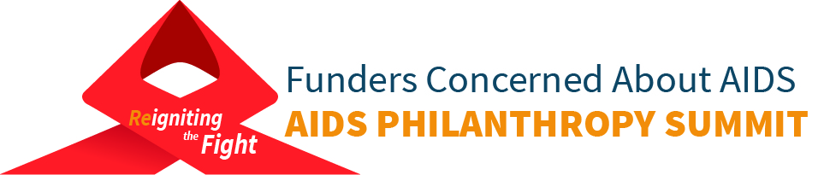
September 18-19, 2017
FHI 360 Conference Center
Washington, DC
DRAFT AGENDA

DAY ONE: SEPTEMBER 18
9-11am Registration and breakfast
9:30-10:45 Optional* Pre-Summit Skills Building
Be Bold! Engaging in and Supporting Advocacy as an Act of Resistance
Join Alliance for Justice for this Pre-Summit training session to explore why advocacy is essential for achieving your foundation’s mission. In addition to an overview of the legal rules, we’ll be assessing your advocacy prowess, working through case studies to see how these rules play out in the advocacy world, and applying the rules to your work by coming up with on-the-spot advocacy campaigns. Whether a seasoned advocate or at a foundation determined to step into advocacy for the first time, attendees will leave this workshop feeling inspired to strategically shape public policy! After this workshop, you will have a clear understanding of how private and public foundations can engage in advocacy, which activities could be seen as risky for foundations, and the legal rules of grant-making and grant agreements. You’ll leave with our Philanthropy Advocacy Playbook and strategies to incorporate advocacy into your foundation’s work.
*Please note, this session is COVERED in the cost of registration. However, you must indicate your interest during the registration process. If you have questions or concerns, please contact Sarah@fcaaids.org.
11:00 Welcome

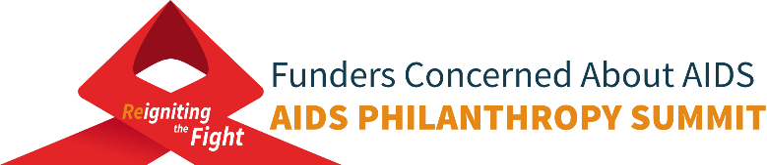

11:15-12:30 Plenary: PLHIV Networks: A Good Idea in the 80s, An Even Better Idea Today
Session designer: Sero Project
Sponsored by: Broadway Cares/Equity Fights AIDS and the Ittleson Foundation
This session, designed by the Sero Project, will discuss the history, role and importance of networks of People Living with HIV (PLHIV) to facilitate empowerment, combat HIV-related stigma, improve the quality of life outcomes of PLHIV and more effectively reduce HIV transmission. Panelists will cover the history of PLHIV networks, from the Denver Principles (which launched the PLHIV self-empowerment movement in 1983), through MIPA/GIPA (UNAIDS 1994 Meaningful/Greater Involvement of People Living with HIV) to the current resurgence in PLHIV organizing and new networks, increasingly global in scope, with broadened foci that adds combating criminalization and discrimination to battling HIV stigma.
The panel will discuss the importance of PLHIV networks using examples from their own local, national and global networks that illustrate their diversity and breadth. Panelists will show how the uniquely situated, if underutilized, PLHIV networks can more readily mobilize the engagement and empowerment of PLHIV, who in turn, have special potential in the struggle to advance our interests. The panel will describe how supporting the expansion of and leadership by PLHIV networks, from the local to the global level, will improve the mental and physical health of PLHIV, reduce stigma and improve public health outcomes.
Moderator: Sean Strub, Sero Project. Panelists: Dr. Carrie Foote, HIV Modernization Movement and PAC U=U; Dr. Andrew Spieldenner, PLHIV Caucus; Venita Ray, Legacy Community Health and Texans Living with HIV; Kamaria Laffrey, Sero Project, PWN, and emPOWERed Legacies.

12:30-2:00 Lunch & FCAA Advocacy Network Plenary
Detail: A follow-up to the Network's January webinar and April convening, this plenary will provide an update on the current status of Trump administration budget and policies and potential impact on global health and HIV/AIDS. Speaker details to come soon.

2:00 – 3:15 Break Out Sessions
- International: Civil Society-driven Actions on Sustainability and Domestic Resource Mobilization for HIV and AIDS
Session Designer: Robert Carr Civil Society Networks Fund
Session Sponsor: Open Society Foundations
- Domestic U.S.: HIV Health Care Access: The Impact of ACÁ Repeal Efforts and Budget Cuts
Session Designers: Center for Health Law and Policy Innovation at Harvard Law School and AIDS Foundation of Chicago
3:00 – 3:30 Break
3:30- 4:45 Plenary: Funding Community Resilience – If not now than when?
Session Designer: Red Umbrella Fund
Details coming soon
4:45-6:15 Reception

DAY TWO: SEPTEMBER 19
9:00 Opening remarks
9:15-10:30 Supporting community-based work: myths, realities, and achieving the end of AIDS by 2030
Session Designers: Aidsfonds, Stephen Lewis Foundation & the Elizabeth Taylor AIDS Foundation
Details and speakers to be announced soon
10:30 Break

10:45-11:45 Break Out Sessions
- International: Adolescent Girls and Young Women: Front and Center in the HIV Response.
Session Designer: Global Fund to Fight AIDS, Tuberculosis and Malaria
- Domestic U.S.: Voices of the Next Generation: The Future of HIV Education and Activism.
Session Designer: Kaiser Family Foundation
11:45-12:45 Open/Networking Lunch
12:45-1:45 Break Out Sessions
- International: Growing the global movement to end HIV criminalization: challenges and opportunities
Session designer: HIV Justice Network
Session sponsor: Robert Carr Civil Society Networks Fund
- Domestic U.S.: Aging with HIV: Challenges and Opportunities
Session designer: ACRIA
Session sponsor: Magic Johnson Foundation
1:45-2:00 Break
2:00 – 3:00 Break Out Sessions
- International: Overcoming Stigma and Discrimination: Are we making real inroads?
Session designer: ViiV Healthcare
- Domestic U.S.: What the Transgender Community Needs Grantmakers to Know.
Session designer: AIDS United
3:00-3:15 Break
3:15-4:45 Closing Plenary: HIV in the U.S. South
Details and speakers to be announced soon.
4:45-5:00 Wrap-Up/Closing Remarks

