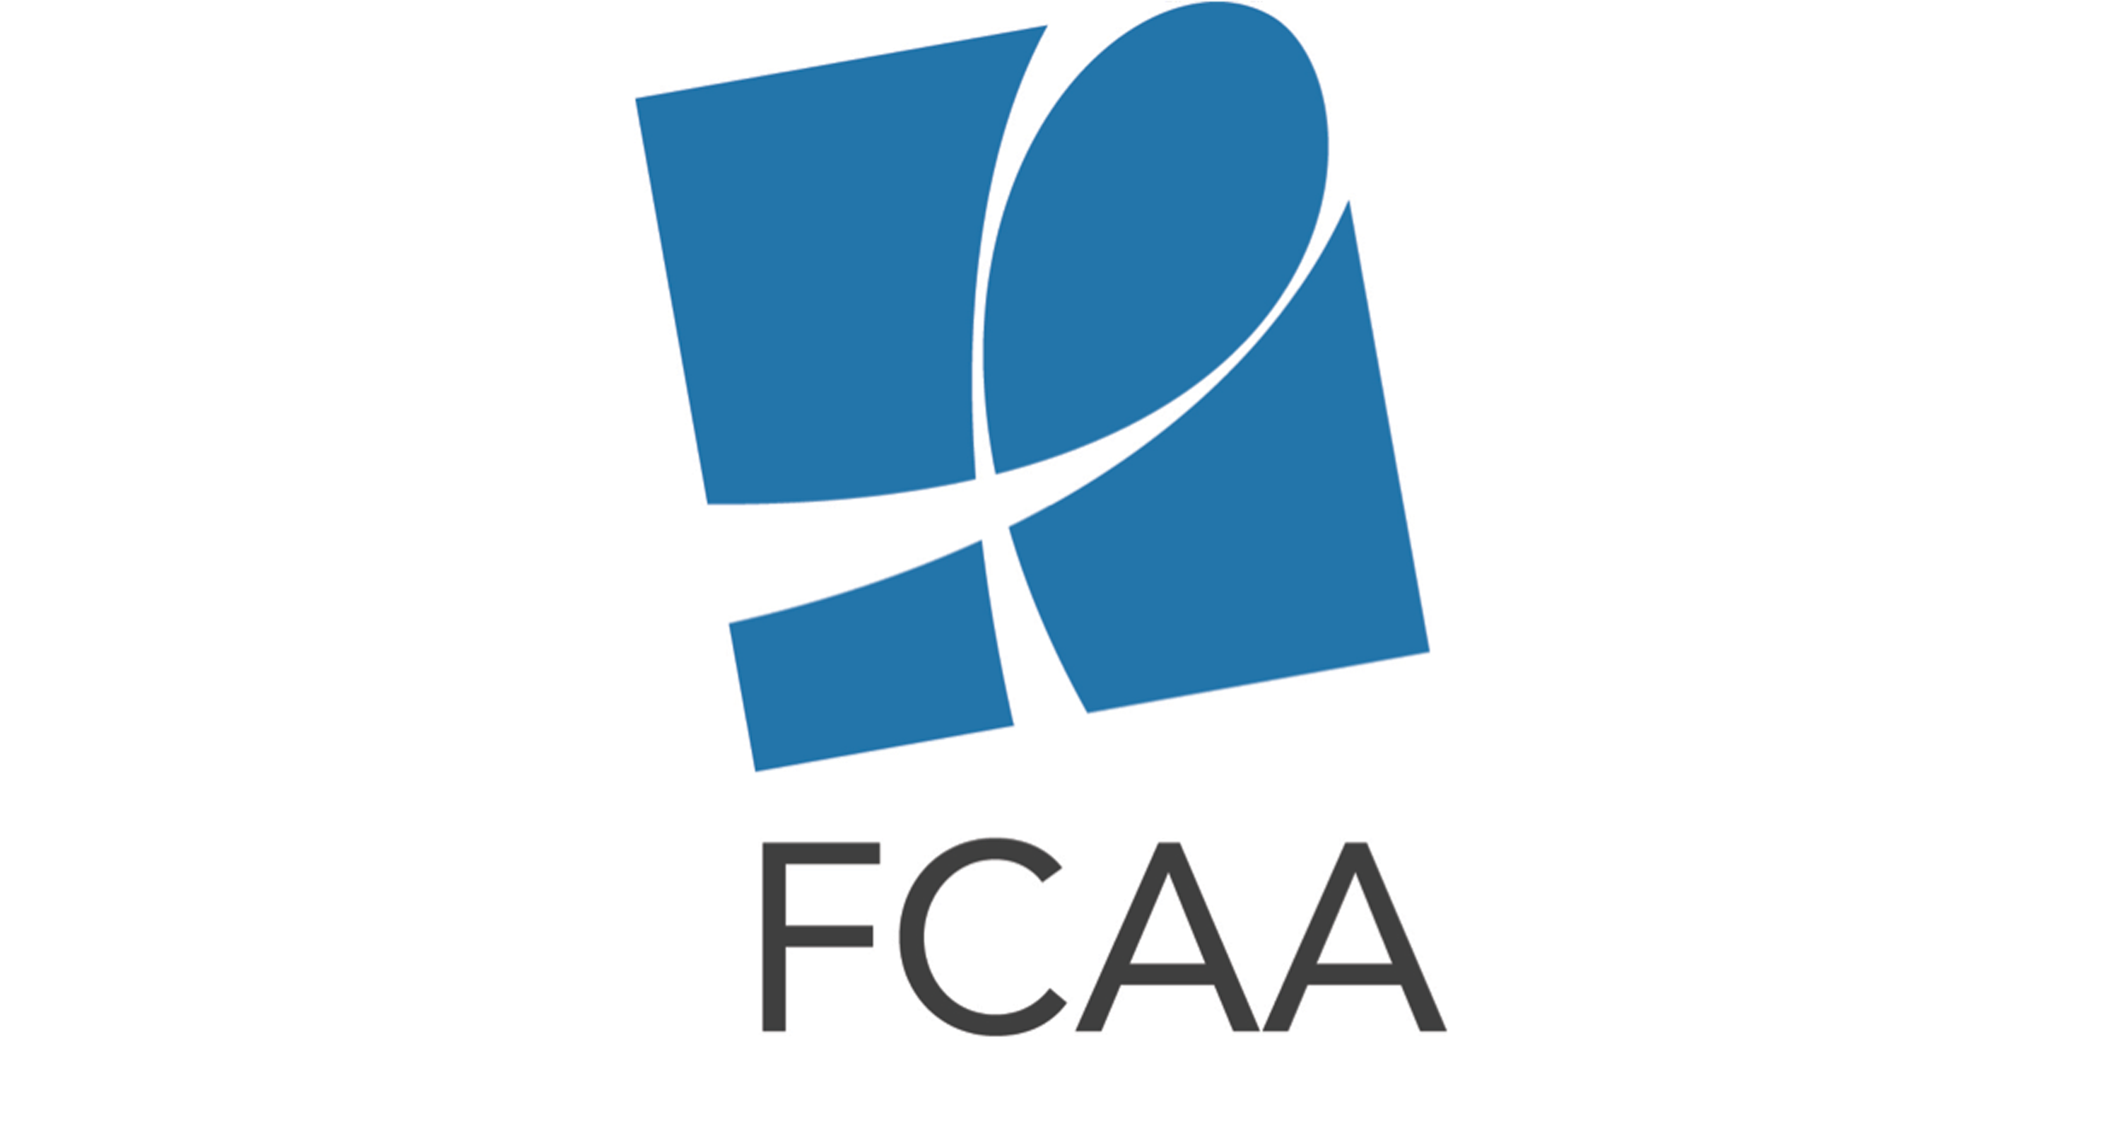
UK Philanthropy for HIV & AIDS Social Media Toolkit

The social media content below is intended to aid in the rollout of the UK Philanthropy for HIV & AIDS infographic.
For related shareable images (suggested in the tweets below), please see: http://bit.ly/2vcuXZN

Twitter Content

New infographic details #HIV funding frm UK private philanthropic sector http://bit.ly/2tHOrRN #FundAIDSFight

Check out analysis of the who, what, where & why of #HIV-related philanthropy from the UK http://bit.ly/2tHOrRN #AIDSFunding

In 2015, UK philanthropic sector contributed £71M in #HIV-related philanthropy http://bit.ly/2tHOrRN #FundAIDSFight
(attach “UKTotalFunding” image)

In 2015, only 13% of UK private #HIV philanthropy addressed #advocacy. Largest amount went to treatment http://bit.ly/2tHOrRN (attach “Intended Use” image)

East & Southern Africa received largest amt of #HIV & #AIDS funding frm UK private philanthropic sector http://bit.ly/2tHOrRN #FundAIDSFight (“GeoDistribution” image)

Almost 50% of new #HIV infections occur w/in key pops. Crucial to increase resources & #AIDSFunding http://bit.ly/2tHOrRN (attach “Top15Populations” image)

(1/3) In 2015 Top10 #HIV philanthropic funders frm UK include: .@ViiVHC .@CIFFchild .@wellcometrust ‏.@ejaf http://bit.ly/2tHOrRN

(2/3) In 2015 Top10 #HIV philanthropic funders frm UK include: .@comicrelief .@Sentebale ‏.@BigLotteryFund
http://bit.ly/2tHOrRN

(3/3) In 2015 Top10 #HIV philanthropic funders frm UK include: Monument Trust .@WeSeeHope ‏‏ ‏.@EgmontTrust ‏
http://bit.ly/2tHOrRN

Facebook Content
Post #1: Donor funding for HIV decreased by 7% from 2015 to 2016 globally, a tend echoed in the UK. Despite being the second largest government donor in the global HIV response, cuts to the UK's bilateral country programs means that overall funding for HIV from the UK is falling. With public funding for the epidemic declining, it is important to recognize the contribution of the UK private philanthropic sector as well as advocate for increased funding. Philanthropic contributions play a critical role in supporting people living with or affected by HIV, as well as in leveraging continued financial, political and programmatic prioritization of HIV from the UK government. Learn more about the state of UK philanthropy for HIV and AIDS in FCAA’s new infographic #FundAIDSFight http://bit.ly/2tHOrRN

