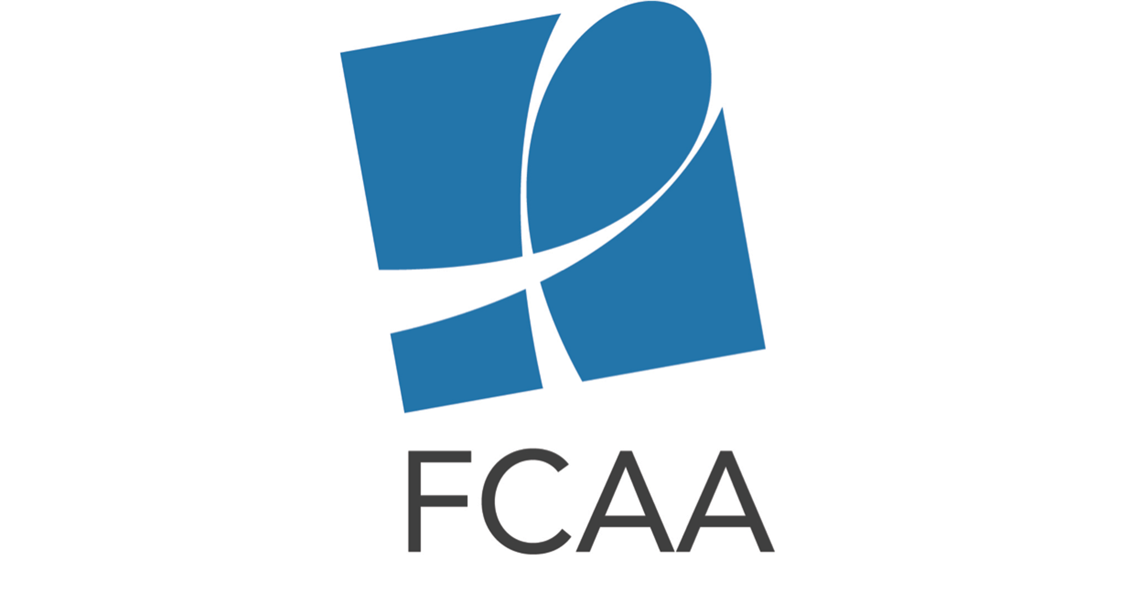

HIV & AIDS Philanthropy for Older Adults Social Media Toolkit

The social media content below is intended to aid in the rollout of the FCAA Spotlight: HIV Philanthropy for Older Adults infographic. Download accompanying images (suggested in tweets below) at: http://bit.ly/2ftQrYR

Twitter Content

General:

New infographic details 1st ever analysis of #HIV philanthropy for older adults bit.ly/2xeeEM5 #FundAIDSFight #NHAAAD

Check out analysis of the who, what, where & why of #HIV-related philanthropy for older adults bit.ly/2xeeEM5 #AIDSFunding #NHAAAD

By 2020, 70% PLWHA in the US will be aged 50+. At current rate, will #HIV-related philanthropy meet needs?
bit.ly/2xeeEM5 #NHAAAD

Breakdown of Infographic Content:

In 2015, $4.69M in #HIV-related philanthropy went to older adults =31% increase from previous yr bit.ly/2xeeEM5 #FundAIDSFight
(attach “FundingOverview” image)

Older adults are not thought of as at-risk pop but are often dual diagnosed for #HIV & #AIDS by the time they are tested. #FundAIDSFight bit.ly/2xeeEM5
(attach “FundingOverview” image)

1/2 Did #HIV & #AIDS philanthropy for older adults target the populations that were most in need? bit.ly/2xeeEM5
(attach “Top5Populations” image) #FundAIDSFight

2/2 #HIV-related philanthropy for adults 50+ did not align w/ most vulnerable pops, leaving many underfunded bit.ly/2xeeEM5
(attach “PopulationsContext” image) #ReignitetheFight #NHAAAD

30% of #HIV-related philanthropy for older adults went to social services, while only 8% went to advocacy #AIDSFunding bit.ly/2xeeEM5 (attach “Top6IntendedUse” image) #NHAAAD

Older adults =17% of new #HIV infections, but only 7% of HIV philanthropy targeting them supported #prevention bit.ly/2xeeEM5 (attach “Prevention” image) #NHAAAD

The US received the most #HIV-related philanthropy for older adults followed by WCA & ESA. #AIDSFunding bit.ly/2xeeEM5 #FundAIDSFight (attach “GeographicDistribution” image)

In 2015, 50% of PLWHA in the US were aged 50+ (2020 est=70%) but they only received >2% of #HIV philanthropy bit.ly/2xeeEM5 ( “USRegionalDistribution” image)

(1/3) In 2015 Top10 #HIV philanthropic funders for older adults include: .@GileadSciences .@MACAIDSFund .@BigLotteryFund bit.ly/2xeeEM5 (attach “Top10Funders” image)

(2/3) In 2015 Top10 #HIV philanthropic funders for older adults include: .@Aidsfonds .@calwellness .@bmsnews .@JNJNews bit.ly/2xeeEM5 (attach “Top10Funders” image)

(3/3) In 2015 Top10 #HIV philanthropic funders for older adults include: The Monument Trust, .@BCEFA
.@ejaf bit.ly/2xeeEM5 (attach “Top10Funders” image)

Facebook Content

Post #1: It is estimated that by 2020, 70% of people living with HIV in the U.S. will be 50 and older. Looking ahead, we need to know what and where this growing population’s greatest needs are in order to ensure that the HIV-related philanthropic sector is keeping pace and providing sufficient support. In commemoration of National HIV/AIDS and Aging Awareness Day (#NHAAAD), we are pleased to share the first analysis of HIV-related philanthropy for older adults (50+). bit.ly/2xeeEM5

