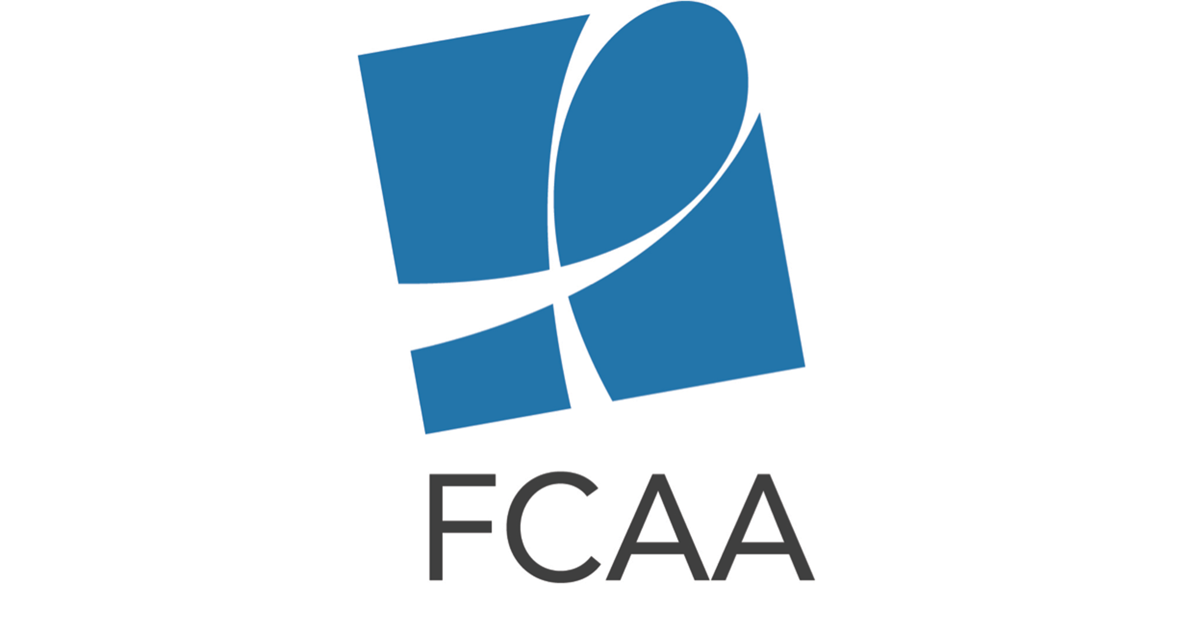
HIV Philanthropy for the US South Social Media Toolkit

The social media content below is intended to aid in the rollout of the HIV Philanthropy for the US South infographic.
Download shareable images to accompany suggested tweets: https://www.dropbox.com/sh/pmhysss0os8rcvk/AACudxUHyccYUZSctgDYDoMMa?dl=0

Twitter Content

General:

New infographic details 2nd analysis of #HIV philanthropy for #USSouth bit.ly/2tQQXJR #FundAIDSFight

New .@FCAA data spotlight shows #AIDSfunding gap for #USSouth & #DeepSouth bit.ly/2tQQXJR

Check out analysis of the who, what, where & why of #HIV-related philanthropy for the #USSouth bit.ly/2tQQXJR
(Add “Overview” image)

Many factors contribute to high #HIV infection rates in #USSouth; we need increase #AIDSfunding to address all of them bit.ly/2tQQXJR #EndAIDS #FundAIDSFight

Breakdown of Infographic Content:

In 2016 $29M in #HIV-related philanthropy went to #USSouth $18.4M went to the #DeepSouth bit.ly/2tQQXJR
(add “Overview” image)

#HIV-related philanthropy for the #USSouth has remained relatively flat since FCAA began analyzing it in depth in 2014. bit.ly/2tQQXJR #FundAIDSFight (add “Philanthropy over time” image)

#USSouth only received 17% of #AIDSfunding despite being home to 45% of #PLWHA in US bit.ly/2tQQXJR
(add “Need vs Response” image)

42% of new #HIV infections in US are in #DeepSouth, but only 22% of HIV philanthropy for prevention went to the region #Prevention bit.ly/2tQQXJR #FundAIDSFight (add “Prevention VS. New Infections” image)

#HIV-related philanthropy for capacity building & leadership devel is key to investing in the capacity of grassroots orgs in the South. How was capacity building supported in 2016? bit.ly/2tQQXJR #FundAIDSFight
(add “Capacity Building” image)

In 2016 the Top 10 #HIV philanthropic funders for #USSouth were: .@GileadSciences .@ejaf .@FordFoundation .@MACAIDSFund .@AIDS_United .@ViiVUS .@JNJNews .@BCEFA .@WASHAIDS .@Health4Texas bit.ly/2tQQXJR #FundAIDSFight ( add “Top10 US South” image)

In 2016 the Top 10 #HIV philanthropic funders for the US #DeepSouth were: .@GileadSciences .@ejaf .@AIDS_United .@ViiVUS .@BCEFA .@MACAIDSFund .@Health4Texas .@ConeHealth .@DIFFANational .@JNJNews bit.ly/2tQQXJR #FundAIDSFight (add “Top10 Deep South” image)

Facebook Content

Post #1: People living in the US South experience tremendous gaps in access to health insurance and care, caused by structural barriers such as poverty, inadequate education, stigma, racism, sexism, homophobia and transphobia. These issues, in turn, pose significant obstacles to accessing treatment and support for HIV and AIDS. FCAA’s latest infographic seeks to bring awareness to, and mobilize resources to address, existing gaps in funding in the US South. bit.ly/2tQQXJR #FundAIDSFight

Post #2: The US South is the epicenter of the national #HIV #AIDS epidemic - home to 45% of all people living with HIV/AIDS in the US. In fact, the nine “Deep South” are home to the highest HIV diagnosis rates and number of people living with HIV than any other US region. However, the region receives less than a quarter of total HIV-related philanthropy for the US each year. Learn more about the state of HIV philanthropy for the US South in FCAA’s new infographic. bit.ly/2tQQXJR #FundAIDSFight

