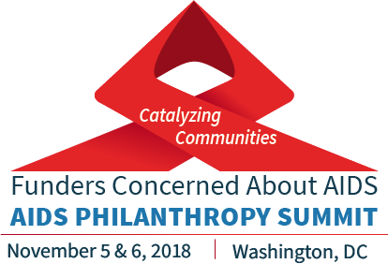

FCAA Summit Sponsorship Opportunities

Funders Concerned About AIDS (FCAA) will convene its 2018 AIDS Philanthropy Summit on November 5 & 6, 2018 in Washington, DC. The FCAA Summit is the premier national conference for grantmakers interested in HIV/AIDS and social justice-related philanthropy, and it attracts around 200 foundation leaders and experts in the field annually.

FCAA is designing this year’s Summit around the theme of “Catalyzing Communities.” Our goal is to support attendees in identifying new tools and opportunities to increase investment in community-based approaches that are integral in the fight against HIV/AIDS. The agenda is intended to be an equal mix of:

- Strategic conversations on what’s happening among impacted communities
- Skills building and best practice-focused sessions on how we are truly reaching and supporting hard to reach and excluded communities on the front lines of the response to HIV and AIDS.

FCAA members now have the opportunity to sponsor different parts of the Summit that align with, or highlight, their grantmaking interests and impact. The following sponsorship levels describe other tangible benefits for Summit sponsors.

SUMMIT SPONSORSHIP OPPORTUNITIES
Opportunity | Price | Benefits
Full Summit Sponsor | $25,000 | - Multiple speaking opportunities on that day (sessions, plenary speakers, etc.)  - Includes up to 5 organizational registration fees  - Other custom branding opportunities (conference bags, etc.)  - Plus all other benefits listed below
Day Sponsor (or combination of other opportunities for $10,000) | $10,000 | - Multiple speaking opportunities on that day (sessions, plenary speakers, etc.)  - Includes up to 3 organizational registration fees  - Other branding opportunities (conference bags, etc.)  - Plus all other benefits listed below
Reception (or combination of other opportunities for $5,000) | $5,000 | - Showcased speaking opportunity before the session/reception  - Includes up to 2 organizational registration fees  - Plus all other benefits listed below
Keynote or plenary | $2,500 | - Introduce the workshop/panel  - Includes 1 organizational registration fee  - Plus all other benefits listed below
Individual Sessions | $1,000 | - Introduce the workshop/panel  - Includes 1 organizational registration fee  - Plus all other benefits listed below
Affinity Group Partner Sponsorship | Non-financial assistance | - Multiple speaking opportunities on that day (sessions, plenary speakers, etc.)  - Includes up to 3 organizational registration fees  - Space for materials/posters in conference “resource” area  - Plus all other benefits listed below
Additional Benefits for All Sponsorship Levels |  | - Branding included on all Summit materials: registration packet, e-blasts, etc.  - Verbal recognition from the podium
Additional Sponsorship Opportunities |  | - Summit video recording/webcasts  - Speaker travel

Contact Information for Sponsorships

Please contact FCAA’s Executive Director, John Barnes, for more information about sponsorships for the FCAA Summit at john@fcaaids.org or (202) 721-1196.

