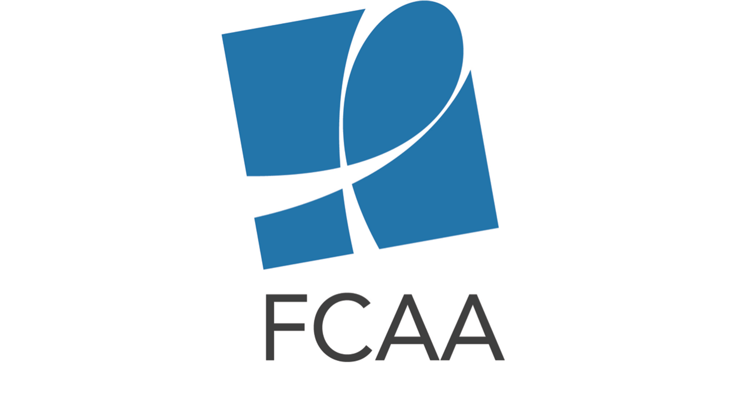
HIV Philanthropy for Food and Nutrition Social Media Toolkit

The social media content below is intended to aid in the rollout of the HIV Philanthropy for Food and Nutrition Services.

Download the accompanying images (suggested in yellow below) for these images at: https://www.dropbox.com/sh/thgnpg3l1pc87vv/AADuuxb7CXPe8bOZH7ZzpPcfa?dl=0

Twitter Content

General:

New infographic from @FCAA details 1st analysis of #HIV philanthropy for food & #nutrition services in the US http://bit.ly/2rvhrgC #AIDSFunding

New .@FCAA data spotlight shows #AIDSfunding gap for food & #nutrition services http://bit.ly/2rvhrgC

Check out analysis of the who, what, where & why of #HIV-related philanthropy for food & #nutrition services http://bit.ly/2rvhrgC (and “GeneralDisbursement” image)

Breakdown of Infographic Content:

Proper nutrition is critical to maintain health & quality of life for #PLWHA. However, in 2016 only 4% ( $6.4M) in #HIV-related philanthropy went to food & #nutrition services in the US http://bit.ly/2rvhrgC #FundAIDSFight (“GeneralDisbursement”” image)

The western region of the US received the highest % of #HIV-related philanthropy for food & #nutrition services, while US territories received <1% http://bit.ly/2rvhrgC #FundAIDSFight (“GEODist” image)

In 2016, 72% of #HIV-related philanthropy for food & #nutrition services in the US went to 10 states, with California receiving (27%), http://bit.ly/2rvhrgC #FundAIDSFight (“Top10Sates” image)

In 2016, the top 10 funders contributed 92% of #HIV-related philanthropy for food & #nutrition services, with the top two, @MACAIDSFund & @BCEFA accounting for 67% #FundAIDSFight http://bit.ly/2rvhrgC (“FunderRank” image)

In 2016 the Top 10 #HIV philanthropic funders for food & #nutrition services in the US were: @BCEFA @MACAIDSFund @GileadSciences @KPShare @DIFFANational @ETAForg @Unitedwaygo #WeingartFoundation @WellsFargo @SeattleFdn http://bit.ly/2rvhrgC

Facebook Content

Post #1: For people living with HIV and AIDS, nutrition-based interventions offer a low-cost way to improve health outcomes. Not only has data shown that food insecure PLWHA are more likely to forgo medical care, putting themselves and others at risk, but proper nutrition itself is critical to help PLWHA maintain their health and quality of life. Despite its importance, food and nutrition services only received roughly 4% of total HIV philanthropy in the US in 2016. Learn about the state of HIV-related philanthropy for food and nutrition services in our latest infographic. http://bit.ly/2rvhrgC

