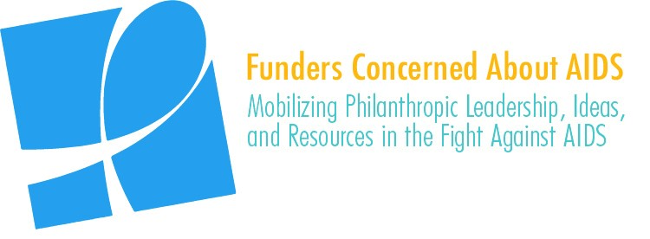

Catalyzing Communities: Strengthening Philanthropic Funding for Community Action on AIDS

SOCIAL MEDIA TOOLKIT

For the past year, Funders Concerned About AIDS (FCAA) has been working to better understand what effective funding for community-based action on AIDS looks like. This effort has taken two separate, but related paths:
- A comprehensive literature review and interviews with community-based organizations, funders and other key stakeholders. This effort culminated in a report identifying key challenges facing community-based organizations and best practices in meeting those challenges.
- An analysis of each of the roughly 3,600 grantee organizations included in FCAA’s resource tracking initiative to determine their entity type (e.g. a civil society organization, a hospital, an academic or research institution, etc.). This effort is intended to better define the funding “eco-system” and will help increase understanding of the first chain in philanthropic support – the recipient organization.

The results from both of these efforts will be shared at the 2018 AIDS Philanthropy Summit in November. We welcome your assistance in helping to build awareness of this information and have created template content to share through your respective social media platforms.

We ask for your help by encouraging you to:
- Begin posting this content on November 5
- Continue to use this content, as appropriate, in the days and weeks following the Summit
- Tag @FCAA in your posts
- When possible use the hashtag #FundAIDSFight on your posts

We hope you find this material useful. As always, please let us know if you have any questions or would like further information.

FACEBOOK

Post #1:
New @FCAA report highlights ways funders can more effectively support community responses to #HIV #AIDS. Communities are at the forefront of the global AIDS response. Key innovations, breakthroughs & much of the progress on the ground would not have happened without the involvement of communities. Yet funding remains sporadic, limited & hampered by structural challenges. @FCAA’s new report identifies effective practices & opportunities for improvements. Learn more: http://bit.ly/2QieaLU #FundAIDSFight #CommunityBasedApproaches
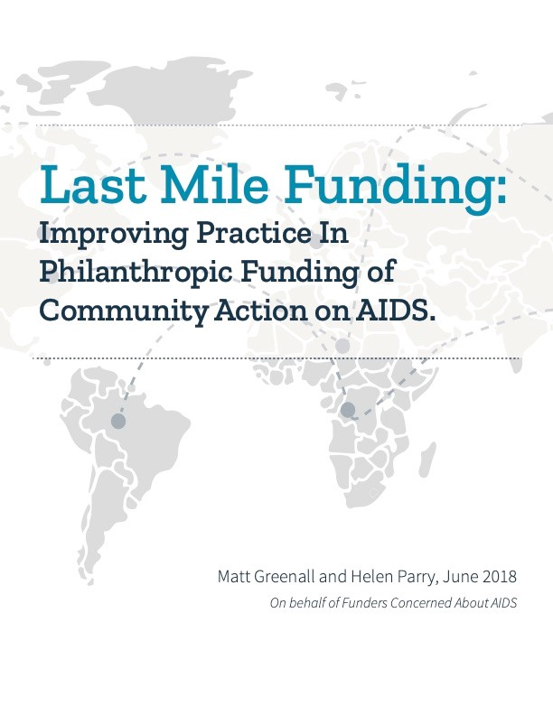

Post #2:
For the past year, @FCAA analyzed ~ 3,600 grantee organizations from its 2016 resource tracking effort and determined that 44% ($306 mil) of HIV-related philanthropy was disbursed to #civilsocietyorganizatons in 2016. A snapshot of this “philanthropic ecosystem” for #HIV #AIDS is available here: http://bit.ly/2QieaLU
#CommunityBasedOrganizations #FundAIDSFight

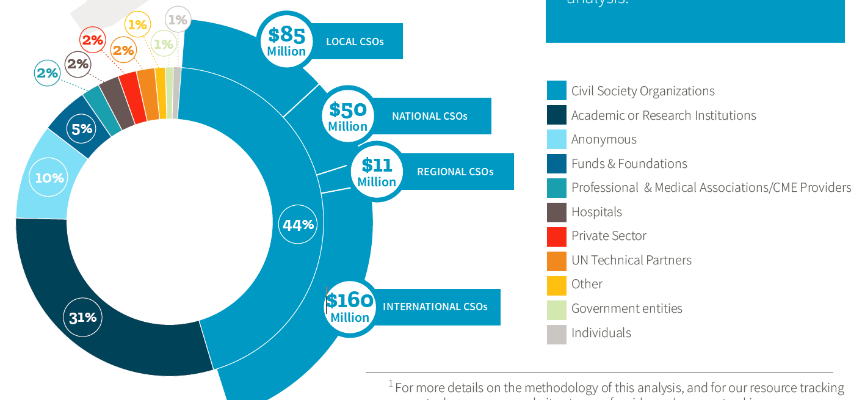

Post #3:
The priorities of #HIV #AIDS funders & #CommunityBasedOrganizations on the front lines of the fight have a lot of overlap. @FCAA’s new report shares insights from ≈ 40 interviews with grantmakers & CBOs to identify synergies. Read the report here: http://bit.ly/2QieaLU #FundAIDSFight

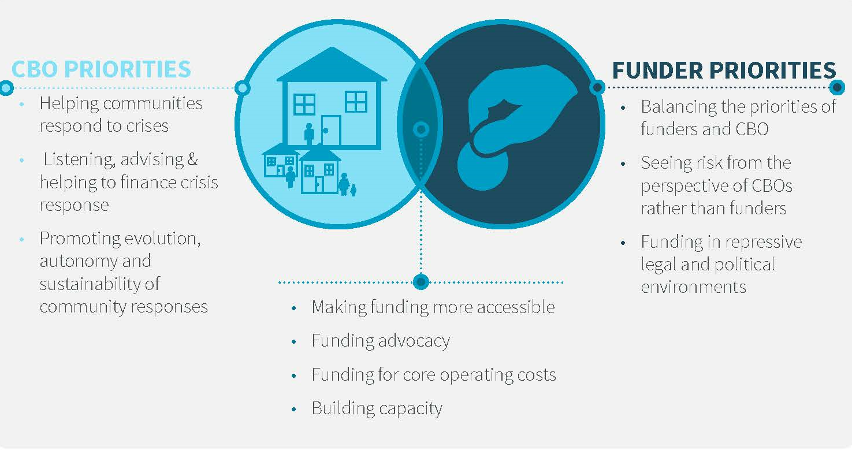

TWITTER

NEW @FCAA REPORT highlights ways in which funders can more effectively support community responses to #HIV #AIDS. Learn more here: http://bit.ly/2QieaLU #FundAIDSFight #CommunityEngagement

Per new @FCAA data, less than ½ of #HIV related philanthropy in 2016 ($306 mil) reached #civilsocietyorganizatons. http://bit.ly/2QieaLU #FundAIDSFight

Communities are complex. The approach to funding #CommunityBasedOrganizations in the context of the #HIV #AIDS response must be as well. @FCAA’s new report can help navigate this landscape. Read it here: http://bit.ly/2QieaLU #FundAIDSFight

There is no single blueprint for the perfect #HIV #AIDS donor/funding model for #CommunityBasedOrganizations. But there ARE best practice/approaches proven to be effective. Want to know what they are? Read @FCAA’s new report: http://bit.ly/2QieaLU #FundAIDSFight #CommunityEngagement

“CBOs said there was little prospect of receiving $ from domestic sources, particularly 4 #HumanRights & #advocacy work” – new @FCAA rpt highlights critical role of philanthropy in supporting community based approaches to #HIV #AIDS. http://bit.ly/2QieaLU #FundAIDSFight

