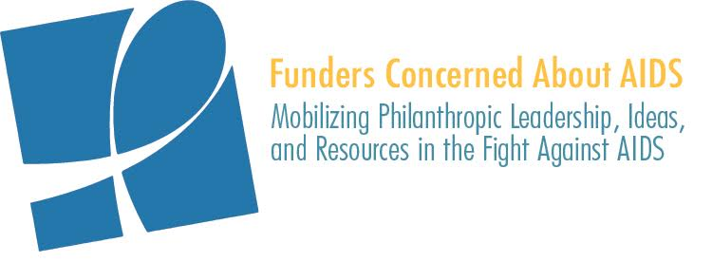

PHILANTHROPIC SUPPORT TO ADDRESS HIV/AIDS
SOCIAL MEDIA TOOLKIT

For the past 16 years, Funders Concerned About AIDS’ signature report, Philanthropic Support to Address HIV/AIDS, has helped to identify gaps, trends, and opportunities in HIV-related philanthropy. This report, the most comprehensive of its kind, captures data on more than 6,770 grants, awarded by 427 funders in 14 countries.

This year, we will be launching the report on November 29, just prior to World AIDS Day. As we do so, we would welcome your assistance in helping to build awareness of the data. We have created template content to share through your respective social media platforms. We ask for your help by encouraging you to:
- Begin posting this content on November 29
- Continue to use this content, as appropriate, in the days and weeks following the launch
- Use the hashtag #FundAIDSFight in your posts
- When possible, tag @FCAA in your posts

We hope you find this material useful. As always, please let us know if you have any questions or would like further information.

FACEBOOK/LINKEDIN

Post #1:
Just in time for #WAD2018, @FCAA published its annual Philanthropic Support to Address HIV/AIDS report. This data — from 6,778 grants, awarded by 427 foundations in 14 countries — can help identify gaps, trends & opportunities in HIV-related philanthropy. Learn more: http://bit.ly/2Qal4Gk #FundAIDSFight

Post #2:
The new edition of @FCAA’s annual resource tracking report shows private philanthropic support for #HIV #AIDS Decreased by $37 million between 2016 and 2017. Per FCAA’s Executive Director, John Barnes:

“For the past two years, we have cautioned that factors including ill-advised policies and flatlining bilateral and multilateral resources were having an affect on philanthropic funding. The 2017 data shows that our concerns have been made a reality - philanthropic funding for HIV and AIDS is at its lowest level in three years.”

Read the report: http://bit.ly/2Qal4Gk #FundAIDSFight

Post #3:
A new report from @FCAA shows that of the 185 funders it has tracked over the past two years, 95 have decreased #HIV #AIDS funding, another 33 remained flat. Only 57 funders increased. This is a trend we need to reverse! Learn more http://bit.ly/2Qal4Gk #FundAIDSFight

TWITTER

Just in time for #WAD2018, new @FCAA report shows philanthropic support for #HIV #AIDS decreased by $37 million between 2016 & 2017. The lowest disbursement in the past three years = cause for alarm! Read the report and take action to #FundAIDSFight. http://bit.ly/2Qal4Gk

Philanthropic funding to #HIV #AIDS is at its lowest level in three years, according to new @FCAA report. Learn more at http://bit.ly/2Qal4Gk #FundAIDSFight

Despite overall decrease in philanthropic funding to fight #HIV #AIDS, there is some good news to report: Increased $ for #trans populations, MSM & economically disadvantaged/homeless populations. Read the full rpt here: http://bit.ly/2Qal4Gk #FundAIDSFight

A BIG THANK YOU! @Gatesfoundation @gileadsciences @viivhc @macaidsfund @ejaf @jnjnews @Aidsfonds @hiltonfound @ragoninstitute @BCEFA were top 10 private #HIV funders in 2017 http://bit.ly/2Qal4Gk #FundAIDSFight @FCAA

In 2017, the top 20 #HIV #AIDS funders awarded $598 million in grants to fight the epidemic. Read a new report from @FCAA to learn more about philanthropic resources for HIV/AIDS http://bit.ly/2Qal4Gk #FundAIDSFight

39 corporate foundations allocated $242 million to fight #HIV #AIDS in 2017. Thank you for your commitment to #FundAIDSFight! http://bit.ly/2Qal4Gk

By 2020 70% of people living w/ #HIV will be in middle income countries. Yet philanthropic funding to address this challenge decreased by 21% in 2017. Learn more about the state of philanthropic #AIDS funding in @FCAA’s new report http://bit.ly/2Qal4Gk #FundAIDSFight

Philanthropic funding for the #HIV and #AIDS Epidemic in the U.S. South increased by a whopping 67% -- $19 million -- in 2017 #FundAIDSFight #fundsouth http://bit.ly/2Qal4Gk

Despite increase in new #HIV infections among people who inject drugs in the U.S. — due to the rise of the #opioid epidemic — this population received roughly 3% of HIV philanthropy, a 11% decrease from 2016 http://bit.ly/2Qal4Gk #FundAIDSFight

#Sexworkers are 13 times more at risk of #HIV compared with the general population, yet received only 2% of HIV philanthropy, a 24% decrease from 2016 http://bit.ly/2Qal4Gk #FundAIDSFight
#HIV philanthropic funding for #AfricanAmericans & #Latinx in the US saw significant increases in 2017, both nearly/more than doubling funding from 2016 http://bit.ly/2Qal4Gk #FundAIDSFight

