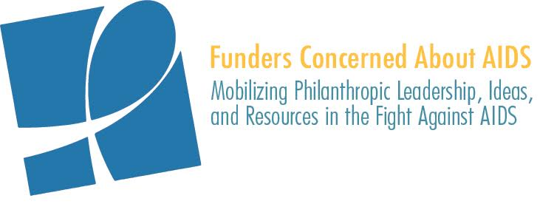

PHILANTHROPIC SUPPORT TO ADDRESS HIV/AIDS
SOCIAL MEDIA TOOLKIT

For the past 17 years, Funders Concerned About AIDS’ signature report, Philanthropic Support to Address HIV/AIDS, has helped to identify gaps, trends, and opportunities in HIV-related philanthropy. This report, the most comprehensive of its kind, captures data on 7,029 grants awarded by 693 funders in 14 countries.

FCAA welcomes your assistance in helping to build awareness of the data. We have created template content to share through your respective social media platforms. We ask for your help by encouraging you to:
- Begin posting this content on February 18th and continue to use this content, as appropriate, in the days and weeks following the launch
- Use the hashtag #FundAIDSFight in your posts
- When possible, tag @FCAA in your posts

FACEBOOK/LINKEDIN

Post #1:
According to new @FCAA report - Philanthropic Support to Address HIV/AIDS in 2018 – private #philanthropic funding for #HIV totaled $651mil, an incremental 2% increase from 2017. This data — on 7,029 grants, awarded by 693 foundations in 14 countries — can help identify gaps, trends & opportunities in HIV-related philanthropy. Learn more: http://www.fcaaids.org/resourcetracking #FundAIDSFight

Post #2:
The new edition of @FCAA’s annual resource tracking report shows private philanthropic support for #HIV #AIDS remained relatively flat in 2018, with only an incremental 2% ($13 mil) increase from 2017. Per FCAA’s Executive Director, John Barnes:

“This increase, driven by relatively few funders, has served to hide the disturbing reality of broader philanthropy’s steady retreat from HIV. In fact, over the course of six years, roughly 30 of the once leading funders have left or significantly decreased their investments in HIV, taking approximately $130 million in resources with them.”

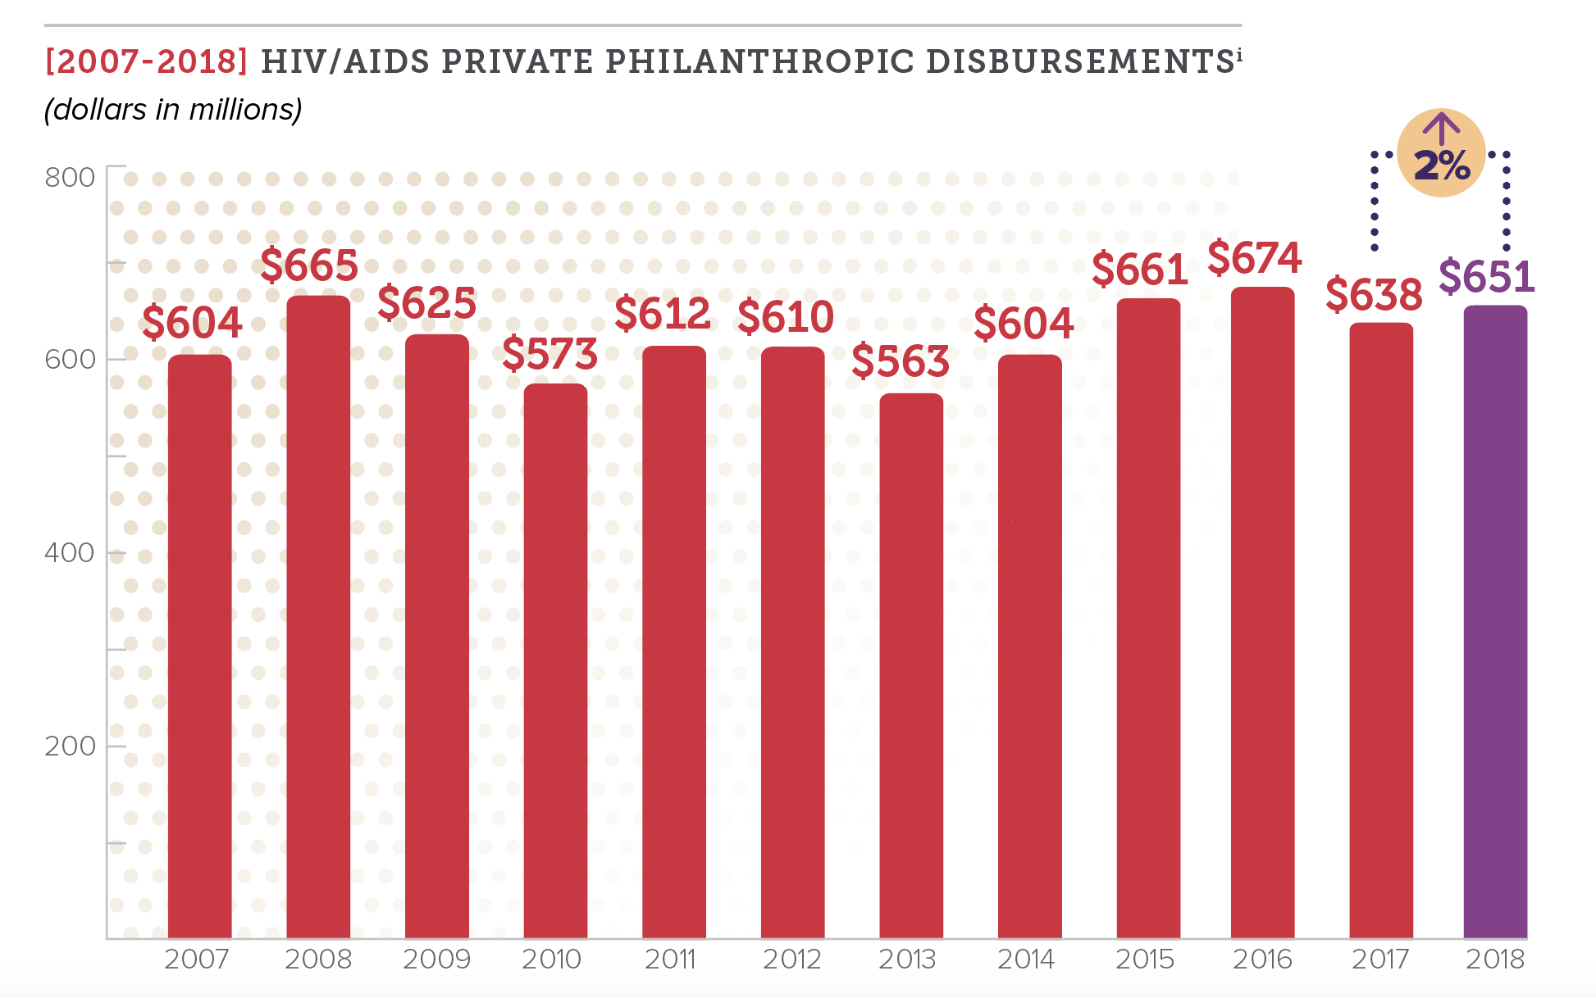
Read the report: http://www.fcaaids.org/resourcetracking #FundAIDSFight

TWITTER

New @FCAA report shows philanthropic support for #HIV #AIDS remained relatively flat between 2017 & 2018, increasing by an incremental 2%. Read the report http://www.fcaaids.org/resourcetracking #FundAIDSFight

Visit the .@FCAA blog to learn more about the context with which we are reading the latest data on private #philanthropic funding for #HIV #AIDS http://bit.ly/2SV2elA #FundAIDSFight

Despite overall flat philanthropic funding to fight #HIV #AIDS in 2018, there is good news to report: Increased $ for #olderadults, & to strategies such as advocacy & capacity building/leadership dvlpment. The full rpt here: http://www.fcaaids.org/resourcetracking #FundAIDSFight

.@Gatesfoundation .@gileadsciences .@wellcometrust .@viivhc .@MACcosmetics .@ejaf .@amfAR .@Aidsfonds .@hiltonfound .@ciffchild named top 10 private #HIV funders in 2018 http://www.fcaaids.org/resourcetracking #FundAIDSFight .@FCAA

In 2018, the top 20 #HIV #AIDS funders represented 87% of all funding, awarding nearly $600 million in grants to fight the epidemic. Read a new report from .@FCAA to learn more about philanthropic resources for HIV/AIDS http://www.fcaaids.org/resourcetracking #FundAIDSFight

