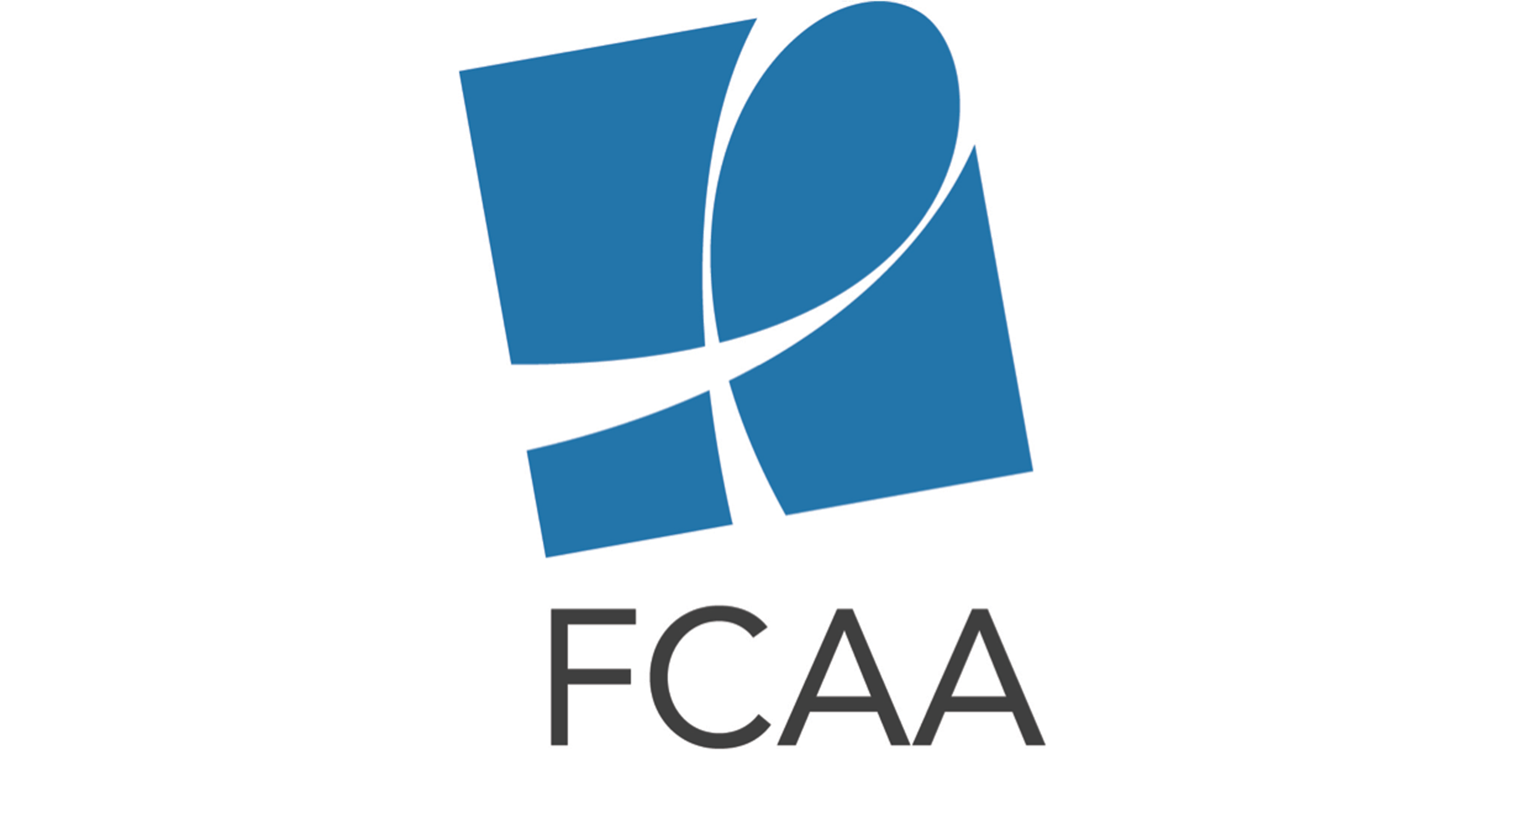
Social Media Toolkit for HIV Philanthropy For Children & Youth Infographic

The social media content below is intended to aid in the rollout of the HIV Philanthropy For Children & Youth infographic. Content with #HLM2016AIDS should be sent during or close to the UN’s 2016 High-Level Meeting on Ending AIDS, Jun 8-10.

Twitter Content
For each post, include the link to the infographic online or attach an appropriate piece of the infographic.

Announcing Release of Infographic

@FCAA just released 1st ever analysis of #HIV-related philanthropy for children & youth. #AIDSFunding bit.ly/1XUGfbh

Check out analysis of the who, what, where, & why of #HIV-related philanthropy for children & youth. #AIDSFunding bit.ly/1XUGfbh

New @FCAA infographic shows why #AIDSfunding for children & youth is critical to #EndingAIDS. #HLMAIDS2016 bit.ly/1XUGfbh

Why Funding for Children and Youth is Important

2.6M children are living w/ #HIV or #AIDS but only 1/4 have access to #ARVs. Increase #AIDSfunding 4 vulnerable pops. bit.ly/1XUGfbh @FCAA

Mothers must have access to #HIV prevention & treatment to keep themselves & their children healthy #AIDSFunding #HLM2016AIDS bit.ly/1XUGfbh @FCAA

1.2M #HIV+ women give birth each year. Need #AIDSFunding for #EMTCT #HLM2016AIDS bit.ly/1XUGfbh @FCAA

#AIDSFunding gap between needs of children & adolescents & available #HIV resources directed toward them bit.ly/1XUGfbh @FCAA

Children & youth cont. to be at significant risk for #HIV & #AIDS. We need to close #AIDSfunding gap to meet needs. bit.ly/1XUGfbh @FCAA

W/O more #AIDSfunding 4 children& adolescents, we risk rolling back gains made to date #AIDSFreeGen #HLM2016AIDS bit.ly/1XUGfbh @FCAA

Breakdown of Infographic Content
Link to download related images: http://bit.ly/1r4Kpk7

In 2014, 18% ($115.6M) of #HIV-related philanthropy addressed children, youth, orphans, and EMTCT #AIDSFunding @FCAA (attach general funding image)

2014 children & youth #HIV funding: 115 funders gave $115.6M in 1191 grants to 922 orgs. #AIDSfunding @FCAA (attach general funding disbursement image)

East & South #Africa received 59% of all #AIDSFunding 4 children, youth, orphans & #EMTCT @FCAA (attach Geo Disbursement image)

(1/2) In 2014 Top10 #HIV funders for children & youth were: @MACAIDSFund @CIFFchild @hiltonfound @gatesfoundation @stephenlewisfdn @FCAA (attach top 10 funder image)

(2/2) Top10 #HIV funders for children & youth con’t.: @ViiVUS @abbvie @FordFoundation @JNJCares @TidesCommunity (attach top 10 funder image)

Top 3 intended uses of #AIDSFunding 4 children & youth were: Prevention, #EMTCT & Advocacy #AIDSFreeGen @FCAA (attach intended use image)

In 2014 #Zambia, #Zimbabwe & #SouthAfrica received most #AIDSfunding for children & youth #EndAIDS @FCAA (attach top 10 countries image)

In 2014 US & India only countries outside S&E Africa on top 10 list for disbursement of #AIDSfunding 4 children & youth @FCAA (attach top 10 countries image)

Distribution of #AIDSfunding 4 children & youth spread evenly between populations. #EMTCT #AIDSFreeGen @FCAA (attach AIDS population breakdown Image)

Facebook Content

Did you know that in 2014 children and youth received 18% of private HIV funding totaling $115.6 million? Did you know that 22% of that funding was used for prevention of HIV, or that 59% went to East and South Africa? Do you know which organizations give grants? Now you can learn about the who, what, where, and why of HIV-related philanthropy for children and youth by checking out our new infographic below. bit.ly/1XUGfbh

Ending AIDS and HIV in children, adolescents, pregnant women, and mothers is critical to ending the epidemic altogether, however, these populations continue to be at significant risk. In fact, based on the findings in our first analysis of HIV-related philanthropy for children and youth, there is a gap between the needs of children and adolescents and the available resources directed toward them. Without addressing this gap, we risk rolling back the gains made to date. Learn more about funding for these vulnerable populations: bit.ly/1XUGfbh
As partners gather this week at #HLM2016AIDS to discuss the AIDS response over the next five years, we want to ensure that significant and sustained funding is directed toward children and youth. Ending AIDS in these vulnerable populations is a critical milestone on the path to defeating it altogether, however our analysis shows there is gap between the needs of children and adolescents and the available resources. Help advocate for children by sharing our infographic and adding your voice to the #HLM2016AIDS conversation. bit.ly/1XUGfbh

