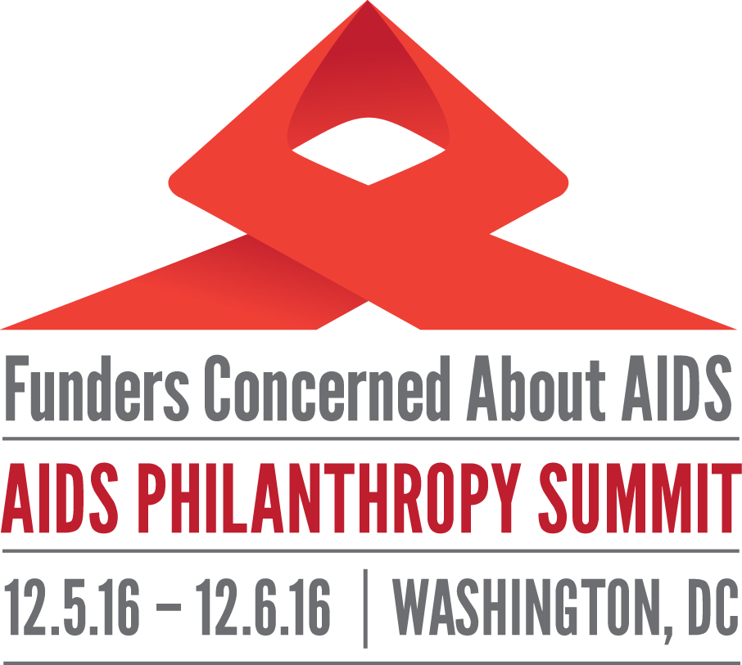

SUMMIT RESOURCES

DAY 1 SESSIONS

THE FINANCIAL LANDSCAPE FOR HIV

- FCAA. Philanthropic Support to Address HIV/AIDS in 2015. December 2016.
http://bit.ly/2hGoJut
- KFF and UNAIDS. FinancingtThe Response to Aids in Low- and Middle-Income Countries: International AssistancefFrom Donor Governments in 2015. July 2016
http://kff.org/global-health-policy/report/financing-the-response-to-hiv-in-low-and-middle-income-countries-international-assistance-from-donor-governments-in-2015/

- UNAIDS. Global Aids Update. 2016.
http://www.unaids.org/en/resources/documents/2016/Global-AIDS-update-2016

- PEPFAR. World AIDS Day 2016: PEPFAR Latest Results. 2016.
https://www.pepfar.gov/documents/organization/264882.pdf
- Health Gap Fact Sheet. 10 Myths & Facts about Donor Funding for the Global HIV Response. September 2016.
https://d3n8a8pro7vhmx.cloudfront.net/healthgap/pages/1092/attachments/original/1472838612/Myths___Facts_Donor_Funding_for_Global_AIDS.pdf?1472838612

EXPLORING GAPS IN THE RESPONSE: THE SYRINGE ACCESS FUND

- amfAR. Issue Brief: Preventing HIV and Hepatitis C Among People Who Inject Drugs.2015
http://fcaaids.org/Portals/0/Uploads/Documents/Public/2015/amfar_infographic_Opioid.pdf

- AIDS United. Syringe Services Programs Fact Sheet.
https://www.dropbox.com/home/Original%20Presentation%20Files/Resources?preview=AU+Fact+Sheet+SSP+101.pdf

- AIDS United. Federal Funding for Syringe Services Programs: What Advocates Should Know. 2016.
https://www.dropbox.com/home/Original%20Presentation%20Files/Resources?preview=AU+SSP+Fact+Sheet+-+Advocates.pdf

- AIDS United. Federal Funding for Syringe Services Programs: What CBO’s Should Know. 2016.
https://www.dropbox.com/home/Original%20Presentation%20Files/Resources?preview=AU+SSP+Fact+Sheet+-+CBOs.pdf

- CDC Vital Signs. HIV and Injection Drug Use: Syringe Services Programs for HIV Prevention. December 2016.
https://www.dropbox.com/home/Original%20Presentation%20Files/Resources?preview=FACT+SHEET_DEC_HIVAids_V13.pdf

- Cyprian, et al. CDC: Morbidity and Mortality Weekly Report. Vital Signs: Trends in HIV Diagnoses, Risk Behaviors, and Prevention Among Persons Who Inject Drugs—United States. November 29, 2016.
https://www.dropbox.com/home/Original%20Presentation%20Files/Resources?preview=MMWR_VitalSigns+HIV+IDU+ebook.pdf
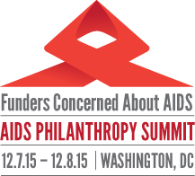

SUMMIT RESOURCES

DAY 2 SESSIONS: US TRACK

ACCESS TO CARE
1. U.S. Department of Health and Human Services. HHS LGBT Policy Coordinating Committee. Advancing LGBT Health & Well-Being. 2016.
https://www.hhs.gov/sites/default/files/2016-report-with-cover.pdf
2. Mayer, Jane. Dark Money: The Hidden History of the Billionaires Behind the Rise of the Radical Right. Double Day Press, 2016.
HEALTH EQUITY FOR WOMEN OF COLOR
1. The White House. National HIV/AIDS Strategy for the United States, Updated to 2020: Indicator Supplement. December 2016
https://www.whitehouse.gov/sites/whitehouse.gov/files/images/nhas-indicators-supplement-dec-2016.pdf
2. Human Rights Watch. "Do You See How Much I'm Suffering Here?": Abuse Against Transgender Women in U.S. Immigration Detention. 2016.
https://www.hrw.org/report/2016/03/23/do-you-see-how-much-im-suffering-here/abuse-against-transgender-women-us
https://www.hrw.org/sites/default/files/report_pdf/us0316_web.pdf
3. TransLatina Coalition. TransVisible: Transgender Latina Immigrants in U.S. Society. 2013.
http://www.chicano.ucla.edu/files/news/transvisiblereport.pdf

PLACE-BASED CHALLENGES TO EQUITY
- Black & Pink. Coming Out of Concrete Closets: A Report on Black & Pinks National LGBTQ Prisoner Survey. 2015.
http://www.blackandpink.org/wp-content/upLoads/Coming-Out-of-Concrete-Closets.-Black-and-Pink.-October-21-2015..pdf
- Movement Advancement Project & Center for American Progress. Unjust: How the Broken Juvenile and Criminal Justice Systems Fail LGBT Youth. August 2016.
http://www.lgbtmap.org/file/lgbt-criminal-justice-youth.pdf
- Movement Advancement Project. LGBT Policy Spotlight: HIV Criminalization Laws. 2016.
http://www.lgbtmap.org/file/policy-spotlight-HIV-criminalization.PDF
- Southern HIV/AIDS Strategy Initiative (SASI): HIV/AIDS in the U.S. Deep South. 2016.
https://southernaids.files.wordpress.com/2011/10/hiv-aids-in-the-us-deep-south-trends-from-2008-2013.pdf

- Consumer Health Foundation. Briefing Paper: Immigration Status as a Social Determinant of Health. 2016.
http://www.consumerhealthfdn.org/wp-content/uploads/2016/11/Focus-on-Health.pdf

- Freedom Inc. Mid-Year Newsletter. May 2016.
https://www.dropbox.com/s/mw64gun6y7o1nmc/Newsletter%20-%20Midyear%202016%20v2.pdf?dl=0
- Freedom Inc. End of the Year Newsletter. Fall 2016.
https://www.dropbox.com/s/7u29yicxtyy16pe/End%20of%20Year%20Newsletter%203%20%281%29.pdf?dl=0

SUMMIT RESOURCES

DAY 2 SESSIONS: INTERNATIONAL TRACK

START FREE, STAY FREE, AIDS FREE
- UNAIDS. Start Free, Stay Free, AIDS Free — A Super-Fast-Track Framework for Ending AIDS Among Children, Adolescents and Young Women by 2020. September 2016. http://www.unaids.org/sites/default/files/media_asset/Stay_free_vision_mission_En.pdf

- Video links: Start Free, Stay Free, AIDS Free and Growing up with HIV. 2016
https://www.dropbox.com/sh/7np492quxcxkf6h/AABxNxjFX8qE9cYqwCVp4Lqwa?dl=0
- AIDS Free in Zimbabwe Film
https://www.youtube.com/watch?v=vC9tV3UnA2c
- Children’s Investment Fund Foundation. Accelerating Children’s HIV Treatment programme (ACT). Getting 300,000 Children on to Life-Saving Treatment. December 1, 2016.
https://ciff.org/news/getting-300000-children-life-saving-treatment/

ADVOCATING FOR THE CHILDREN OF KEY POPULATIONS

- The Coalition for Children Affected by AIDS. Making the Children of Key Populations a Priority for Equitable Development: A Briefing. https://www.dropbox.com/home/Original%20Presentation%20Files/Resources?preview=Making+the+Children+of+Key+Populations+a+Priority+Advocacy+Briefing+FINAL.pdf

- Baral S., et al. Worldwide burden of HIV in transgender women: a systematic review and meta-analysis. Lancet Infect Dis. 2013.
http://www.natap.org/2013/HIV/PIIS1473309912703158.pdf

- ACLU & National Center for Transgender Equality. Protecting the Rights of Transgender Parents and their Children: A Guide for Parents and their Lawyers. March 2013.
https://www.aclu.org/sites/default/files/field_document/aclu-tg_parenting_guide.pdf

REACHING KEY AFFECTED POPULATIONS

- PEPFAR. Key Populations Investment Fund.
https://www.pepfar.gov/priorities/keypopulations/index.htm
- Mama Cash, RUF, OSF. Funding for Sex Worker Rights: Opportunities for Foundations to Fund More and Better. 2014.
http://www.redumbrellafund.org/wp-content/uploads/2014/11/Report_funding-sex-worker-rights_FINAL_WEB.pdf

ADDITIONAL RESOURCES

- UNAIDS. Program Coordinating Board Report. November 11, 2016.
http://www.unaids.org/sites/default/files/media_asset/20161111_UNAIDS_PCB39_NGO-Report_EN.pdf

- HRC HIV 360 Fellowship
https://www.youtube.com/watch?v=DI1ZVOEvT3o

