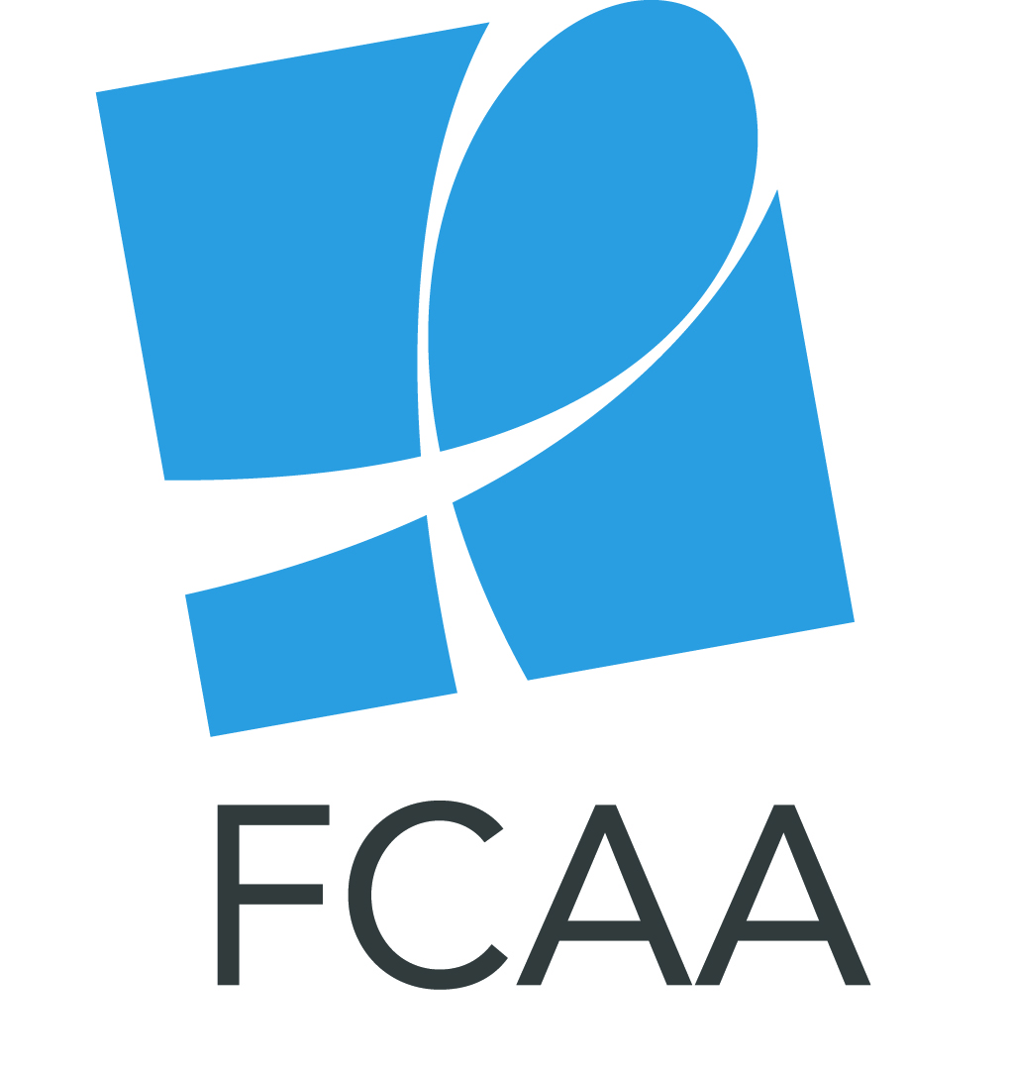

AIDS2018 SOCIAL MEDIA TOOLKIT

With important dialogue taking place at AIDS2018, Funders Concerned About AIDS (FCAA) wants to ensure that philanthropy is a part of the conversation. We hope that you will join us in bringing increased focus to philanthropic funding in Amsterdam by sharing our messages through your social media channels.

We are also hoping to generate awareness around some of our materials including our:
- 2016 resource tracking report
- Funder Guide to AIDS2018

We have prepared the following toolkit to help you do that. Suggestions for using this material include:
- Posting content in the days leading up to AIDS2018 to help create awareness of issues related to philanthropic funding.
- Utilizing this content during your time at the conference.
- Live tweeting about relevant conversations in which you participate throughout your time in Amsterdam.
- Tagging @FCAA and using the hashtag #FundAIDSFight in your posts.

Sample Facebook Posts
- As conversations take place around #AIDS2018, let’s remember that philanthropic funding is an important part of efforts to fight the epidemic. We are calling on the private sector to increase support and leverage its unique abilities to respond to an increasingly uncertain funding environment. #FundAIDSFight #EndAIDS

- Before you head to #AIDS2018, arm yourself with the most current data on the state of philanthropic funding. @FCAA’s signature report, Philanthropic Support to Address HIV/AIDS, is the most comprehensive study of its kind, capturing data on 7,019 grants, awarded by 392 foundations in 15 countries. The report identifies gaps, trends, and opportunities in HIV-related philanthropy. http://bit.ly/2JOmaB4 #FundAIDSFight [Use with SummaryRT2016.jpg]

- At #AIDS2018, there will no doubt be a lot of talk about #advocacy. Philanthropic funders have a history of providing critical resources to help in this area - helping to fight stigma & discrimination, inform policy and protect the rights of the most vulnerable. #FundAIDSFight #HIV #AIDS [Use with AdvocacyRT2016.jpg shareable]

Sample Tweets
- Will you be in Amsterdam for #AIDS2018? While there, be sure to connect with @FCAA to learn more about the state of philanthropic funding to fight #HIV #AIDS. #FundAIDSFight

- As you prepare for #AIDS2018, refresh your knowledge on the state of private funding for #HIV #AIDS: http://bit.ly/2JOmaB4 #FundAIDSFight #EndAIDS

- DYK: in 2016, global private funding for #HIV totaled US$ 680 million, the third straight year of growth in philanthropic funding to fight the epidemic. Meet with @FCAA at #AIDS2018 to learn more http://bit.ly/2JOmaB4 [Use with Increase.jpg shareable]

- We can’t let flagging resources/ill-informed policy roll back decades of progress against #HIV #AIDS. Now more than ever, the private sector must increase support & leverage its unique abilities to respond. At #AIDS2018, let’s work to #ReigniteTheFight! #FundAIDSFight
- Community-based responses are at the forefront of ensuring resources available for the #AIDS global fight are used effectively. Philanthropic organizations funding AIDS initiatives must support hard to reach & excluded community-based responses. #FundAIDSFight #AIDS2018

