Social Media Toolkit
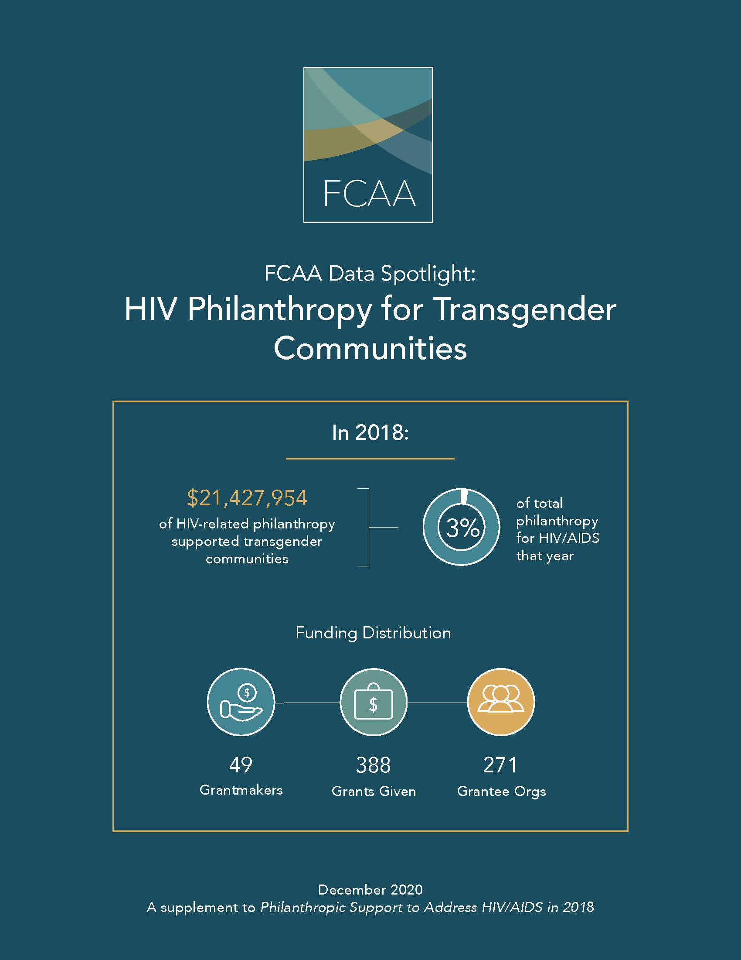
The social media content below is intended to aid in the rollout of the HIV Philanthropy for Transgender Communities (2018)

Twitter Content
New .@FCAA infographic details 1st analysis of #HIV #philanthropy for trans-led organizations in 2018. #fundingdata bit.ly/2KmWUam

Check out analysis of the who, what, where & why of #HIV-related #philanthropy for #transgender communities in 2018 #fundingdata bit.ly/2KmWUam

In 2018 $21 mil in #HIV-related #philanthropy went to #transgender communities, just 3% of total HIV philanthropy #fundingdata bit.ly/2KmWUam

While #HIV #philanthropy for #transgender communities has more than doubled since 2014, it has never represented more than 5% of total HIV philanthropy in a given year. #fundingdata bit.ly/2KmWUam

W/ the @TransJusticeFP definition of #transled, FCAA identified that 30% (42) of all orgs that received an HIV-related grant benefiting #transgender communities in the U.S. were trans led. This equals $2.8 mil in funding -just 1% of all HIV philanthropy bit.ly/2KmWUam

The U.S received more than half of all #HIV philanthropy for #transgender communities in 2018. #fundingdata bit.ly/2KmWUam

In the U.S., 40% of #HIV #philanthropy for #transgender communities went to projects of a national benefit, followed by 30% to the work in the #USSouth. #fundingdata #fundsouth bit.ly/2KmWUam

According to #GUTC & @LGBTfunders, for every $100 awarded by US foundations, only four cents supports #transgender communities. Learn more about the cascade of funding to transgender communities among #HIV and #LGBT philanthropy #fundingdata bit.ly/2KmWUam

The top 10 #HIV related funders of #transgender communities in 2018 = @GileadSciences @ViiVHC @MACVIVAGLAMFund @Aidsfonds_intl @ejaf @Sidaction @AIDS_united #anonymousdonor @GroundswellFund @TidesCommunity bit.ly/2KmWUam

Insta/Facebook Post

Using the #TransJusticeFundingProject @TransJusticeFP definition of #transled, FCAA identified that 30% (42) of all orgs that received an HIV-related grant benefiting #transgender communities in the U.S. were trans led. This equals just $2.8 mil in funding. Just 1% of total HIV philanthropy for the year.

Thank you to our partners in this important analysis @3WaveFund @AIDSUnited @lgbtfunders @translawcenter #transgenderstrategycenter@BorealisPhil bit.ly/2KmWUam

Social Media Images:

