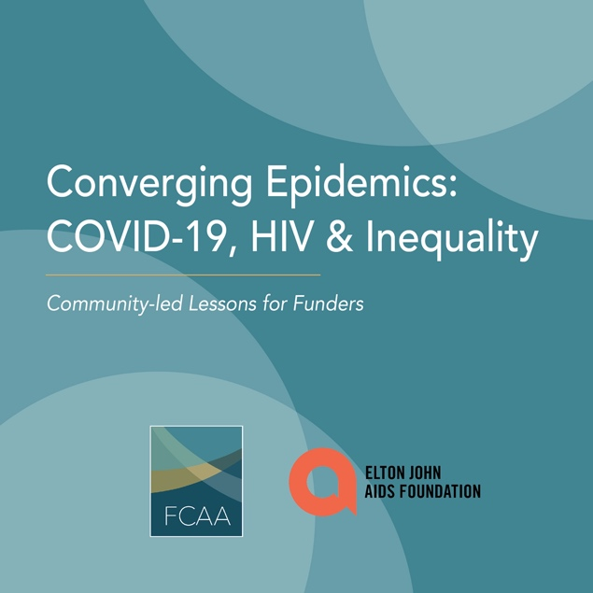

Social Media Toolkit

Funders Concerned About AIDS (FCAA) and the Elton John AIDS Foundation (EJAF) are rolling out a new report titled, Converging Epidemics: COVID-19, HIV & Inequality. To help create awareness of this important information, we have prepared a toolkit with template content we hope you will share by:

- Posting content on Twitter, Facebook, Instagram and LinkedIn
- Using the jpg we have provided with the image shown at the top of this page
- Tagging FCAA and EJAF on:
  - Twitter: @FCAA @EJAF
  - Facebook: @FCAAIDS @EltonJohnAIDSFoundation
  - Instagram: @FCAAIDS @EJAF
- Use hashtags: #convergingepidemics #fundaidsfight

We hope you find this material helpful. As always, please let us know if you have any questions or would like further information.

For Twitter

New report from @FCAA & @EJAF highlights how communities & #philanthropy are responding to #convergingepidemics of #COVID19 #HIV and #inequality. http://bit.ly/convergingepidemics
Click to Tweet: https://ctt.ac/J5EZ3

New @alliancemag op-ed from @FCAA & @EJAF calls for coordination among #philanthropy to address #convergingepidemics of #COVID19, #HIV & #systemicinequalities https://www.alliancemagazine.org/blog/a-call-for-coordination/

Click to Tweet: https://ctt.ac/mF6zA

New report highlights convergence of #COVID19 #HIV & #SystemicInequality. @FCAA @EJAF http://bit.ly/convergingepidemics

Click to Tweet: https://ctt.ac/bGH63

New report from @FCAA & @EJAF shows challenges presented by #COVID19 are not new for people living with or at risk of #HIV who have been disproportionately affected by these issues for decades. #systemicInequality http://bit.ly/convergingepidemics
Click to Tweet: https://ctt.ac/pcmv9

How can funders & governments combat #convergingepidemics of #COVID19, #HIV & #SystemicInequality? Listen to communities & work collaboratively with them & each other! Learn more in a new report from @FCAA & @EJAF. http://bit.ly/convergingepidemics

Click to Tweet: https://ctt.ac/InD4Z

#COVID19 didn’t create structural & systemic issues for #PLWHIV. But it DID bring them into sharp focus. So, how do we solve them? A new report from @FCAA & @EJAF provides some recommendations for #philanthropy & governments. #FundAIDSFight #SystemicInequality http://bit.ly/convergingepidemics

Click to Tweet: https://ctt.ac/VGtkZ

For Instagram

A new report commissioned by @FCAAIDS & @EJAF highlights the convergence of #COVID19, #HIV & #SystemicInequality. The key takeaway: funders and governments must listen to communities and work collaboratively with them—and with each other! Read the report here. http://bit.ly/convergingepidemics

#HIV #AIDS #COVID19 #SystemicInequality #FundAIDSFight #converging epidemics

For Facebook

A new report commissioned by @FCAAIDS & @EltonJohnAIDSFoundation highlights the convergence of #COVID19, #HIV & #SystemicInequality. The key takeaway: funders and governments must listen to communities and work collaboratively with them—and with each other! Read the report here. http://bit.ly/convergingepidemics

#HIV #AIDS #COVID19 #SystemicInequality #FundAIDSFight #convergingepidemics

