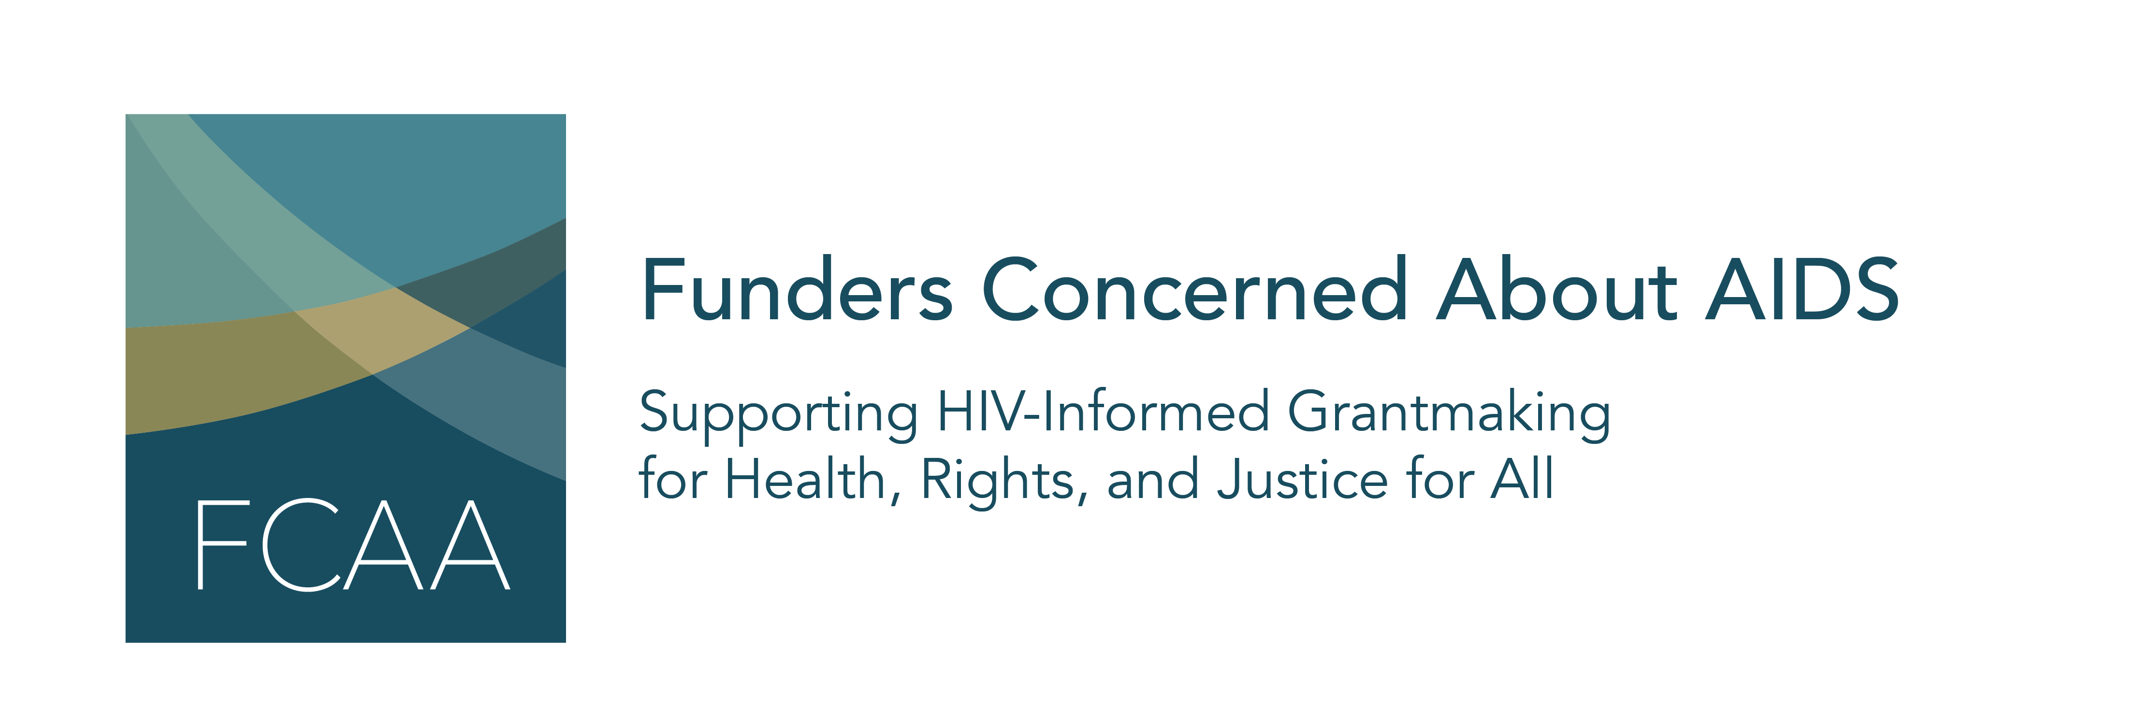

Funders Concerned About AIDS’ signature report, Philanthropic Support to Address HIV/AIDS, is now in its 18th year. For nearly two decades, this information has helped to identify gaps, trends, and opportunities in HIV-related philanthropy. This report, the most comprehensive of its kind, captures data on 5,692 grants awarded by 264 funders to 3,023 grantees.

As it rolls out the latest edition, FCAA welcomes your assistance in building awareness of the data. We have created template content to share through your respective social media platforms. We ask for your help by encouraging you to:
- Begin posting this content on May 6th and continue to use these assets, as appropriate, in the days and weeks following the launch
- Use the hashtag #FundHIVFight in your posts
- When possible, tag @FCAA in your posts

We hope you find this material helpful. As always, please let us know if you have any questions or would like further information.

Image/Asset | Facebook/LinkedIn/Instragram | Twitter
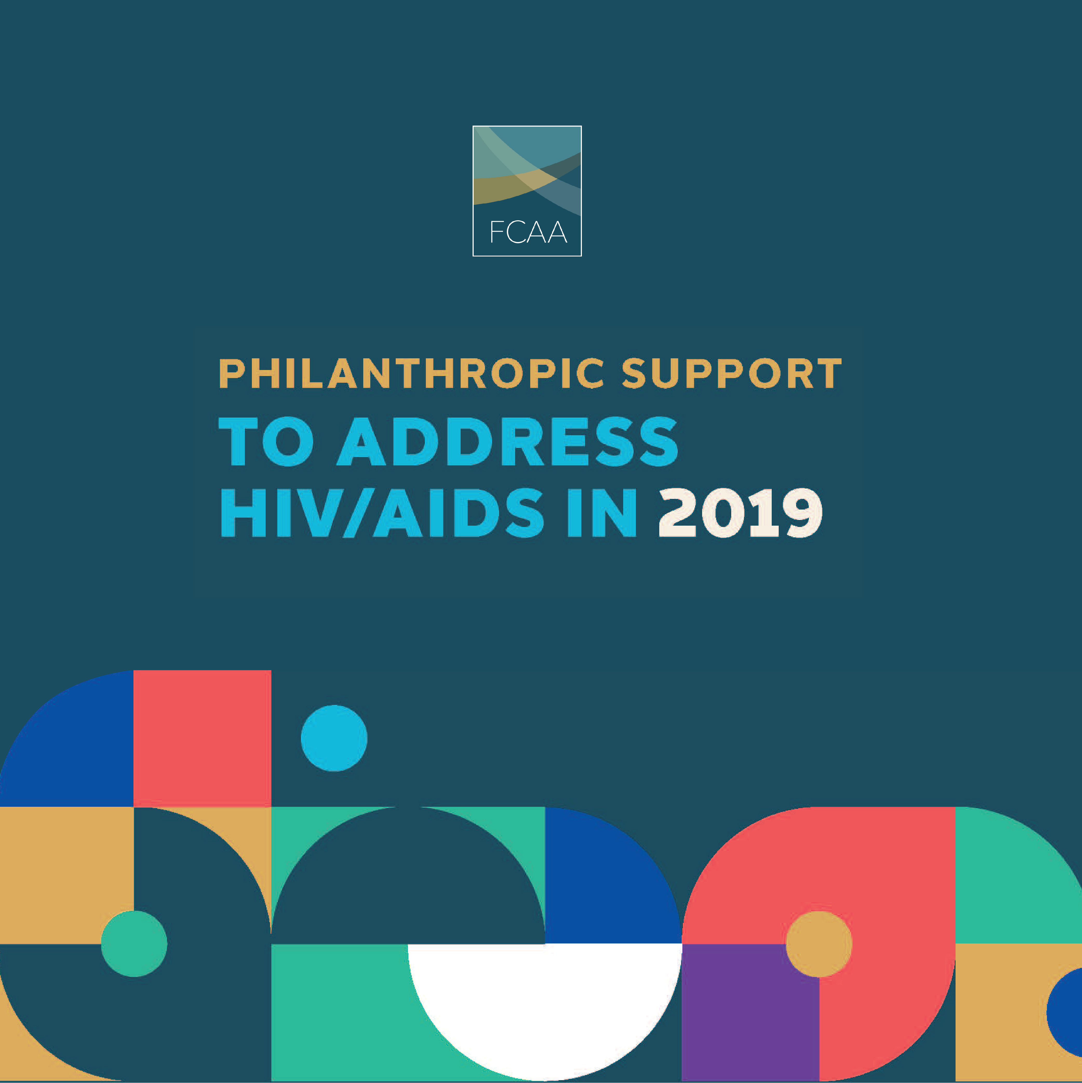 | @FCAAIDS’ new report shows that 2019 marked the highest level of philanthropic HIV funding. BUT there’s a lot more to the story:  - The number of funders remains limited  - Resources are decreasing in critical areas  Read the full report to learn more. http://bit.ly/FCAART2019  #FundHIVFight #AIDSFunding #HIV #AIDS #Philanthropy | 2019 marked the highest level of philanthropic #HIV funding to date. BUT there are significant caveats. Read all about it in @FCAA’s new report http://bit.ly/FCAART2019  #FundHIVFight #AIDS #Philanthropy
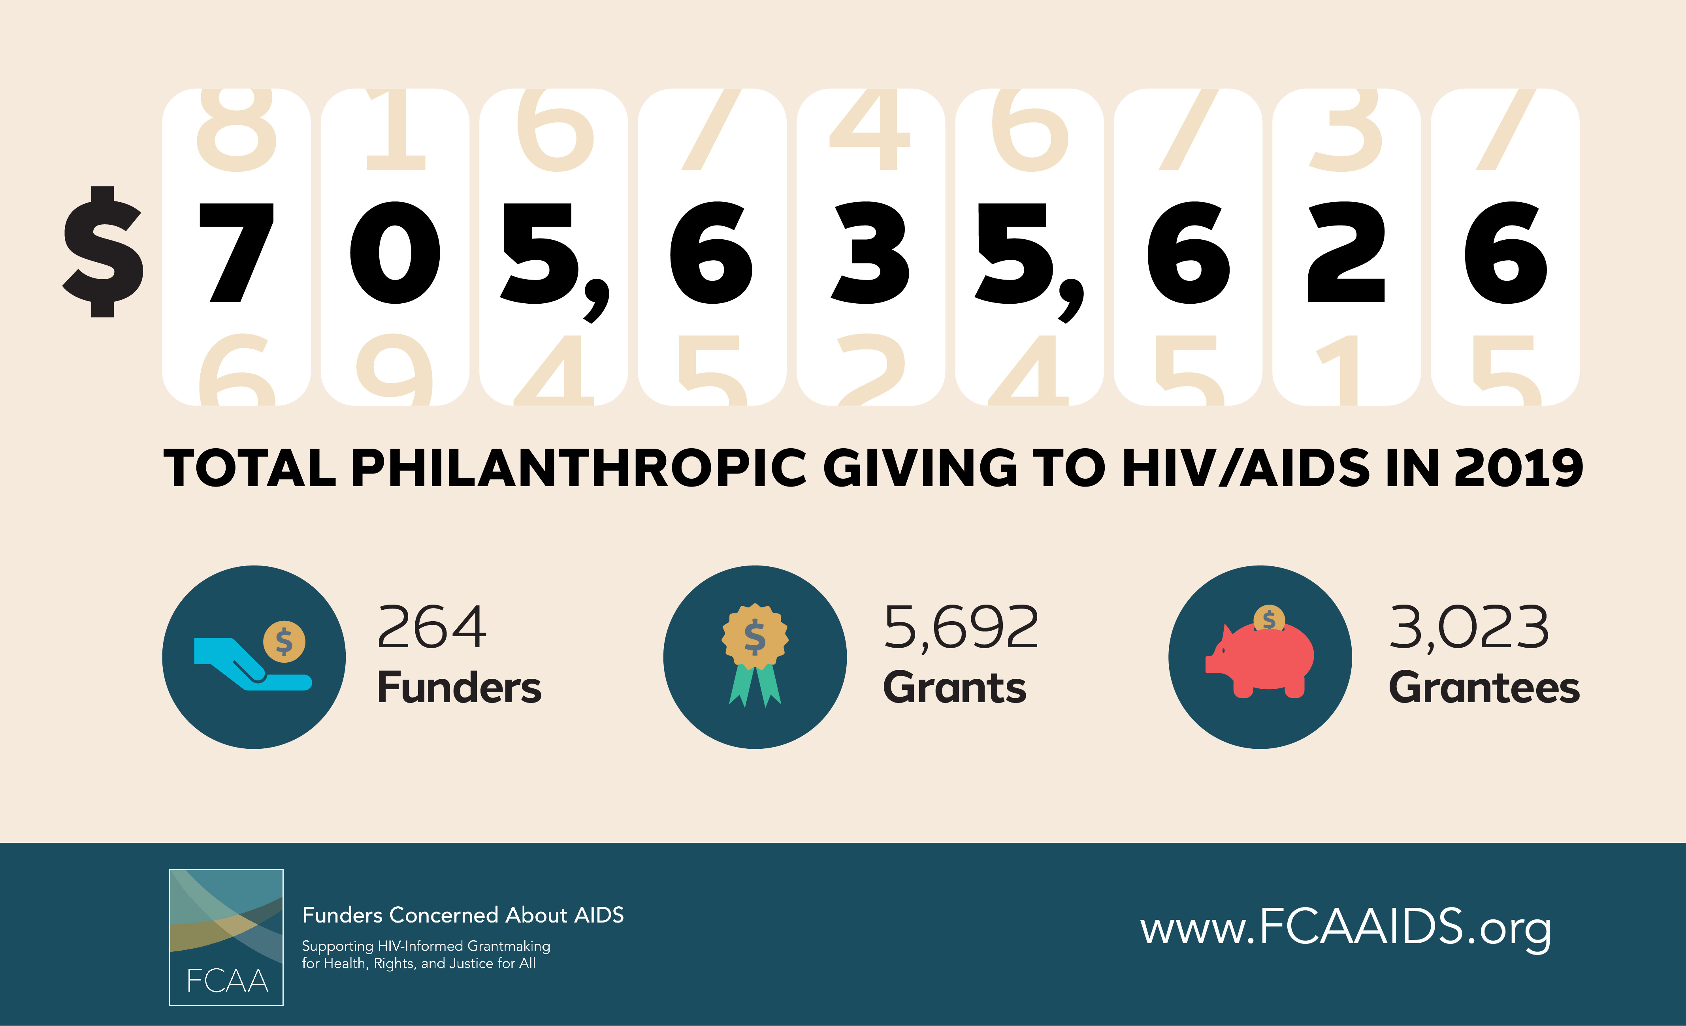 | In 2019, HIV/AIDS-related giving among private philanthropic organizations reached its highest level (nearly $706 million) since @FCAAIDS began tracking this data nearly 20 years ago.  BUT…  This increase was almost entirely driven by a one-time payment from one funder. Without that, here would have been an overall decrease in HIV-related philanthropy.  Required reading: http://bit.ly/FCAART2019  #FundHIVFight #HIV #AIDS #Philanthropy | Philanthropic funding for #HIV reached an all-time high in 2019 – due largely to 1 payment from 1 funder. W/o that? There was an overall decrease in resources. Read @FCAA’s new report for more details http://bit.ly/FCAART2019 #FundHIVFight
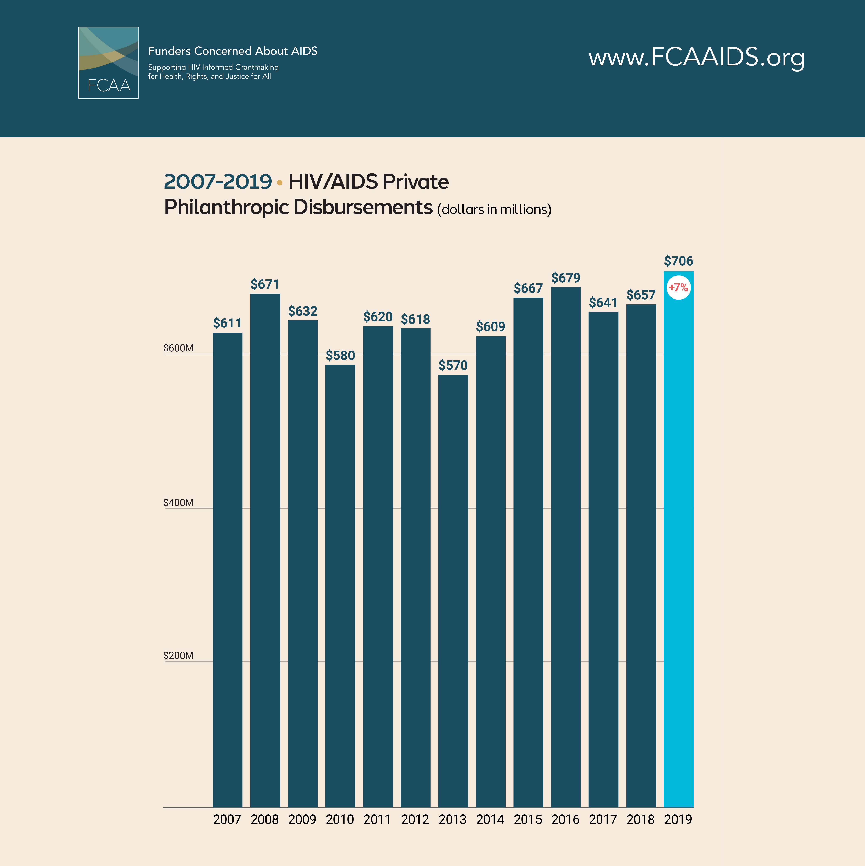 | HIV-related philanthropy has stayed relatively unchanged - between $600 million & $700 million - for a decade. This is not the way to reach our 2030 goals.  Get the details, as well as strategies for moving forward, in @FCAAIDS’ new report. http://bit.ly/FCAART2019  #FundHIVFight #HIV #AIDS #Philanthropy #SDG #SustainableDevelopmentGoals | The level of philanthropic funding for #HIV #AIDS really hasn’t changed much in 10 years. This isn’t the way to achieve 2030 goals. Read @FCAA’s new report to learn more http://bit.ly/FCAART2019 #FundHIVFight #SDG
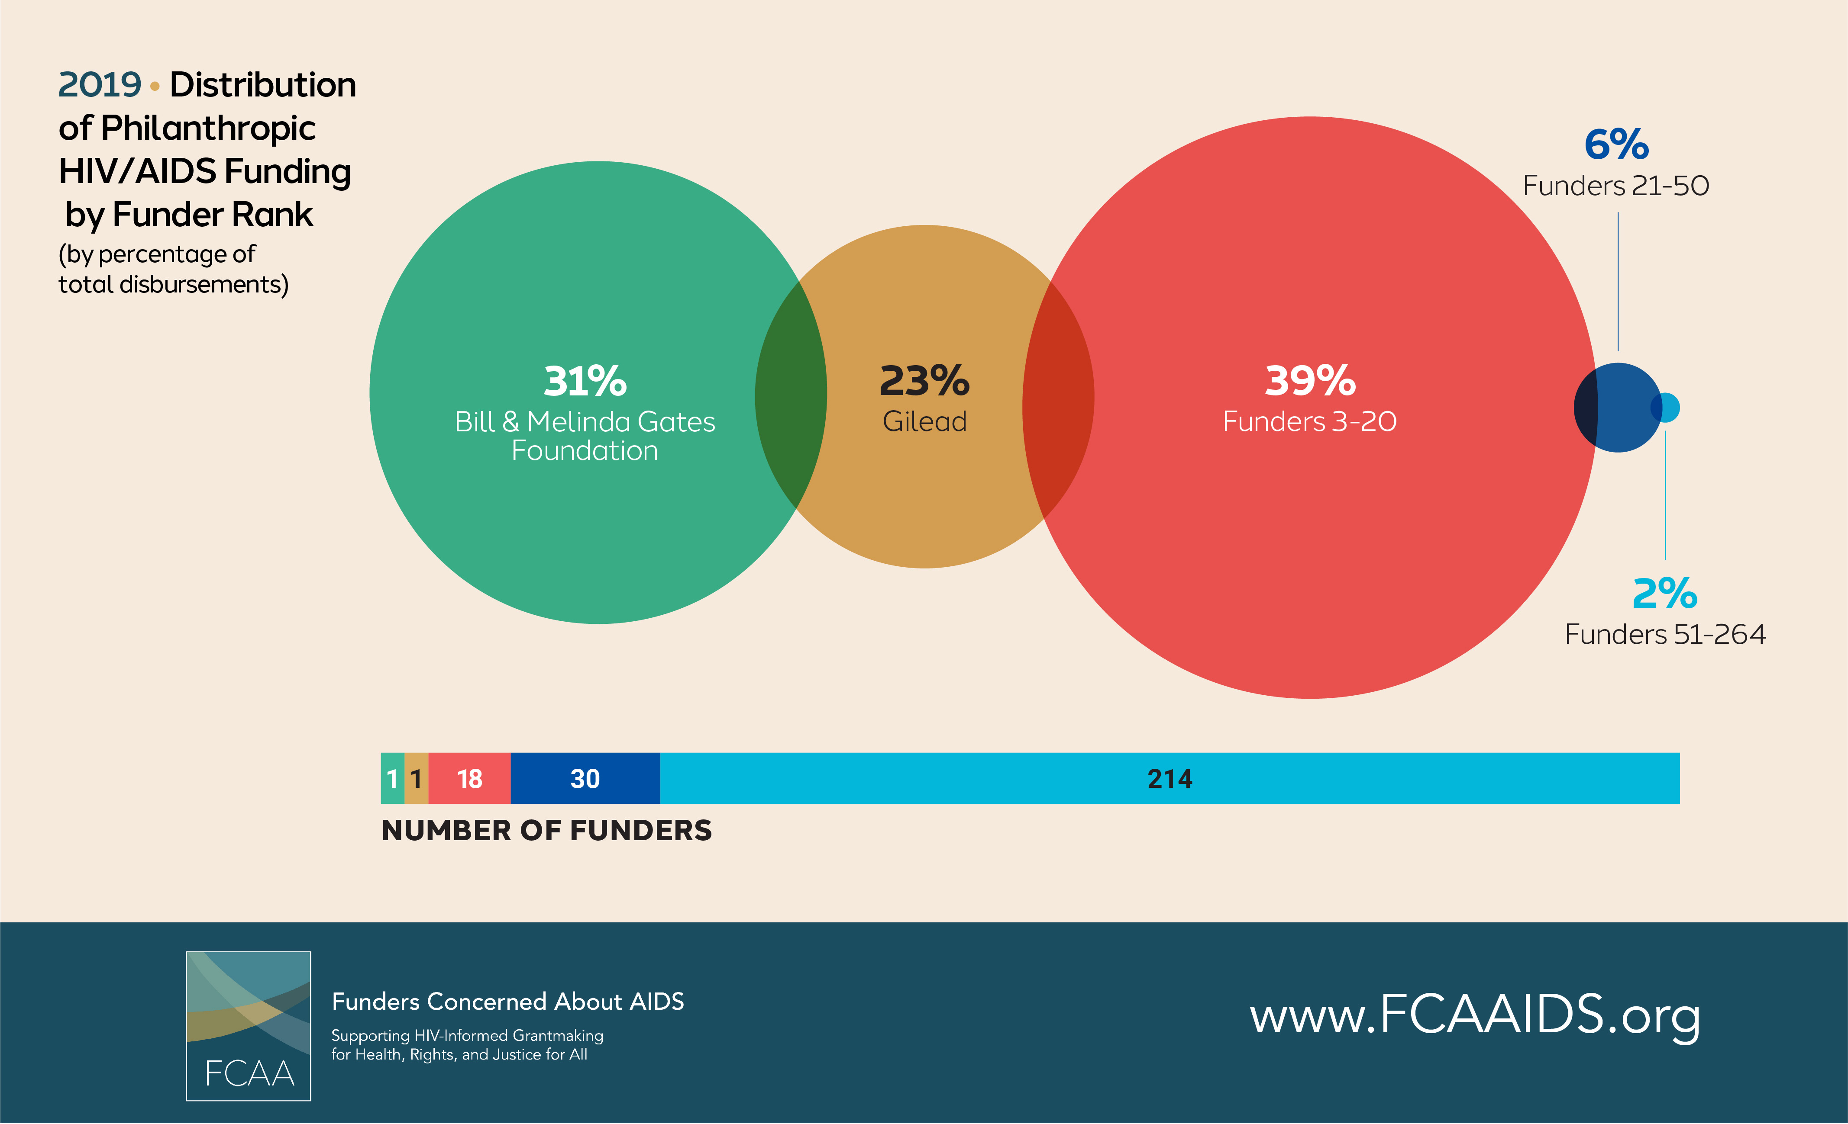 | Philanthropic HIV funding is worryingly concentrated - the top 20 philanthropic HIV funders accounted for 92% of total funding in 2019.  Get more details in @FCAAIDS’ latest report http://bit.ly/FCAART2019  #FundHIVFight #HIV #AIDS #Philanthropy #AIDSFunding | Philanthropic funding for #HIV is in a precarious spot: a small group of grantmakers account for 92% of total funding. Get the details in @FCAA’s new report http://bit.ly/FCAART2019 #FundHIVFight #Philanthropy
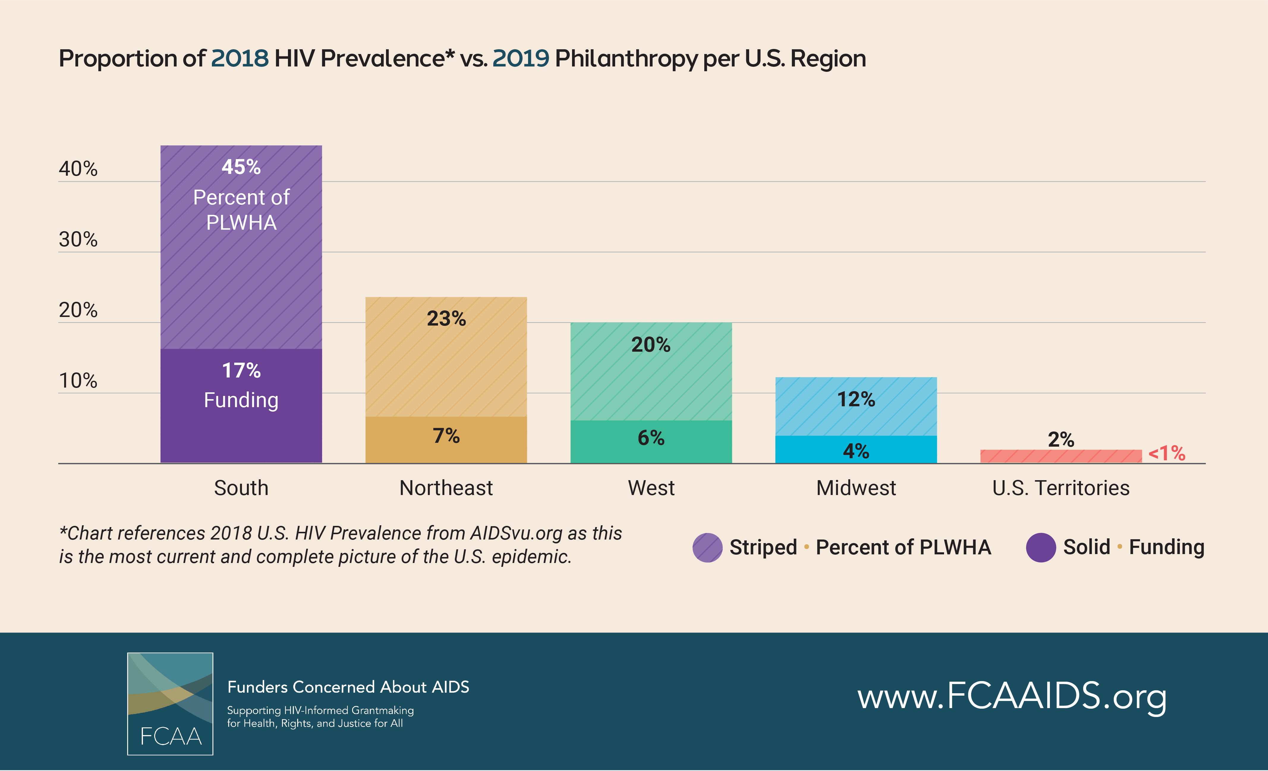 | @FCAAIDS’ new report compared  the percentage of philanthropic HIV funding with the percentage of people living with HIV/AIDS per U.S. region (per @AIDSvu) and found that there are still clear gaps in the response.  Read the full report http://bit.ly/FCAART2019  #FundHIVFight #HIV #AIDS #Philanthropy #AIDSFunding #PLWHIV | Comparing philanthropic #HIV funding against % of #PLWHIV (per @AIDSvu), @FCAA report finds that trajectory of $ follows the trend of prevalence BUT there are still clear gaps.  http://bit.ly/FCAART2019 #FundHIVFight
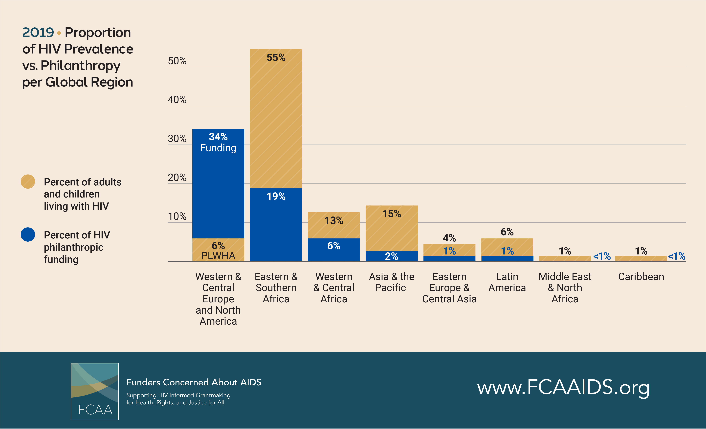 | @FCAAIDS’ latest resource tracking data compares  philanthropic HIV funding with the number people living with HIV/AIDS per global region (per @unaids) highlighting the gaps that remain in Eastern & Southern Africa as well as regions in Asia and the Pacific.  Read the full report here. http://bit.ly/FCAART2019  #FundHIVFight #HIV #AIDS #Philanthropy #AIDSFunding | By comparing the latest funding against @UNAIDS data on #PLWHIV, @FCAA highlights gaps remain in philanthropic for #HIV #AIDS in Eastern & Southern Africa, Asia & the Pacific. http://bit.ly/FCAART2019  #FundHIVFight
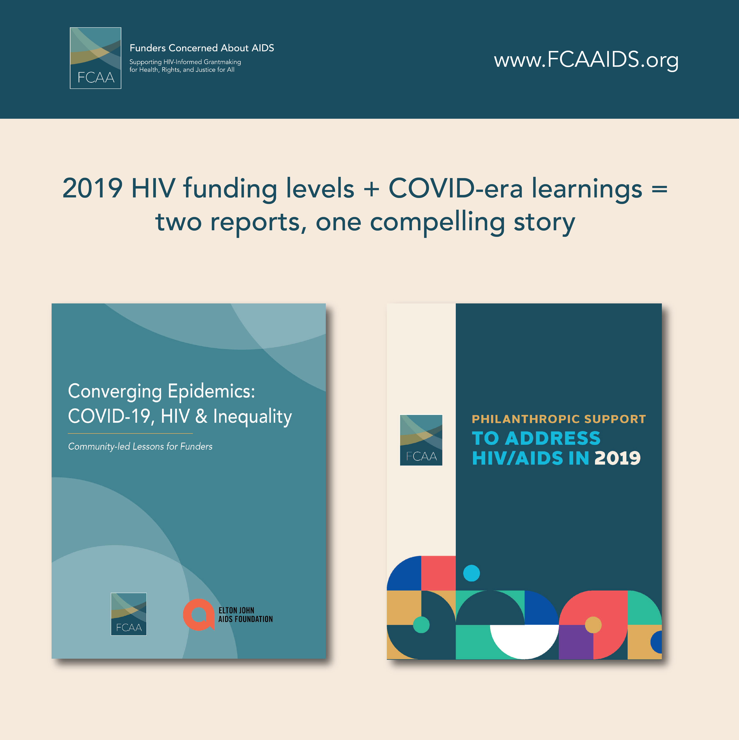 | With two reports, @FCAAIDS provide one compelling story about #HIV philanthropic funding. In short, the gaps that existing pre-pandemic have only been compounded by COVID-19. Read both reports for the full story. www.FCAAIDS.org  #FundHIVFight #HIV #AIDS #COVID19 #COVID #Philanthropy #GlobalHealth #GlobalHealthFunding | In two new reports, @FCAA examines #prepandemic #HIV funding levels of key issues + highlights how they’ve been compounded by #COVID19. Learn more at www.FCAAIDS.org #FundHIVFight

