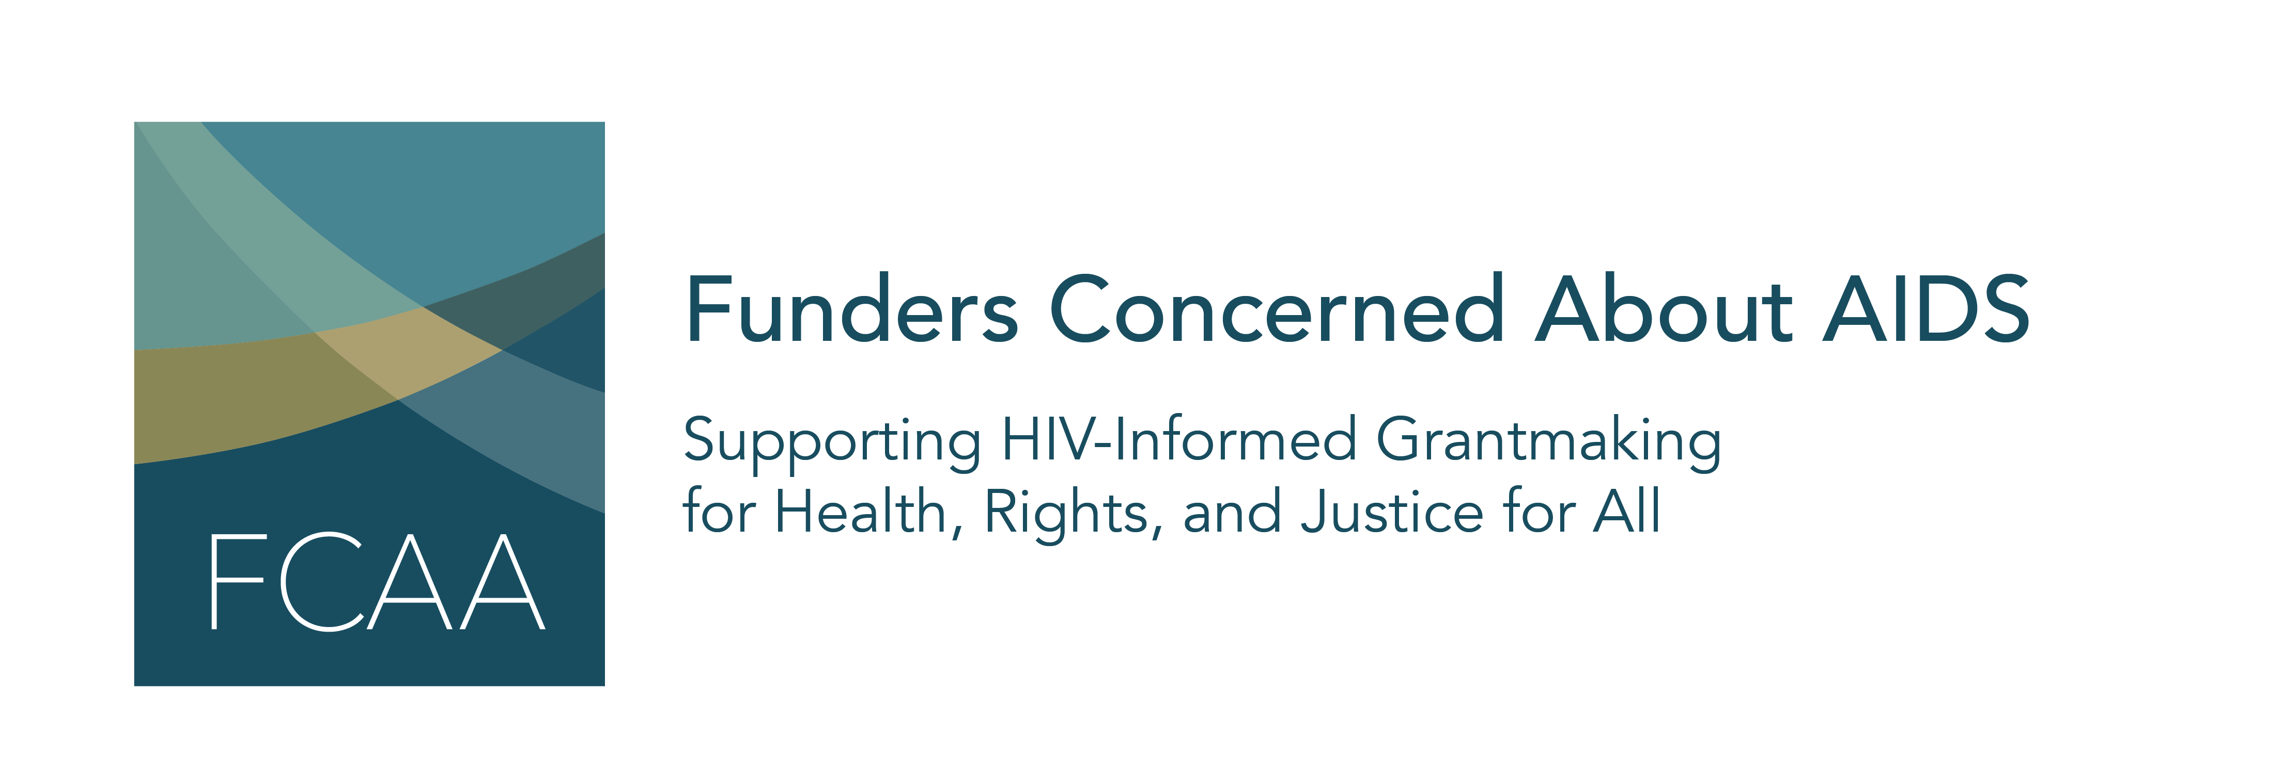

Funders Concerned About AIDS’ signature report, Philanthropic Support to Address HIV/AIDS, is now in its 18th year. For nearly two decades, this information has helped to identify gaps, trends, and opportunities in HIV-related philanthropy. The latest report, published in May of 2021, is the most comprehensive of its kind, and captures data on 5,692 grants awarded by 264 funders to 3,023 grantees in 2019.

FCAA is now accepting 2020 calendar year data! Below is a list of suggested social media content to help identify data on HIV-related grantmaking.

- Did you fund #HIV related work in 2020? .@FCAA is now accepting data on HIV-related grants disbursed in calendar year 2020. Make sure your grants count, submit today! #call4data #fundHIVfight #resourcetracking https://grants.fcaaids.org/

- Make sure your grants are counted by submitting your data for the next .@FCAA #resourcetracking report on #HIV related grantmaking. Now accepting CY 2020 data! #fundHIVfight https://grants.fcaaids.org/

- Did your grantmaking priorities intersect with #HIV in 2020? Please consider sharing your data for the next .@FCAA #resourcetracking report on HIV-related grantmaking – now accepting CY 2020 data. https://grants.fcaaids.org/

- Understanding the landscape of #HIV related grantmaking is only made possible by receiving annual submissions of grants data from funders like YOU. Share your CY 2020 data with .@FCAA today! #call4data #fundHIVfight #resourcetracking https://grants.fcaaids.org/

