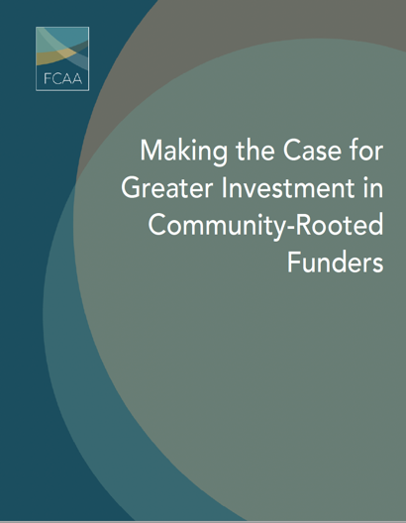

Social Media Toolkit

Funders Concerned About AIDS (FCAA) is rolling out a new report titled, Making the Case for Greater Investment in Community-Rooted Funders. To help create awareness of this important information, we have prepared a toolkit with content we hope you will share by:

- Posting content on your social media feeds
- Using the hashtag #FundHIVFight
- Using the shareable images we have provided
- Tagging @FCAA in your posts

We hope you find this material helpful. As always, please let us know if you have any questions or would like further information.

New @FCAA report helps make the case for ⬆️ investment in #HIV related intermediaries, esp. those that are community-rooted & community-led. Read the report here https://bit.ly/3uL3L0a #FundHIVFight #philanthropy #participatory | 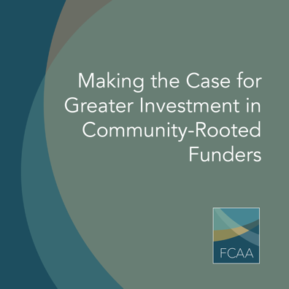
#Communityrooted funders working at the intersection of #HIV, #HumanRights & #RacialJustice are critical to reaching global health goals. @FCAA’s new report explores their role, added value, impact & key challenges/needs. Read more here https://bit.ly/3uL3L0a #philanthropy

Community-rooted funders, different in many ways, share a commitment to centering the communities they represent & serve: hear their stories in @FCAA’s new report . https://bit.ly/3uL3L0a #FundHIVFight #philanthropy #participatory

What is a community-rooted funder? One that centers the communities they represent & serve. Read about the critical role these orgs play in the fight against #HIV in @FCAA’s new report. https://bit.ly/3uL3L0a #philanthropy #participatory | 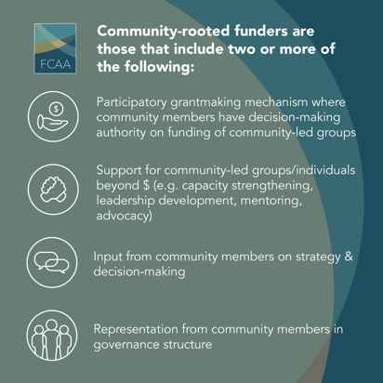
Though critical to the fight against #HIV, most recent data on HIV-related philanthropic funding for intermediary & community-rooted funders shows that it has remained flat in recent years. Further data can be found in @FCAA’s new report https://bit.ly/3uL3L0a #FundHIVFight | 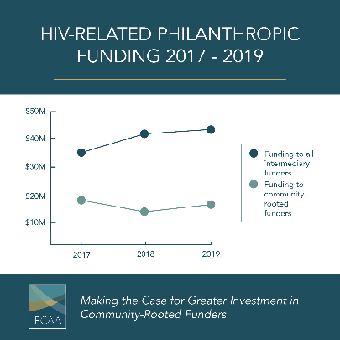
#Intermediary funders, including those that are #communityrooted, receive only a small share of #HIV-related #philanthropy each year.  Further data can be found in @FCAA’s new report https://bit.ly/3uL3L0a #FundHIVFight #participatory | 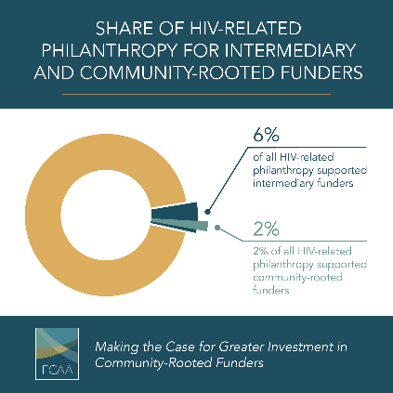
In @FCAA’s new report, @ISDAOSankofa’s ED, Caroline Kouassiaman talks about the importance of #communityrooted funding. Read what she has to say: https://bit.ly/3uL3L0a | 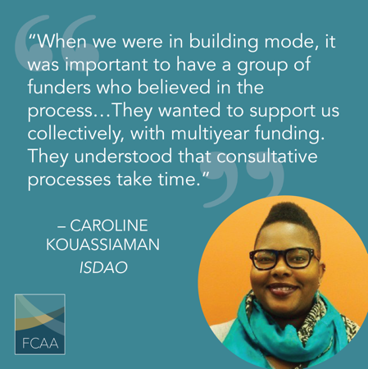
To learn how @ContigoFund is strengthening leadership through #communityrooted funding in the U.S. South read @FCAA’s new report. https://bit.ly/3uL3L0a #LGBTQ #fundsouth | 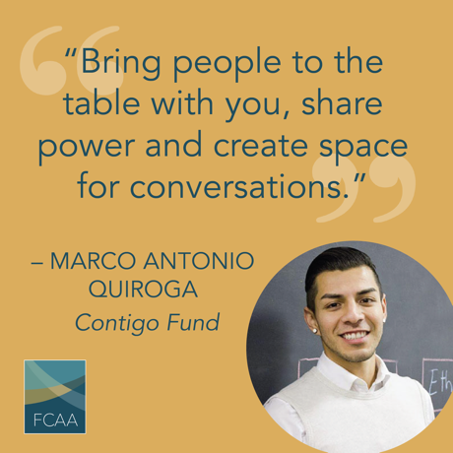
To learn how @SouthernAIDSCo is strengthening leadership through #communityrooted funding in the U.S. South read @FCAA’s new report. https://bit.ly/3uL3L0a #FundHIVFight #fundsouth | 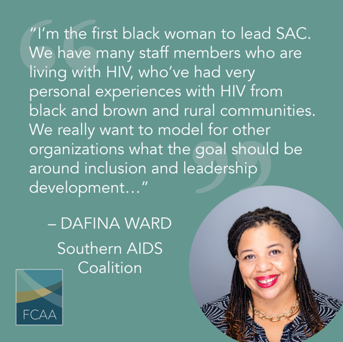

To learn how @Yplus_Global is centering #youth voice & advocacy, read @FCAA’s new report. https://bit.ly/3uL3L0a #FundHIVFight #PLWHIV #SocialJustice | 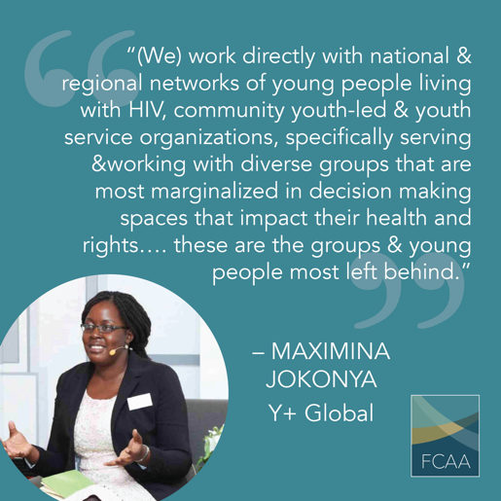
To learn how @AdvocatesTweets are centering #youth voice & advocacy, read @FCAA’s new report. https://bit.ly/3uL3L0a #FundHIVFight #PLWHIV #SocialJustice

To learn how @redumbrellafund uses the power of #participatory grantmaking with criminalized populations read @FCAA’s new report. https://bit.ly/3uL3L0a #FundHIVFight #FundSexWorkers #ParticipatoryGrantMaking | 