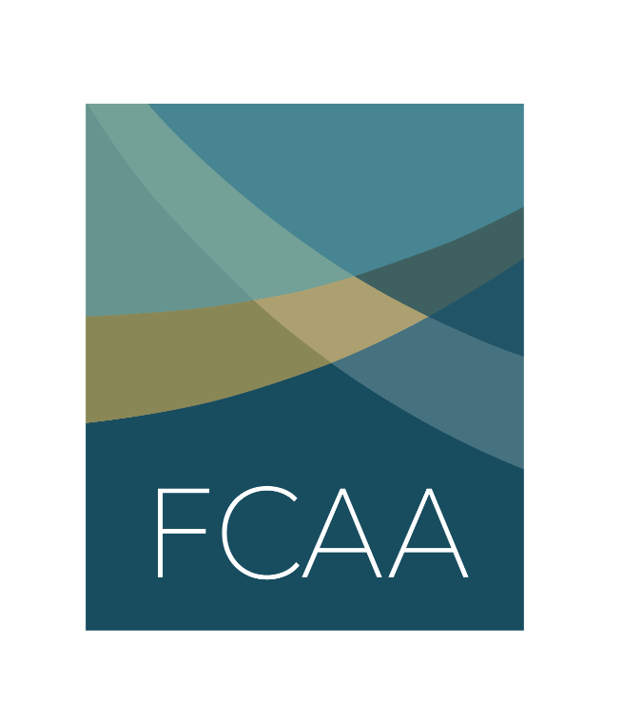

Social Media Toolkit

In advance of World AIDS Day 2021, Funders Concerned About AIDS (FCAA) is releasing Racial Justice in HIV Philanthropy Guiding Principles. This guidance was developed to help funders change their approach to philanthropy and outlines actionable steps funders can take within four areas to increase funding for racial equity and move our community towards racial justice.

To help share this guidance as broadly as possible, we have prepared a toolkit with template content below. We would be grateful if you would share these messages through your respective social media channels.

Suggestions for helping us get the word out include:
- Tagging @FCAA in your posts
- Use the hashtag #FundHIVFight so that we can track your posts

Copy | Image
In advance of #WorldAIDSDay2021, @FCAA calls on funders to commit to #RacialJustice principles by holding themselves accountable to #AntiRacist funding that dismantles #StructuralRacism  https://bit.ly/RacialJusticePrinciples #FundHIVFight | 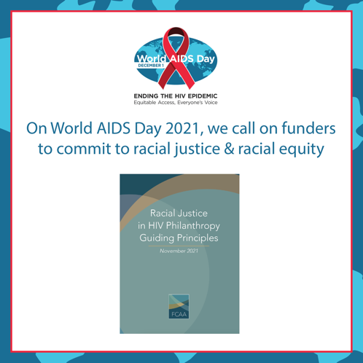
In advance of #WorldAIDSDay2021, @FCAA calls on funders to commit to #RacialJustice principles by increasing funding for #RacialEquity

https://bit.ly/RacialJusticePrinciples #FundHIVFight

#HIVCommunity! Let #HIV informed funders know you want the principles outlined in @FCAA’s new #RacialJustice guidance applied in practice. Read the principles and sign on here https://bit.ly/RacialJusticePrinciples #FundHIVFight

Structural racism has long been driver of #HIV epidemic within US #BIPOC communities. @FCAA’s new racial justice principles provides guidance for HIV-informed funders to address this challenge. https://bit.ly/RacialJusticePrinciples #FundHIVFight | 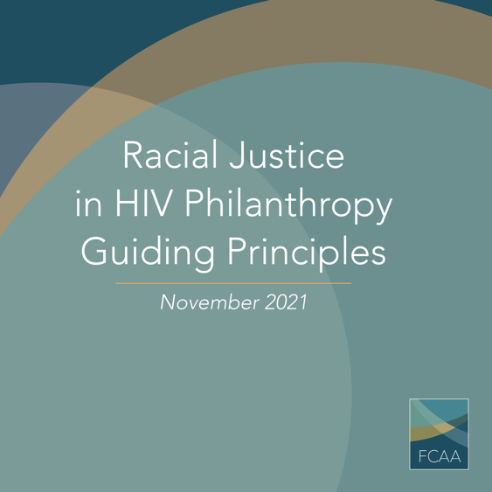
Per @LaadyV, #RacialJustice in #HIV is not merely treating the symptoms, it’s about fixing the system. @FCAA’s Racial Justice in HIV Guiding Principles help funders take a step in that direction. https://bit.ly/RacialJusticePrinciples #FundHIVFight | 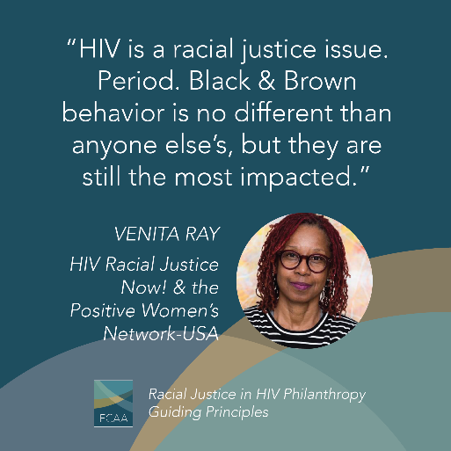
From just talking the talk to actually walking the walk: new @FCAA Racial Justice in HIV Guiding Principles provide actionable ways for funders to increase #RacialJustice & #RacialEquity in grantmaking. https://bit.ly/RacialJusticePrinciples #FundHIVFight  #FundHIVFight @chcimpact | 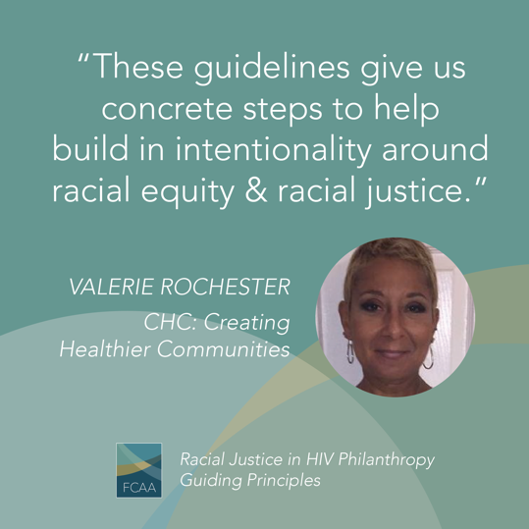
How can funders put @FCAA’s #RacialJustice in #HIV Guiding Principles into practice? @GileadSciences’ Darwin Thompson offers advice based on his experience. Learn more at https://bit.ly/RacialJusticePrinciples #FundHIVFight  #RacialEquity | 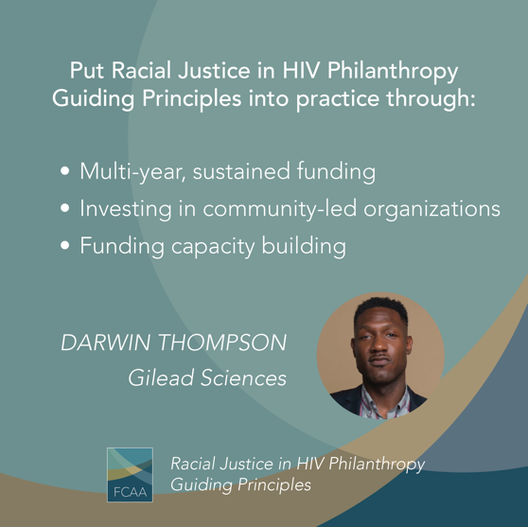
Responding to calls for more philanthropic #AntiRacist action, new racial justice principles for #HIV informed funders provides guidance in 4 key areas. https://bit.ly/RacialJusticePrinciples #FundHIVFight | 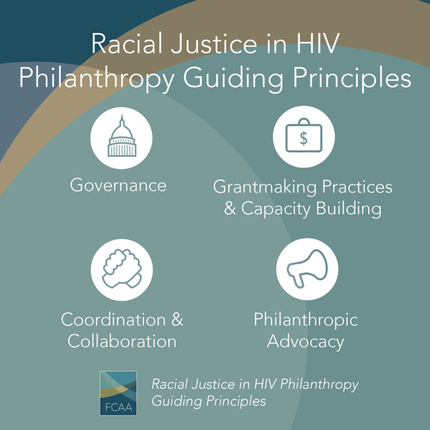
#BIPOC communities represent 70% of #PLWHIV in the US; but receive only 14% of HIV-related philanthropy. @FCAA Racial Justice in HIV Philanthropy Principles seek to address this resource gap. https://bit.ly/RacialJusticePledge #FundHIVFight | 