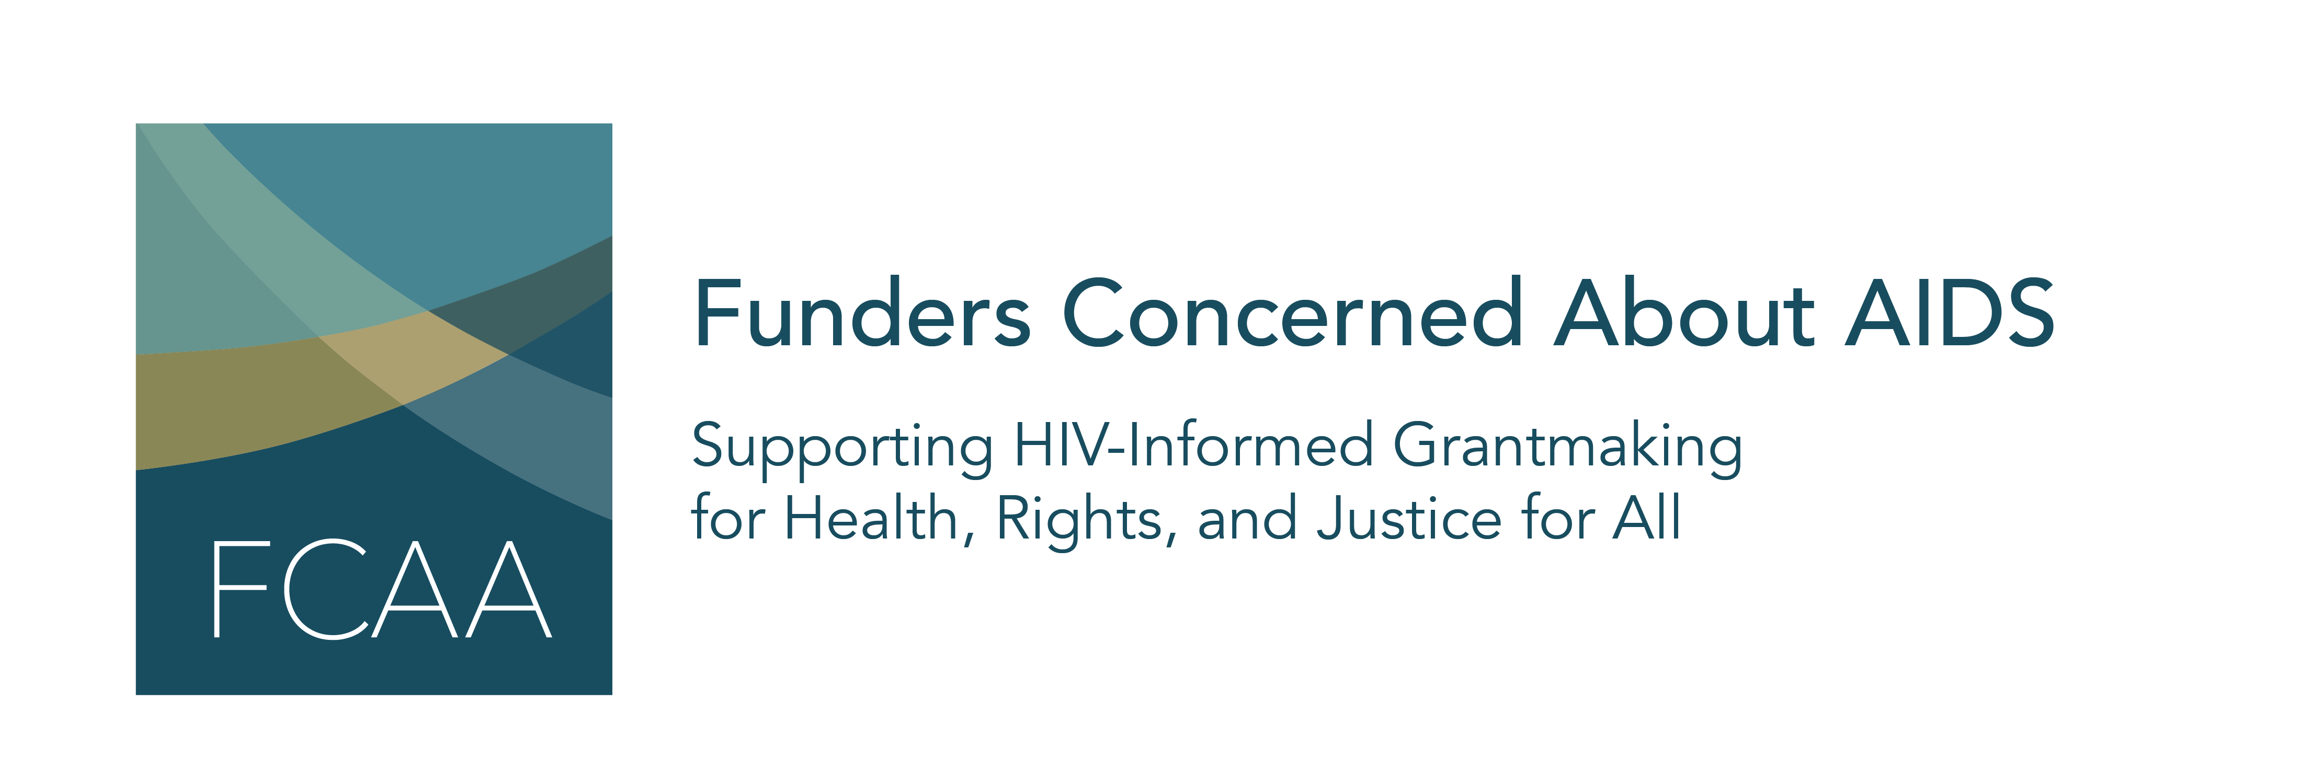

Funders Concerned About AIDS’ signature report, Philanthropic Support to Address HIV and AIDS, is now in its 19th year. For nearly two decades, this information has helped to identify gaps, trends, and opportunities in HIV-related philanthropy. This report, the most comprehensive of its kind, captures data on 5,758 grants awarded by 323 funders to 2,944 grantees.

As it rolls out the latest edition, FCAA welcomes your assistance in building awareness of the data. We have created template content to share through your respective social media platforms. We ask for your help by encouraging you to:
- Begin posting this content on May 19th and continue to use these assets, as appropriate, in the days and weeks following the launch
- Use the hashtag #FundHIVFight in your posts
- When possible, tag @FCAA in your posts

We hope you find this material helpful. As always, please let us know if you have any questions or would like further information.

Image/Asset | Post
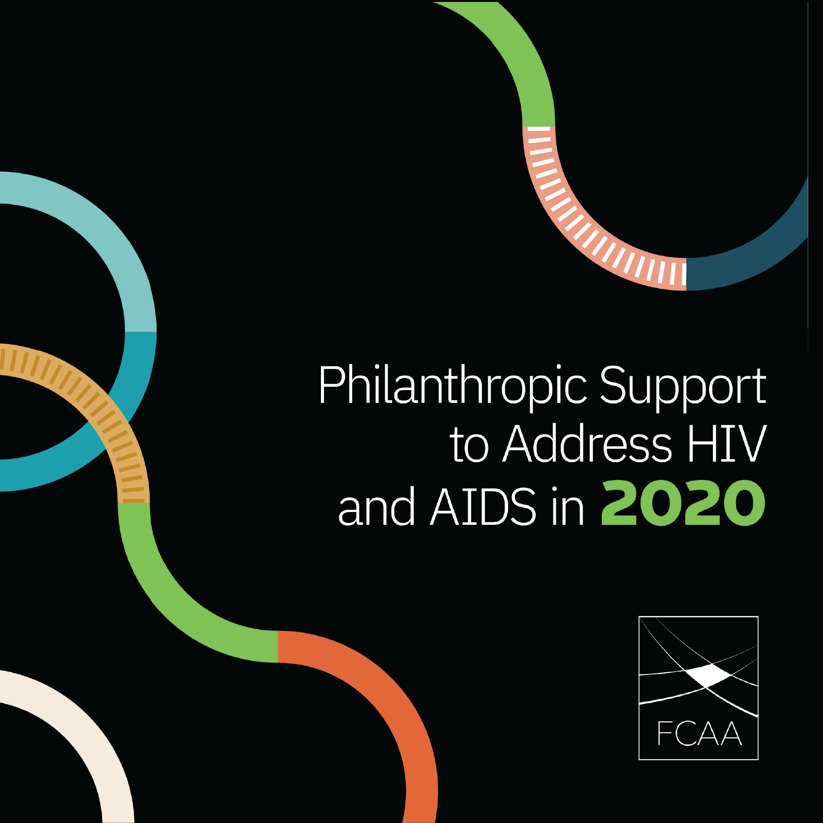 | The first #COVID era assessment of private #HIV funding is now available. Read @FCAA's new report to learn how the #pandemic impacted HIV-related philanthropic funding. https://bit.ly/FCAART2020  #FundHIVFight #Philanthropy
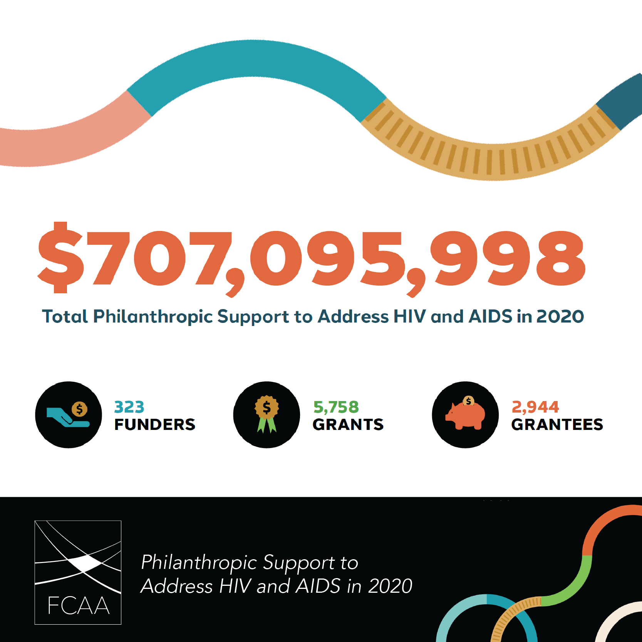 | Hot off the presses! @FCAA’s annual report on philanthropic funding to address #HIV. This year’s edition captures data on 5,758 grants awarded by 323 funders to 2,944 grantees. https://bit.ly/FCAART2020  #FundHIVFight #Philanthropy
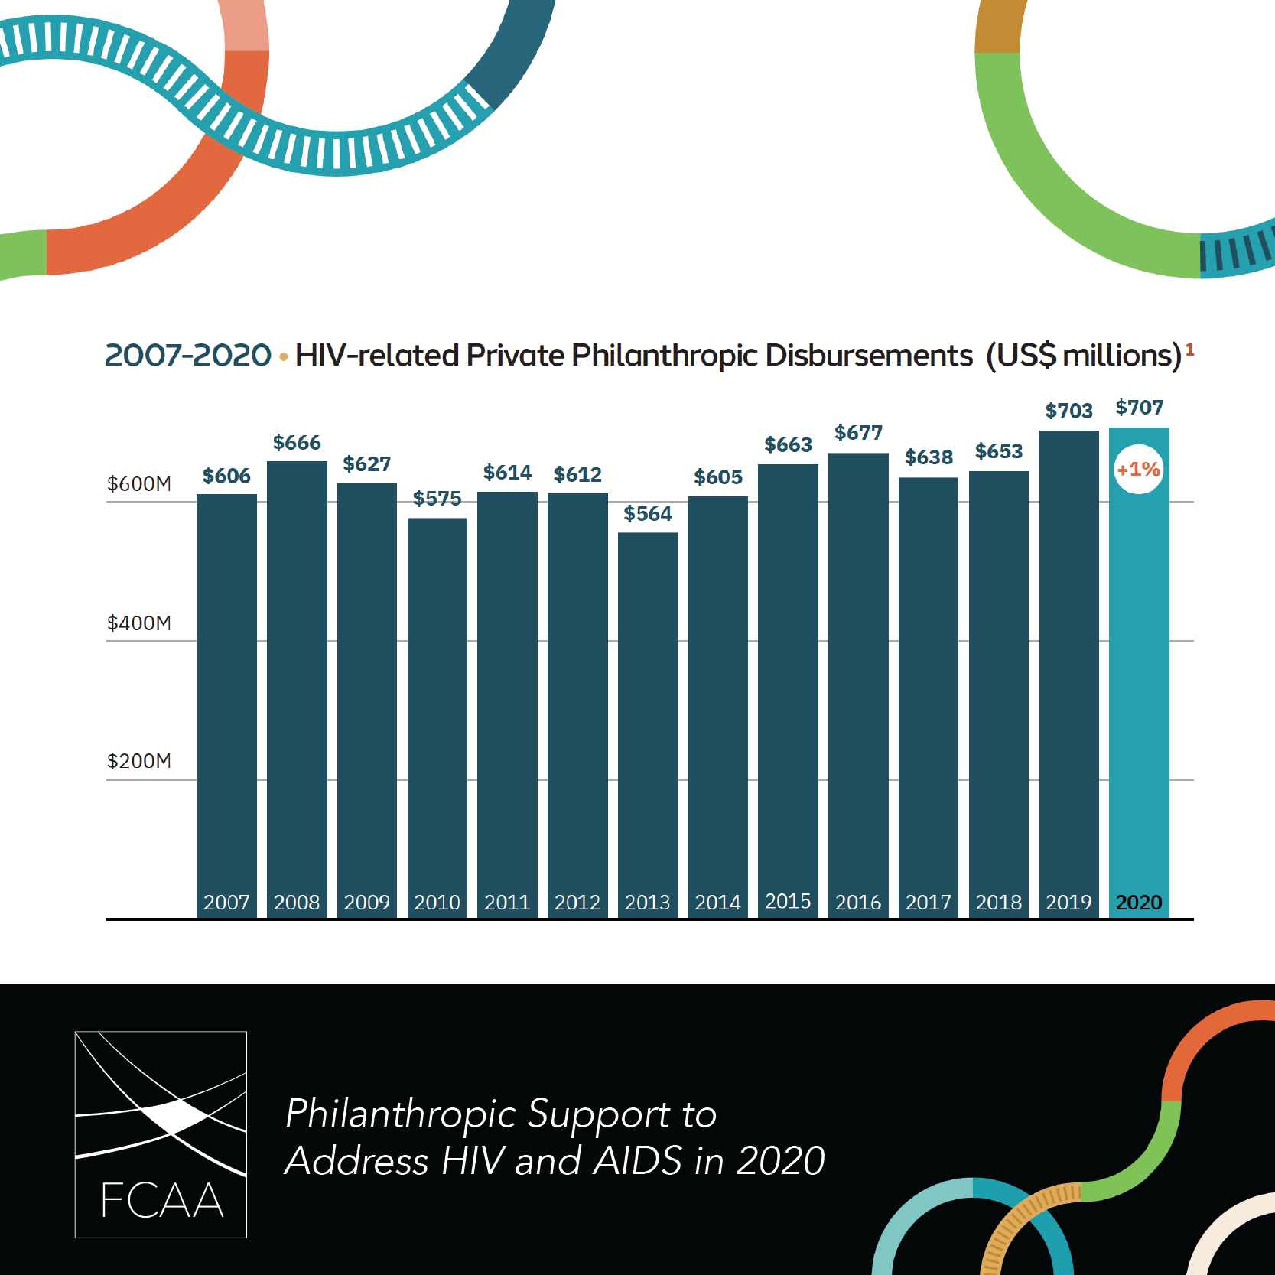 | It might look like private funding for #HIV was steady in 2020, but the data in @FCAA’s new report shows a dangerous reliance on a shrinking pool of funders. This is an enormous concern for the stability of HIV-related #philanthropy https://bit.ly/FCAART2020  #FundHIVFight #HIV
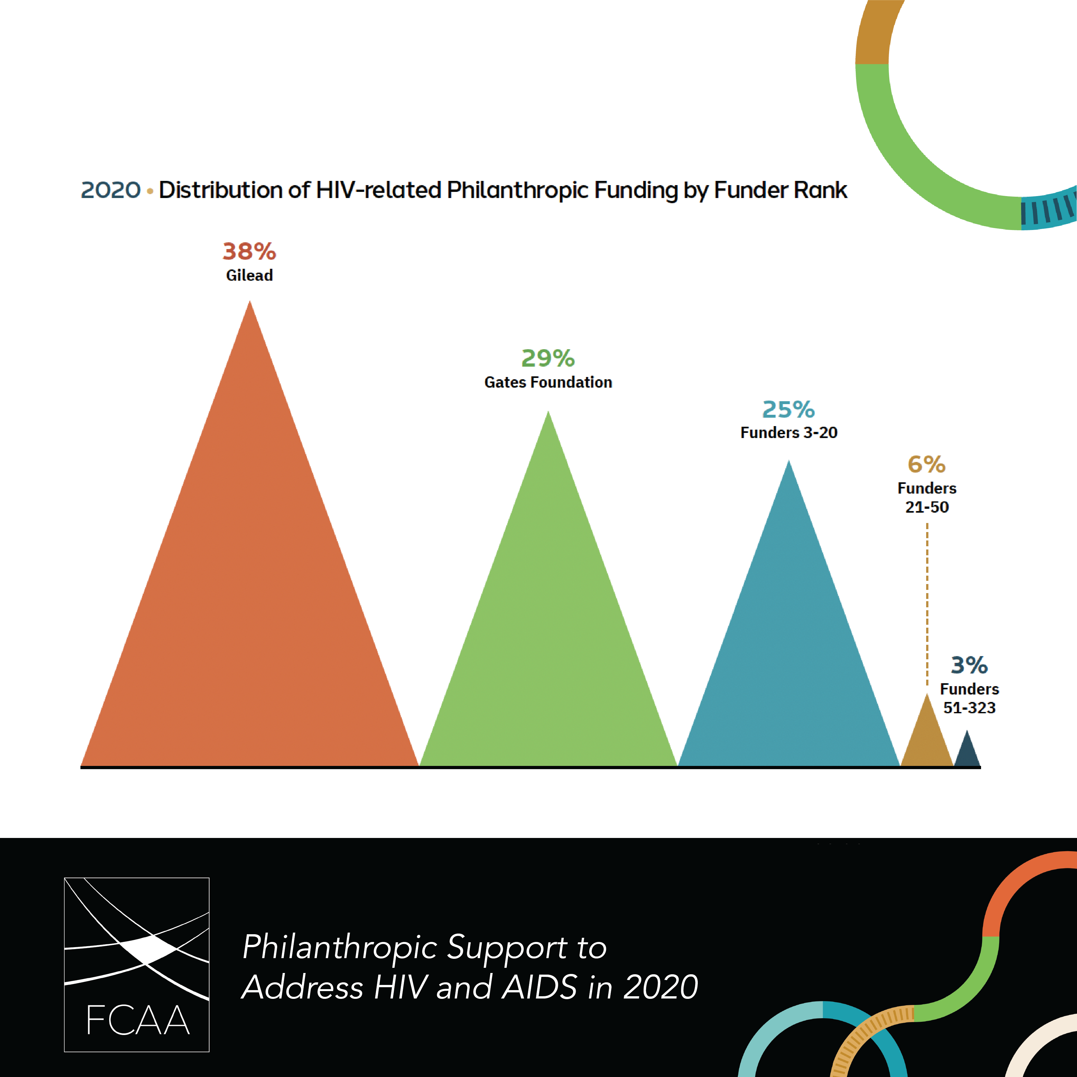 | #HIV related philanthropic funding is precarious, relying largely on just a few funders year after year. The top 2 funders = 67% of all funding. For the full picture, read @FCAA’s new report. https://bit.ly/FCAART2020  #FundHIVFight #Philanthropy
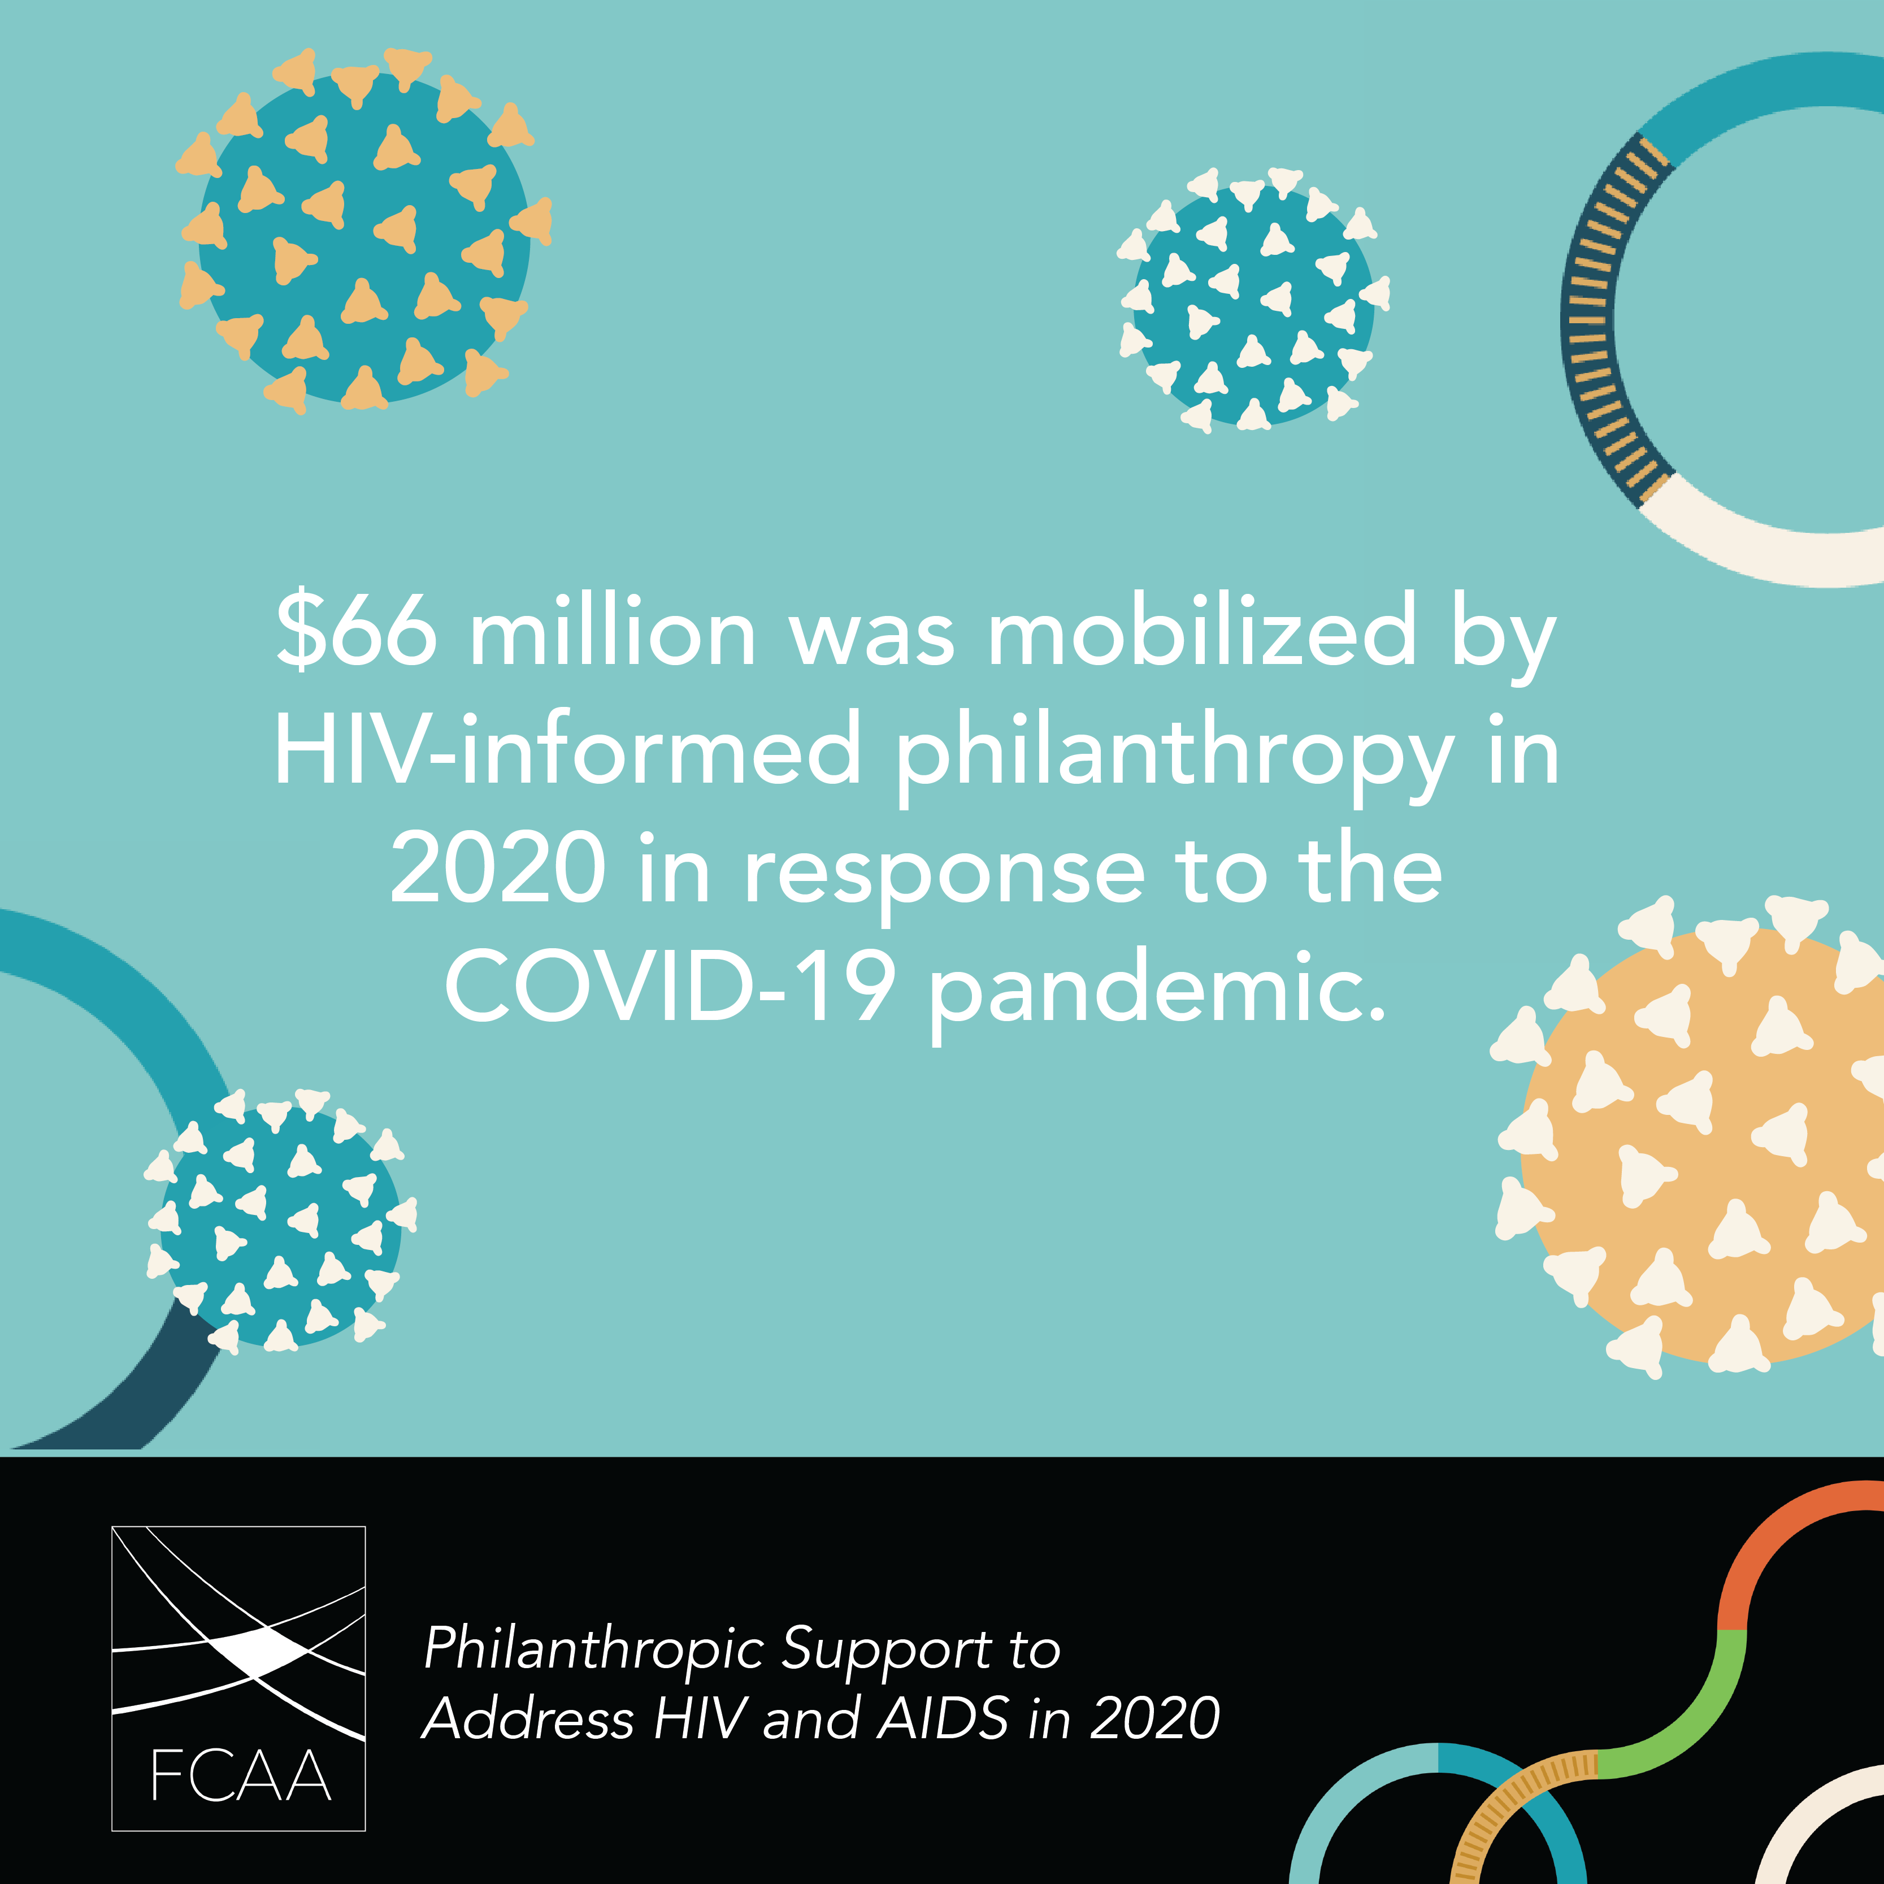 | In 2020, #HIV related philanthropy directed $66 million to respond to the #COVID19 pandemic. Read @FCAA’s new report for more context. https://bit.ly/FCAART2020 #FundHIVFight #Philanthopy
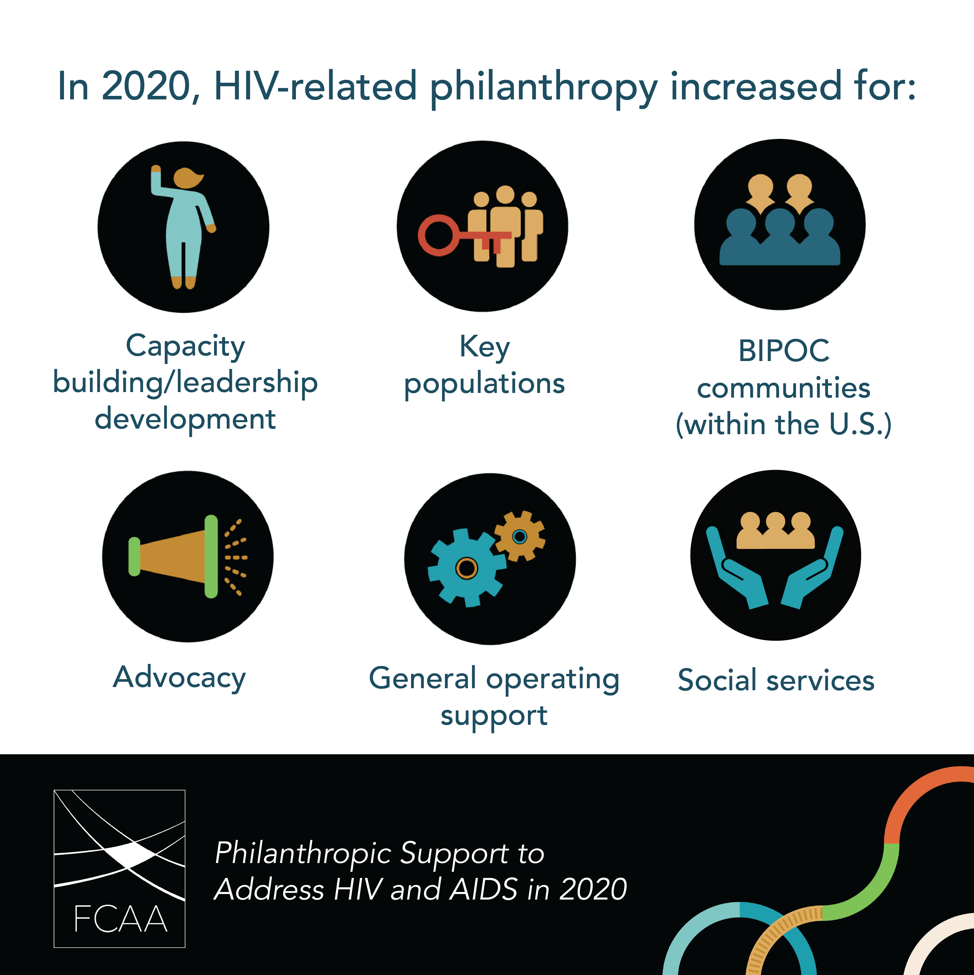 | Even though, as a whole private HIV-related #philanthropy was flat in 2020, it did increase in key areas. Learn more about the state of #HIV private philanthropic giving in @FCAA’s new report. https://bit.ly/FCAART2020 #FundHIVFight
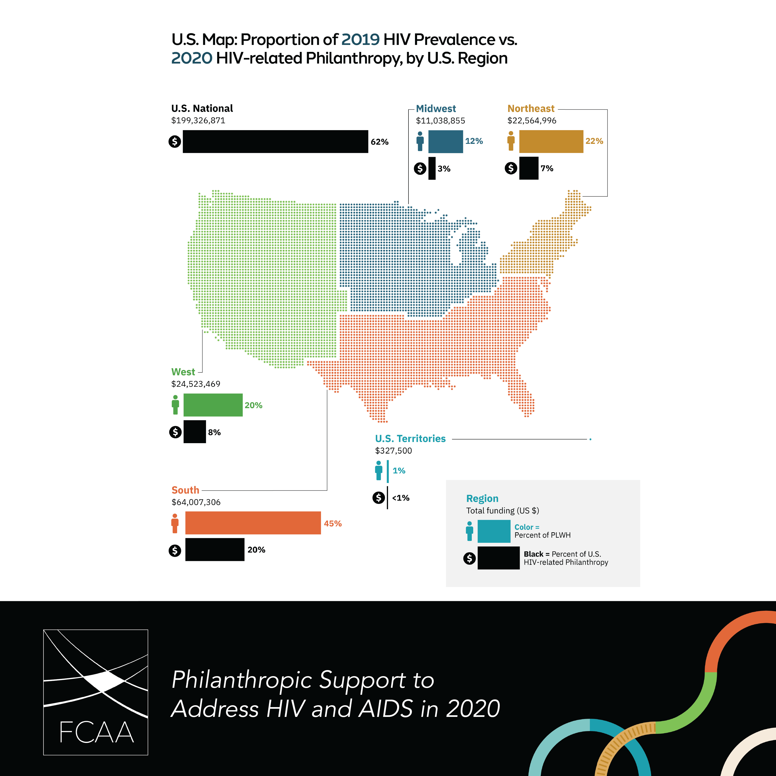 | Comparing philanthropic #HIV funding against % of #PLWH (per @AIDSvu) in the US, @FCAA report finds that trajectory of $ follows the trend of prevalence BUT there are still clear gaps.  https://bit.ly/FCAART2020 #FundHIVFight #Philanthropy
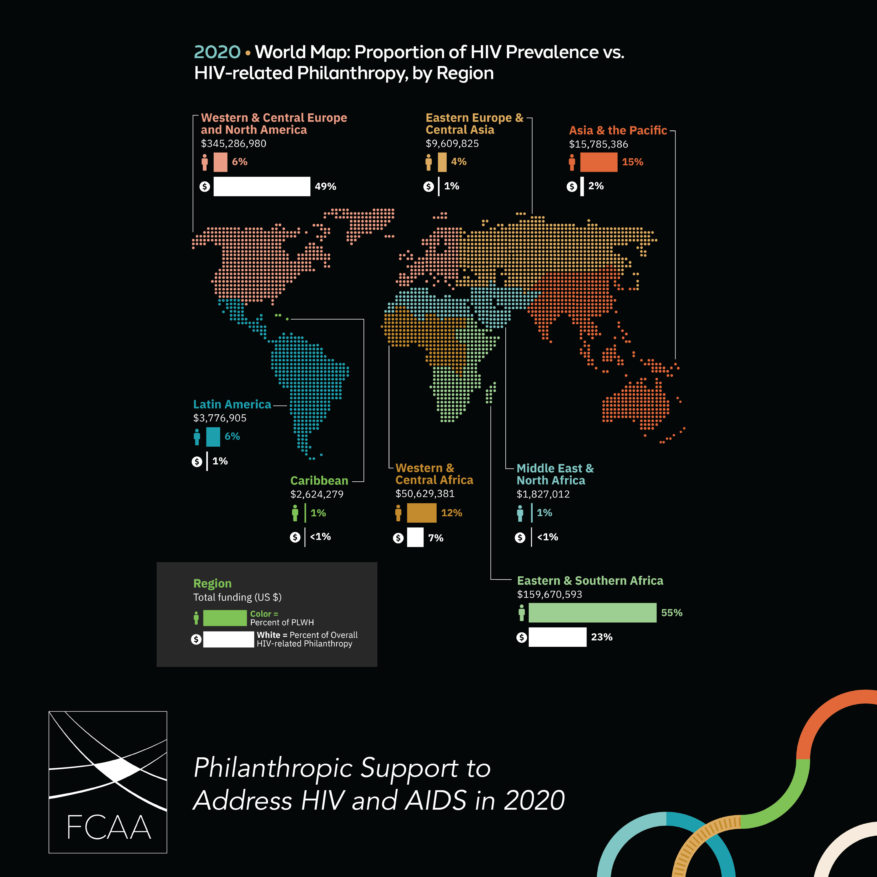 | By comparing the latest funding against @UNAIDS data on #PLWH, @FCAA highlights gaps remain in global philanthropic response to #HIV, including in Eastern Europe & Central Asia where new infections continue to rise.  #FundHIVFight https://bit.ly/FCAART2020
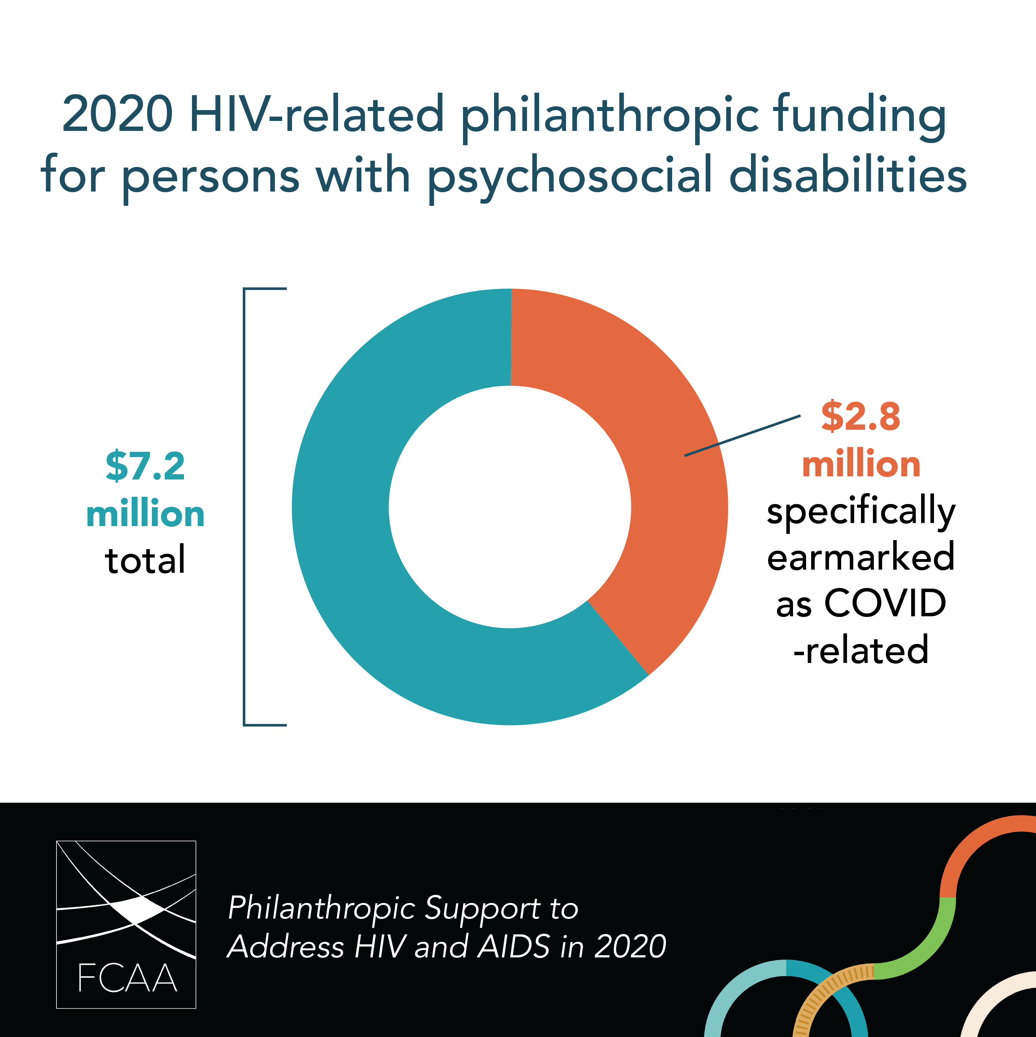 | In 2020, #HIV related philanthropic funding for persons with #psychosocial disabilities grew for the first time in years, likely an intentional funding strategy responding to heightened, #COVID induced loneliness & #MentalHealth challenges. https://bit.ly/FCAART2020  #FundHIVFight

