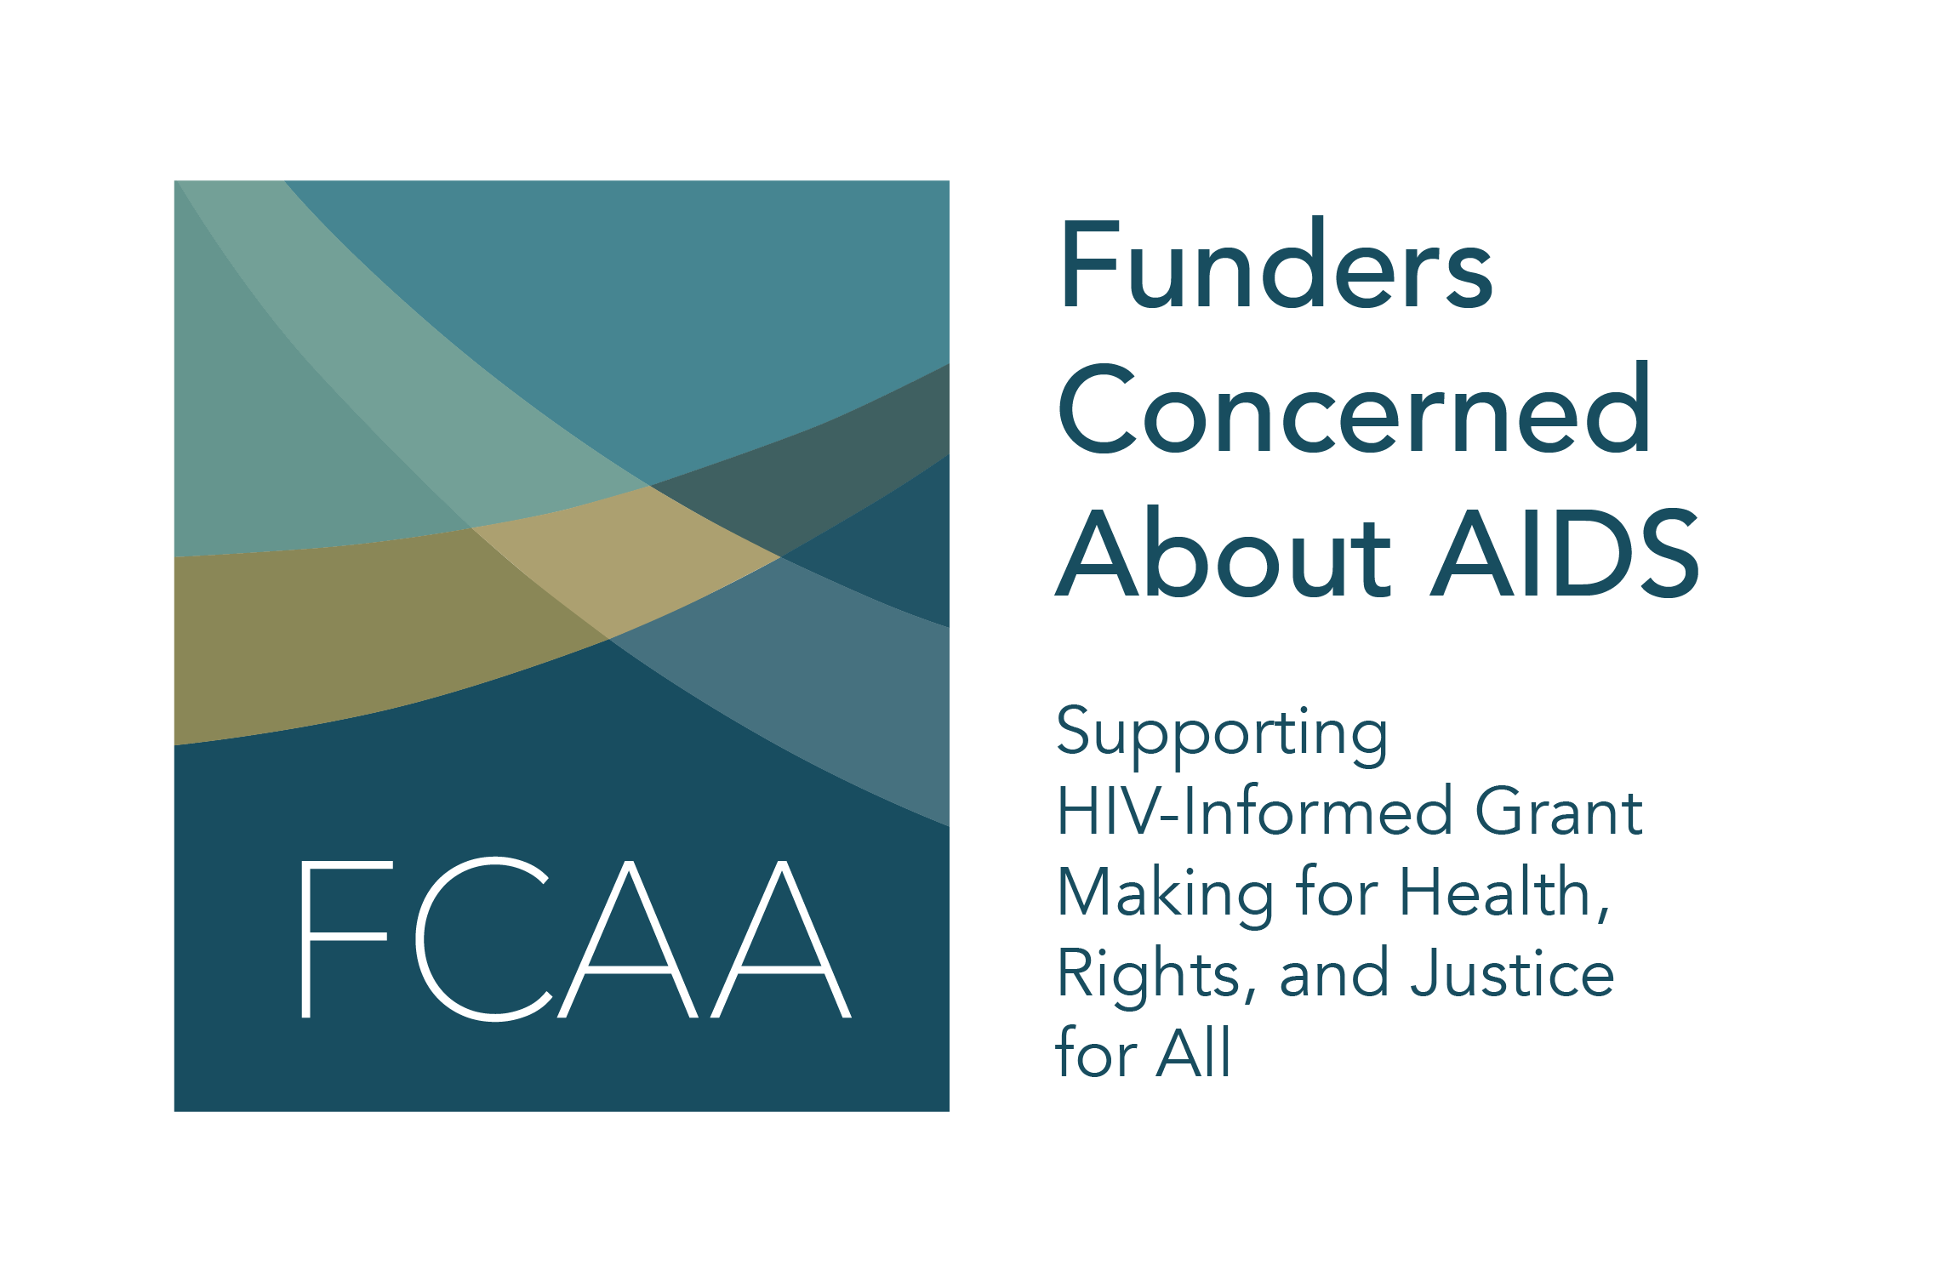
AIDS 2022 SOCIAL MEDIA TOOLKIT

Funders Concerned About AIDS (FCAA) wants to ensure that philanthropy is a part of the important conversations taking place at AIDS 2022. We hope that you will join us in bringing increased focus to philanthropic funding in Montreal by sharing our messages through your social media channels. We have prepared the following toolkit to help you do that.

The first tweet refers audiences to FCAA’s landing page of research and resources, as well as a funder roadmap to the AIDS 2022 conference. On page 1 – 3, the toolkit emphasizes recent resource tracking data on the philanthropic response to HIV. Pages 3 - 5 provide language to spotlight recent FCAA research and resources that connect to key issues on the AIDS 2022 program.

Suggestions for using this material include:
- Posting content in the days leading up to AIDS 2022 to help create awareness of issues related to philanthropic funding.
- Utilizing this content during your time at the conference.
- Live tweeting about relevant conversations in which you participate throughout your time in Montreal.
- Tagging @FCAA and using the hashtag #FundHIVFight in your posts.

FCAA RESEARCH, RESOURCES & AIDS2022 FUNDER MAP
Philanthropic funders - everything you need to prepare for #AIDS2022 is all in one place. @FCAA has created a landing page with the latest research, tools, social media content, & a funder roadmap to the conference. https://bit.ly/FCAAAIds2022 #HIV | 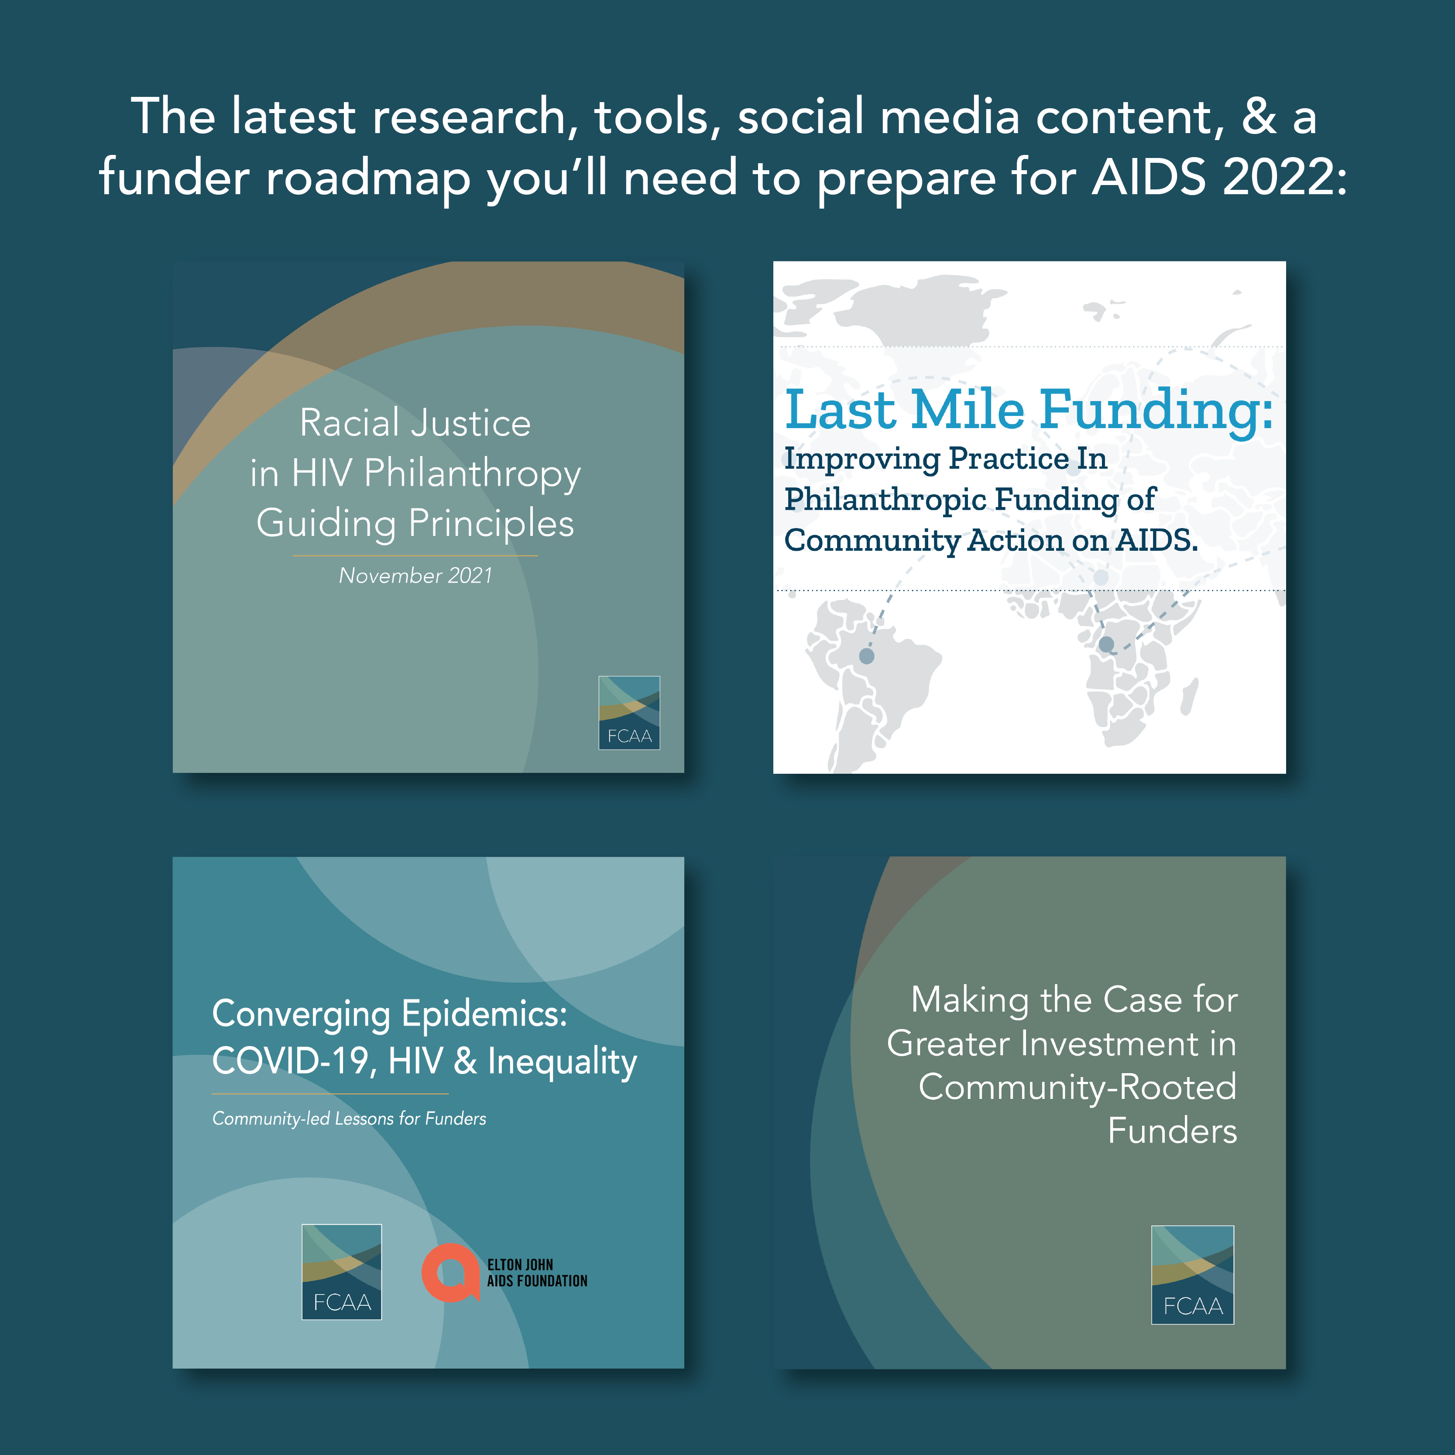
RESOURCE TRACKING
Heading into #AIDS2022, remember that #HIV related philanthropic funding is precarious, relying on a just few funders year after year. For the full picture, read @FCAA’s new report https://bit.ly/FCAART22 and join us in Montreal to call on the private sector to increase support! | 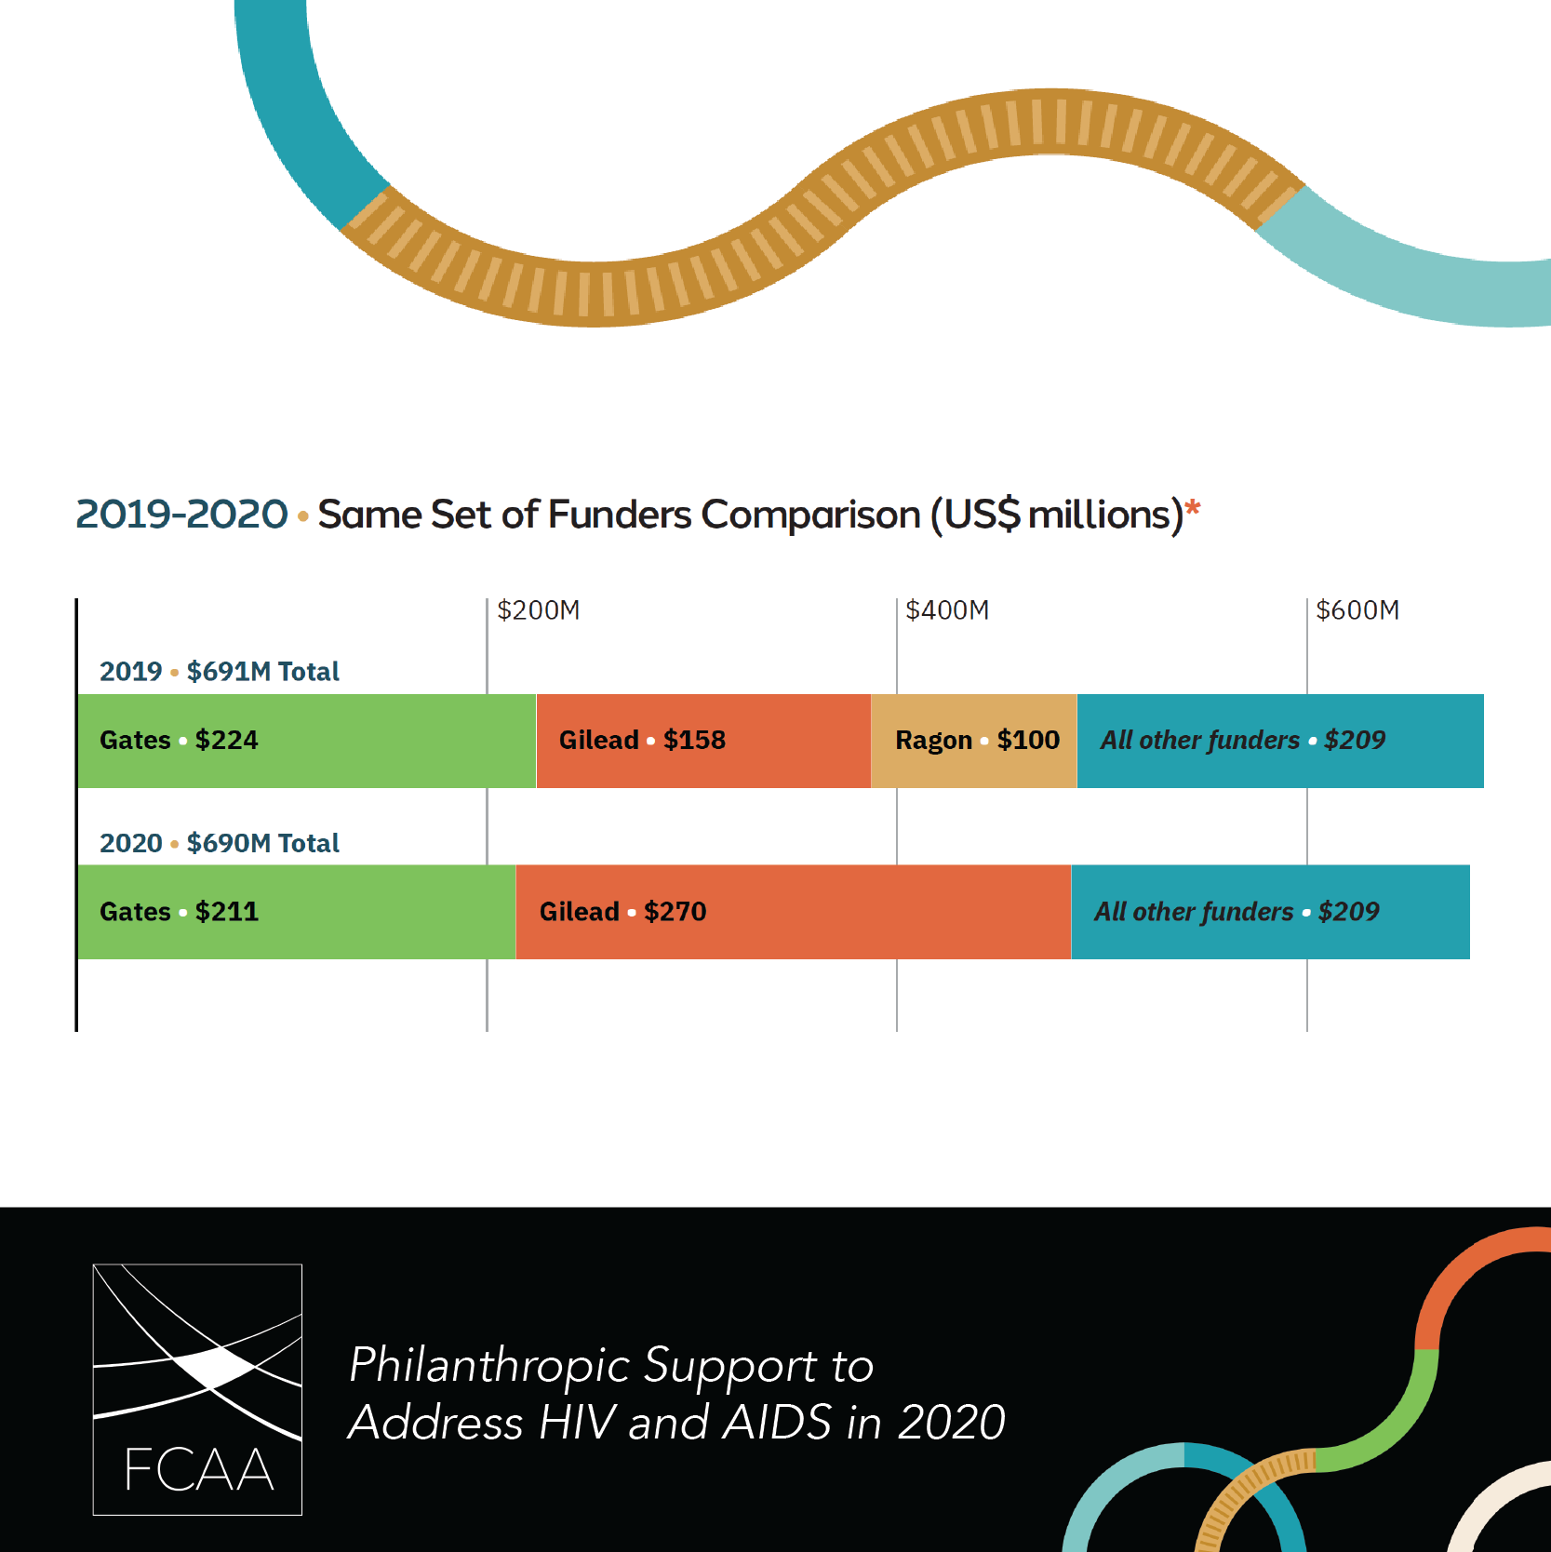
Heading to #AIDS2022? Do your homework by reading @FCAA's latest report on the state of philanthropic funding. It captures data on >5,000 grants, awarded by 323 foundations in 10 countries. https://bit.ly/FCAART22 #FundHIVFight | 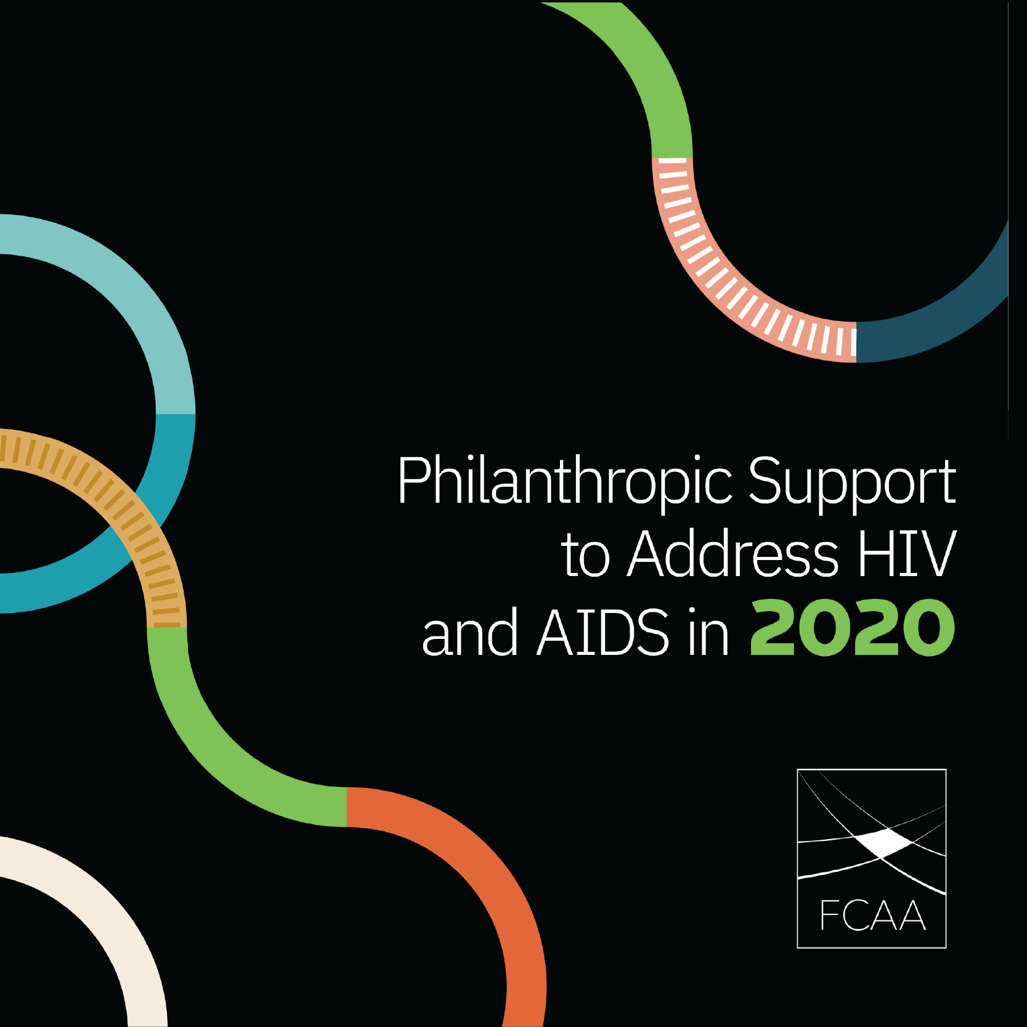
In 2020, #HIV related philanthropy directed ˜$66 million to respond to the #COVID19 pandemic. Will this funding be sustained over time? Read @FCAA’s report prior to #AIDS2022 then see what funders have to say in Montreal! https://bit.ly/FCAART22 #FundHIVFight #Philanthopy | 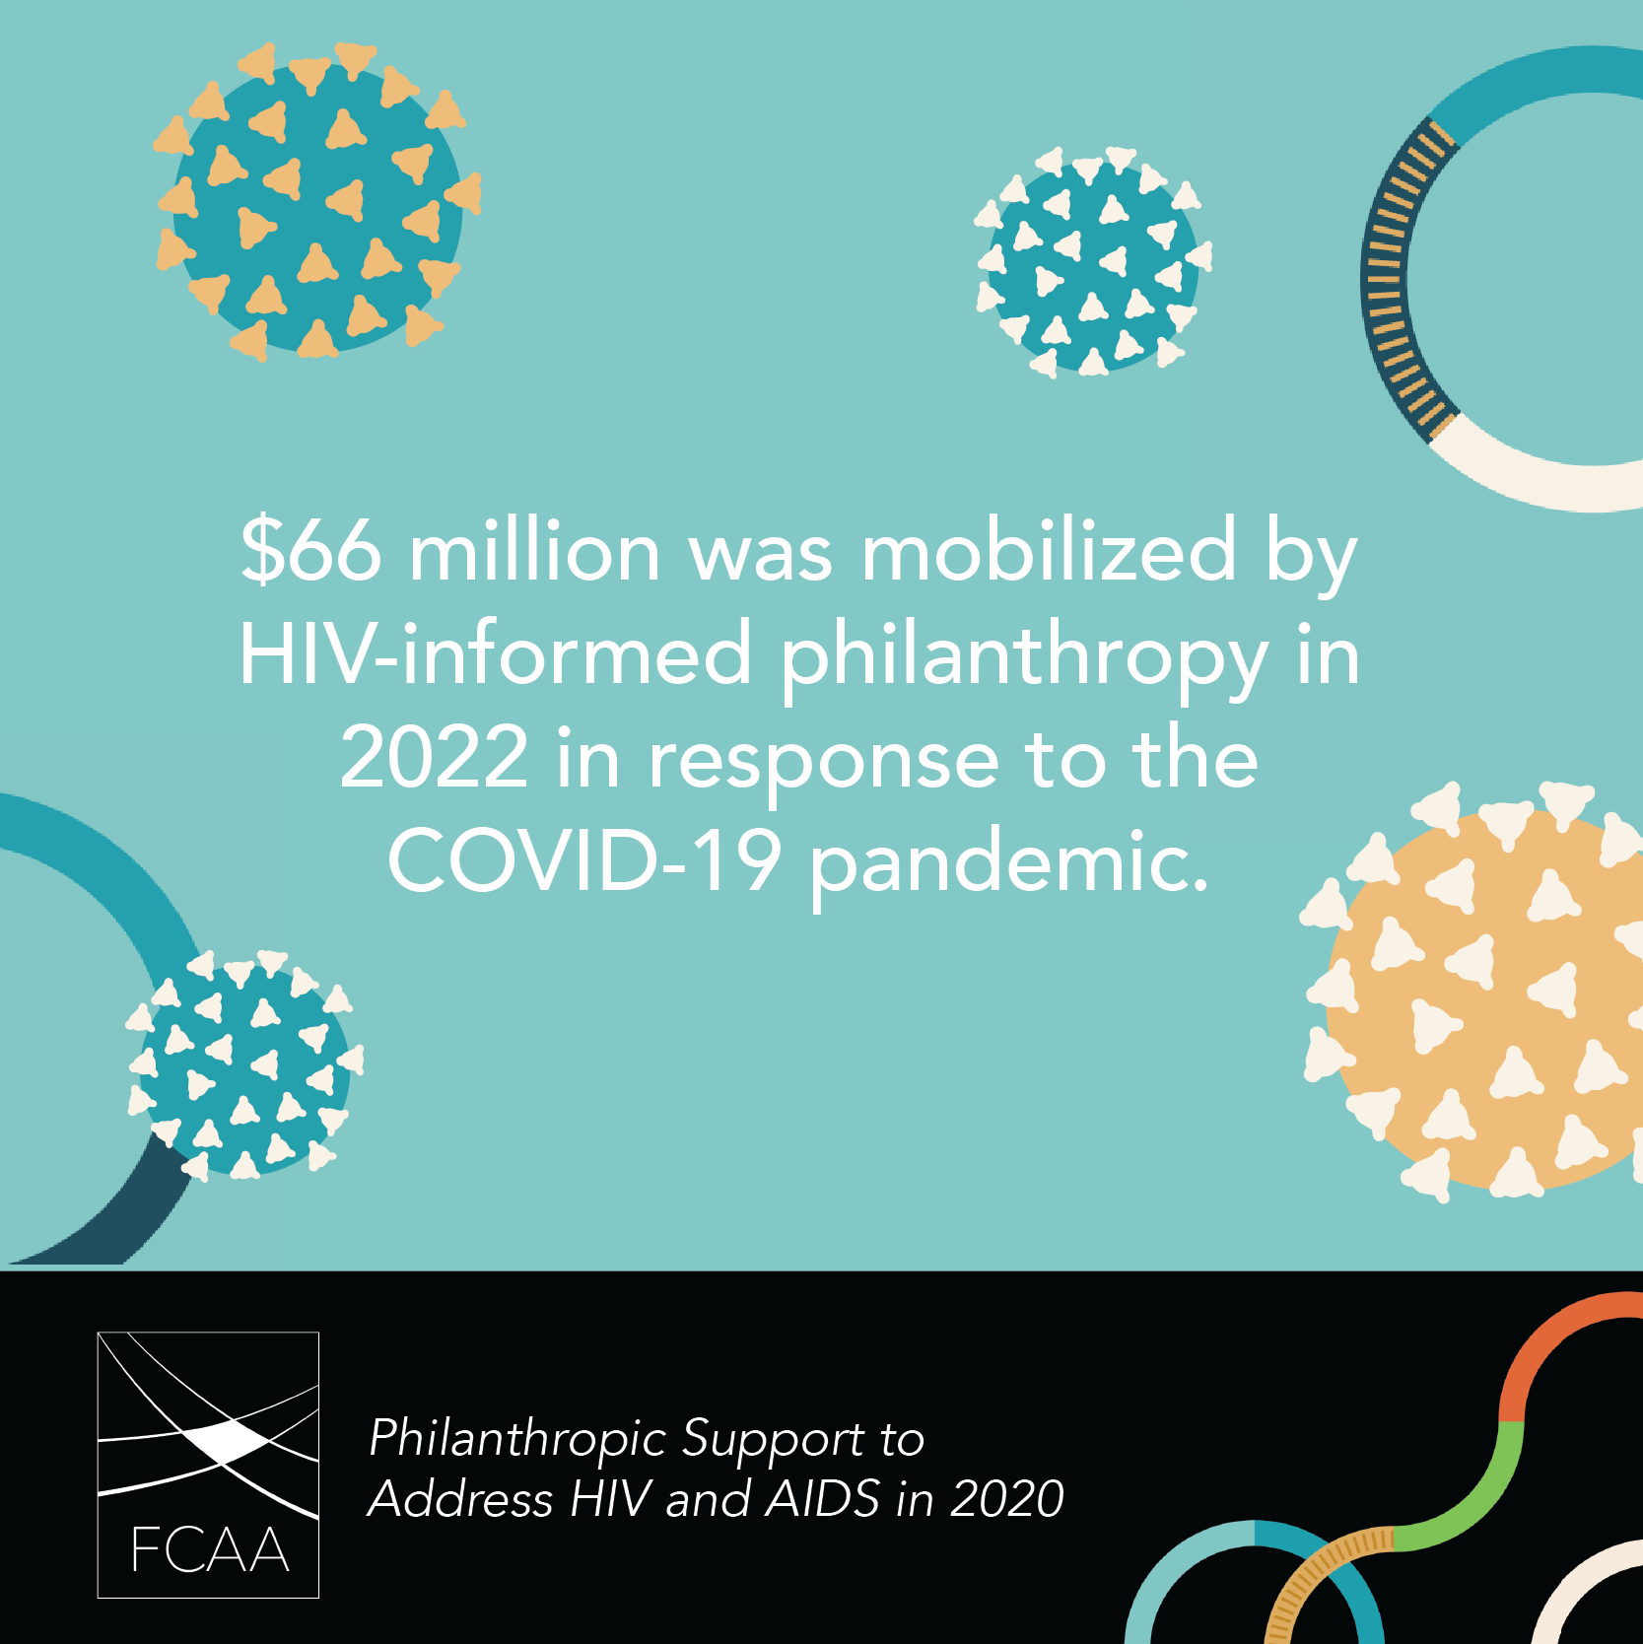
Hello #AIDS2022 attendees! Did you fund #HIV related work in 2021? Are you  - A traditional funder  - An #intermediary  - Did you make even 1 grant to an external org?  Make sure it's counted in @FCAA’s upcoming #call4data! https://grants.fcaaids.org/  #FundHIVFight | 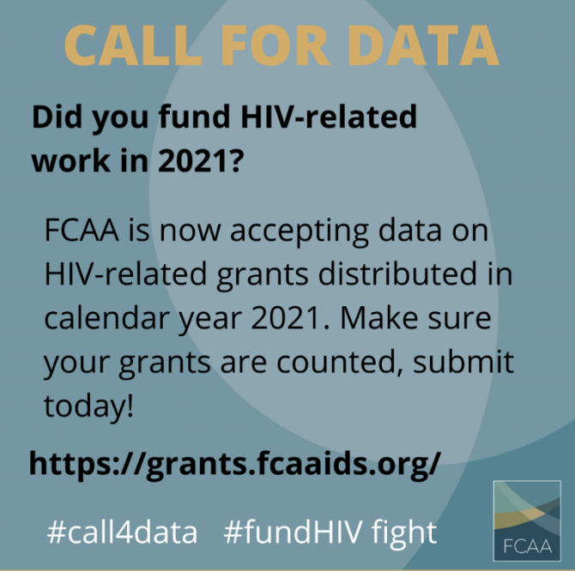
Investments in #KeyPopulations will be a key agenda item at #AIDS2020. Do your homework and learn more by reading @FCAA’s most recent resource tracking report. https://bit.ly/FCAART22 #FundHIVFight | 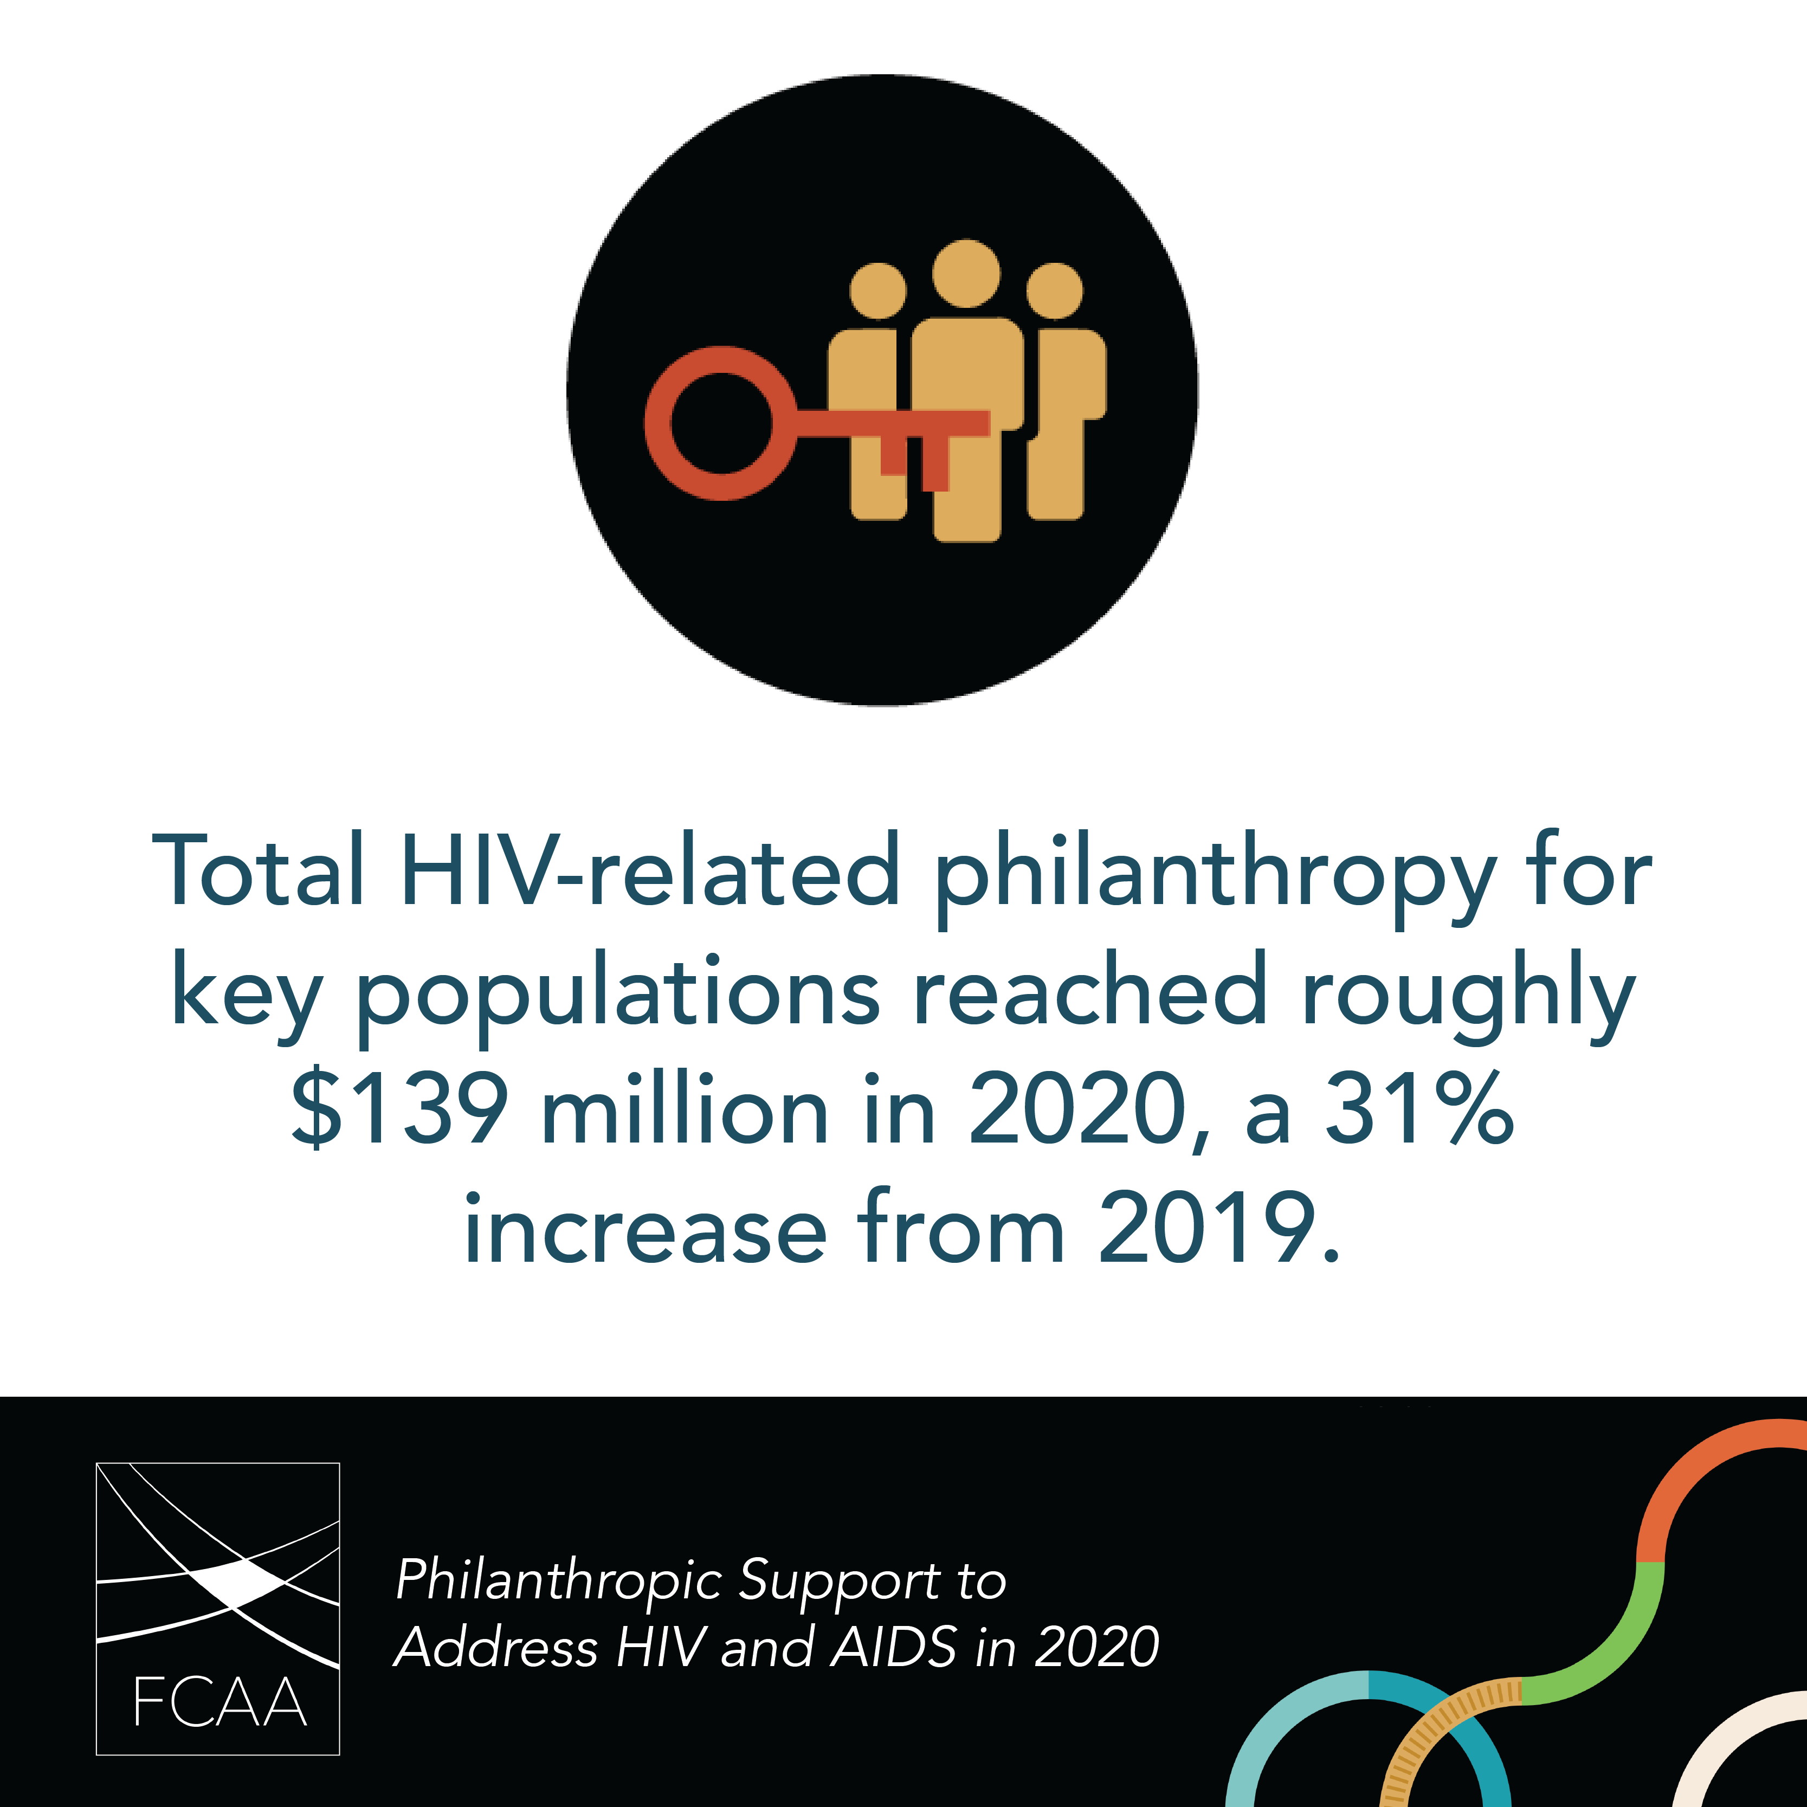
RACIAL JUSTICE PRINCIPLES
We hope #AntiRacist action is on the #AIDS2022 agenda. The Racial Justice Principles for #HIV informed funders, released by @FCAA, offers guidance in 4 key areas. Be sure to read it before heading to Montreal! https://bit.ly/RacialJusticePrinciples #FundHIVFight | 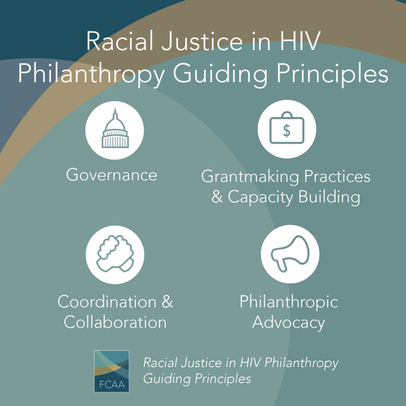
CONVERGING EPIDEMICS
Continued impacts of #COVID19 on the #HIV response will be a key agenda item @ #AIDS2022. Do your homework before Montreal by reading this report from @FCAA & @eltonjohnaidsfoundation highlighting convergence of COVD-19, HIV & #SystemicInequality. https://bit.ly/CovidandHIV | 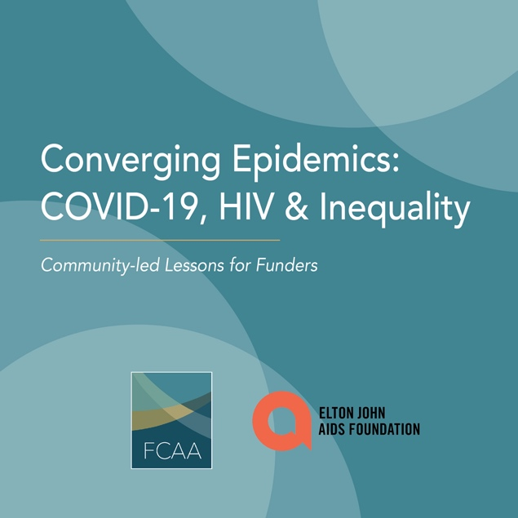
COMMUNITY ROOTED FUNDERS
At #AIDS2022, let’s continue to make the case for ↑investment in #HIV related intermediaries, esp. those that are community-rooted & community-led. Prepare by reading this @FCAA report. https://bit.ly/3uL3L0a #FundHIVFight #Philanthropy | 